NOTSAFE on 2019-06-05

# NOTSAFE2019-06-05 20:16:07.425358.jpg

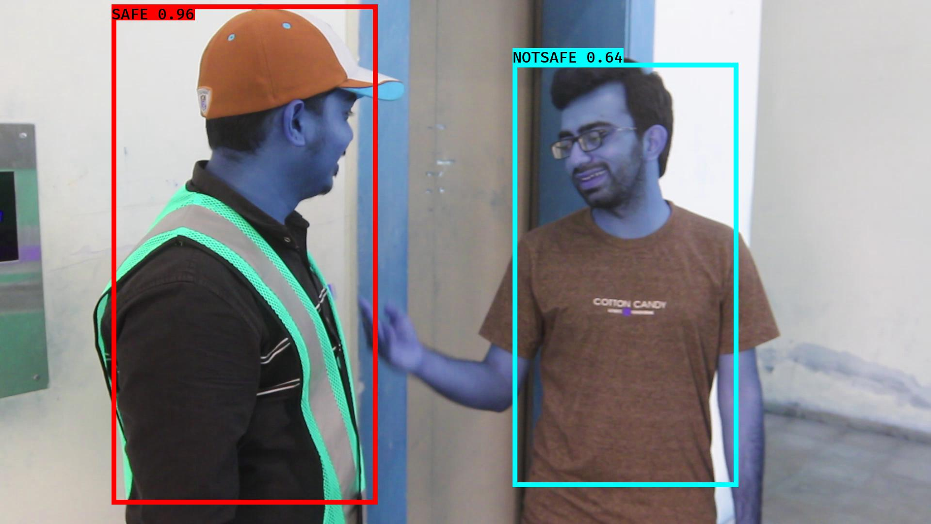

# NOTSAFE2019-06-05 20:16:10.225294.jpg

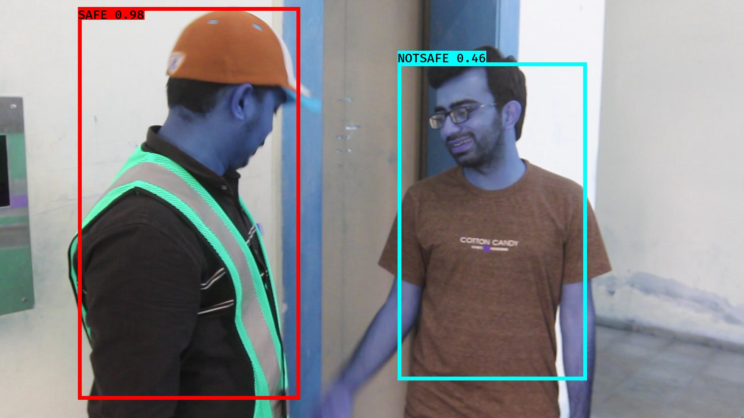

# NOTSAFE2019-06-05 20:16:33.825429.jpg

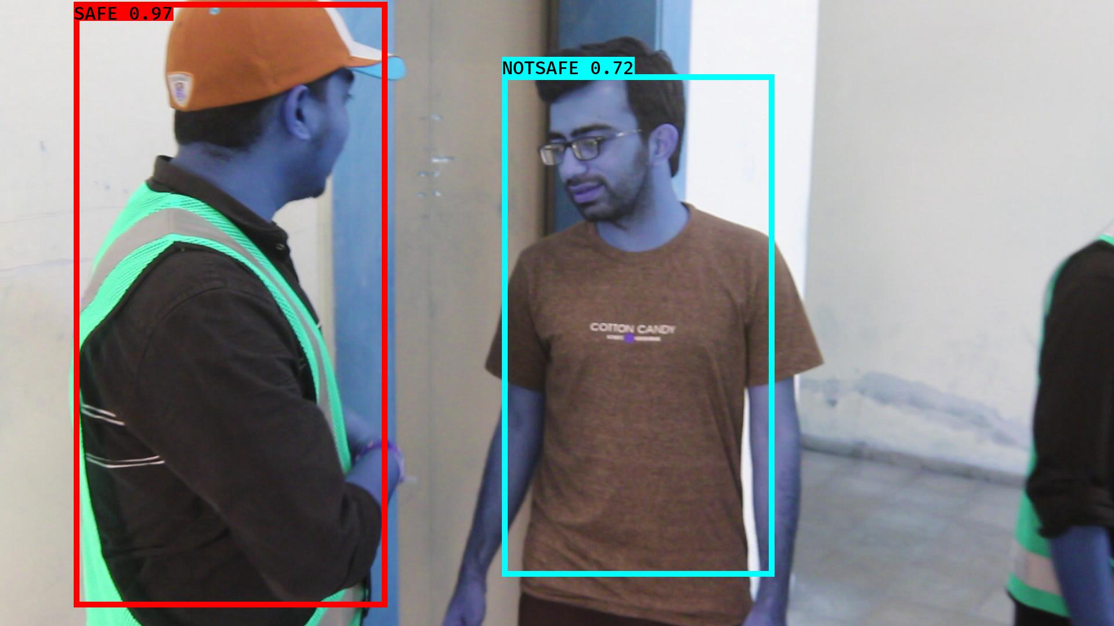

# NOTSAFE2019-06-05 20:15:59.441868.jpg

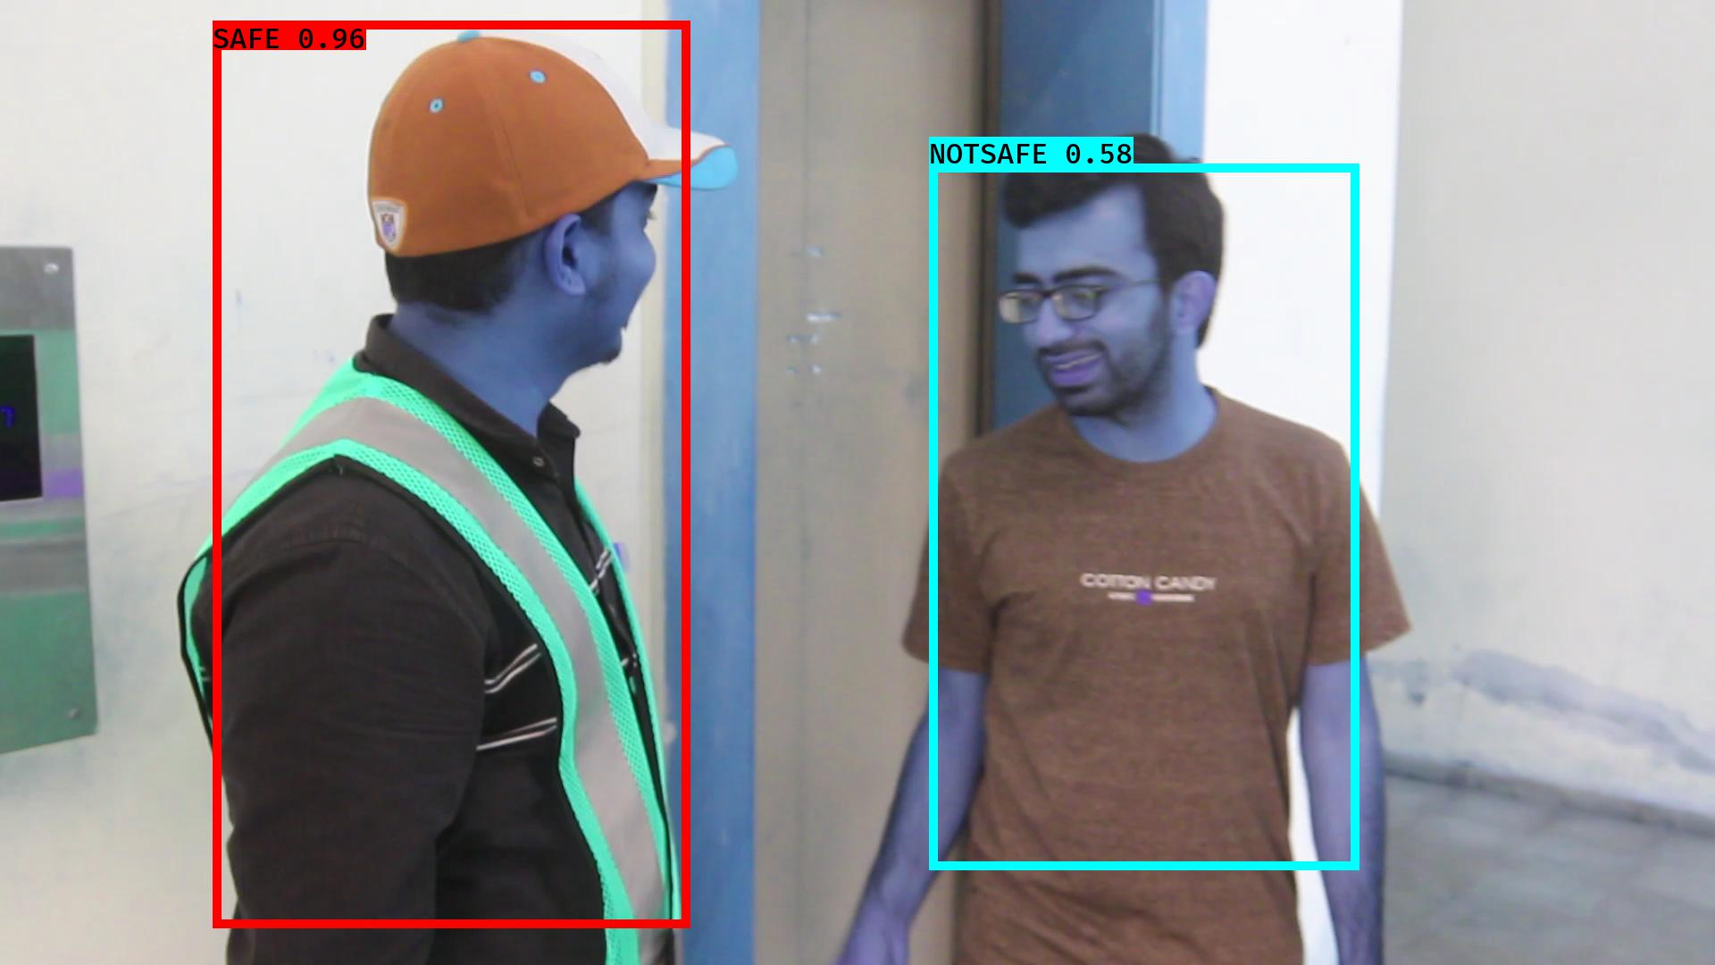

# NOTSAFE2019-06-05 20:16:50.389207.jpg

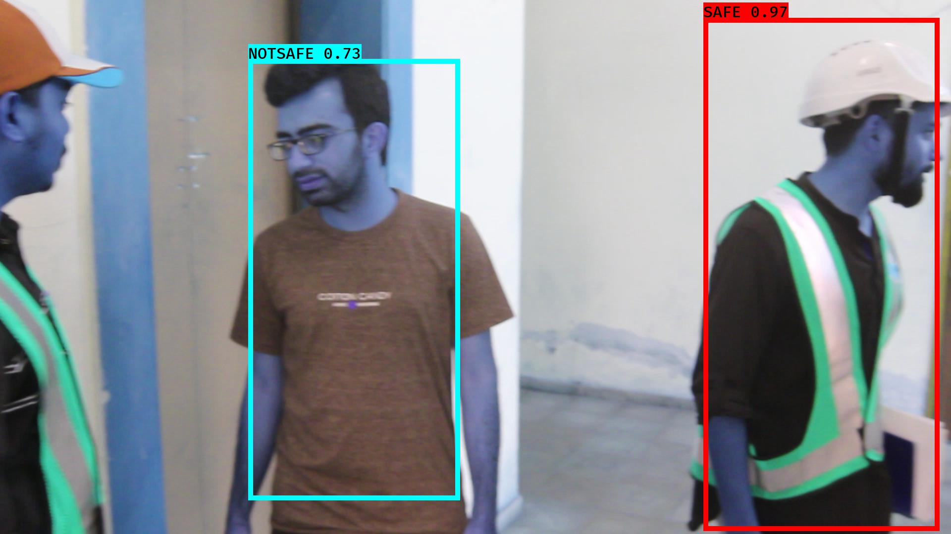

# NOTSAFE2019-06-05 20:16:00.727989.jpg

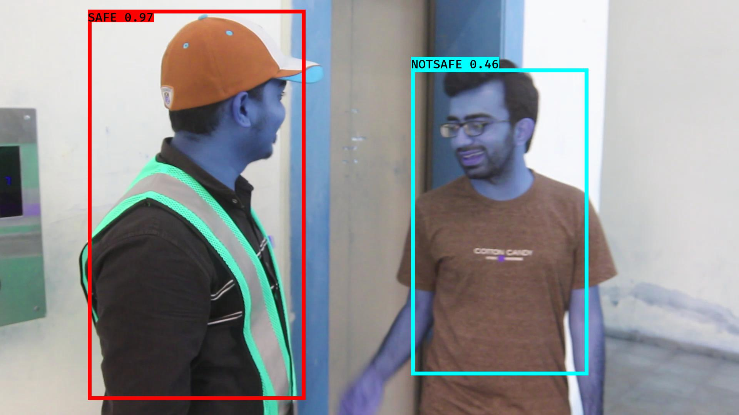

# NOTSAFE2019-06-05 20:16:29.680065.jpg

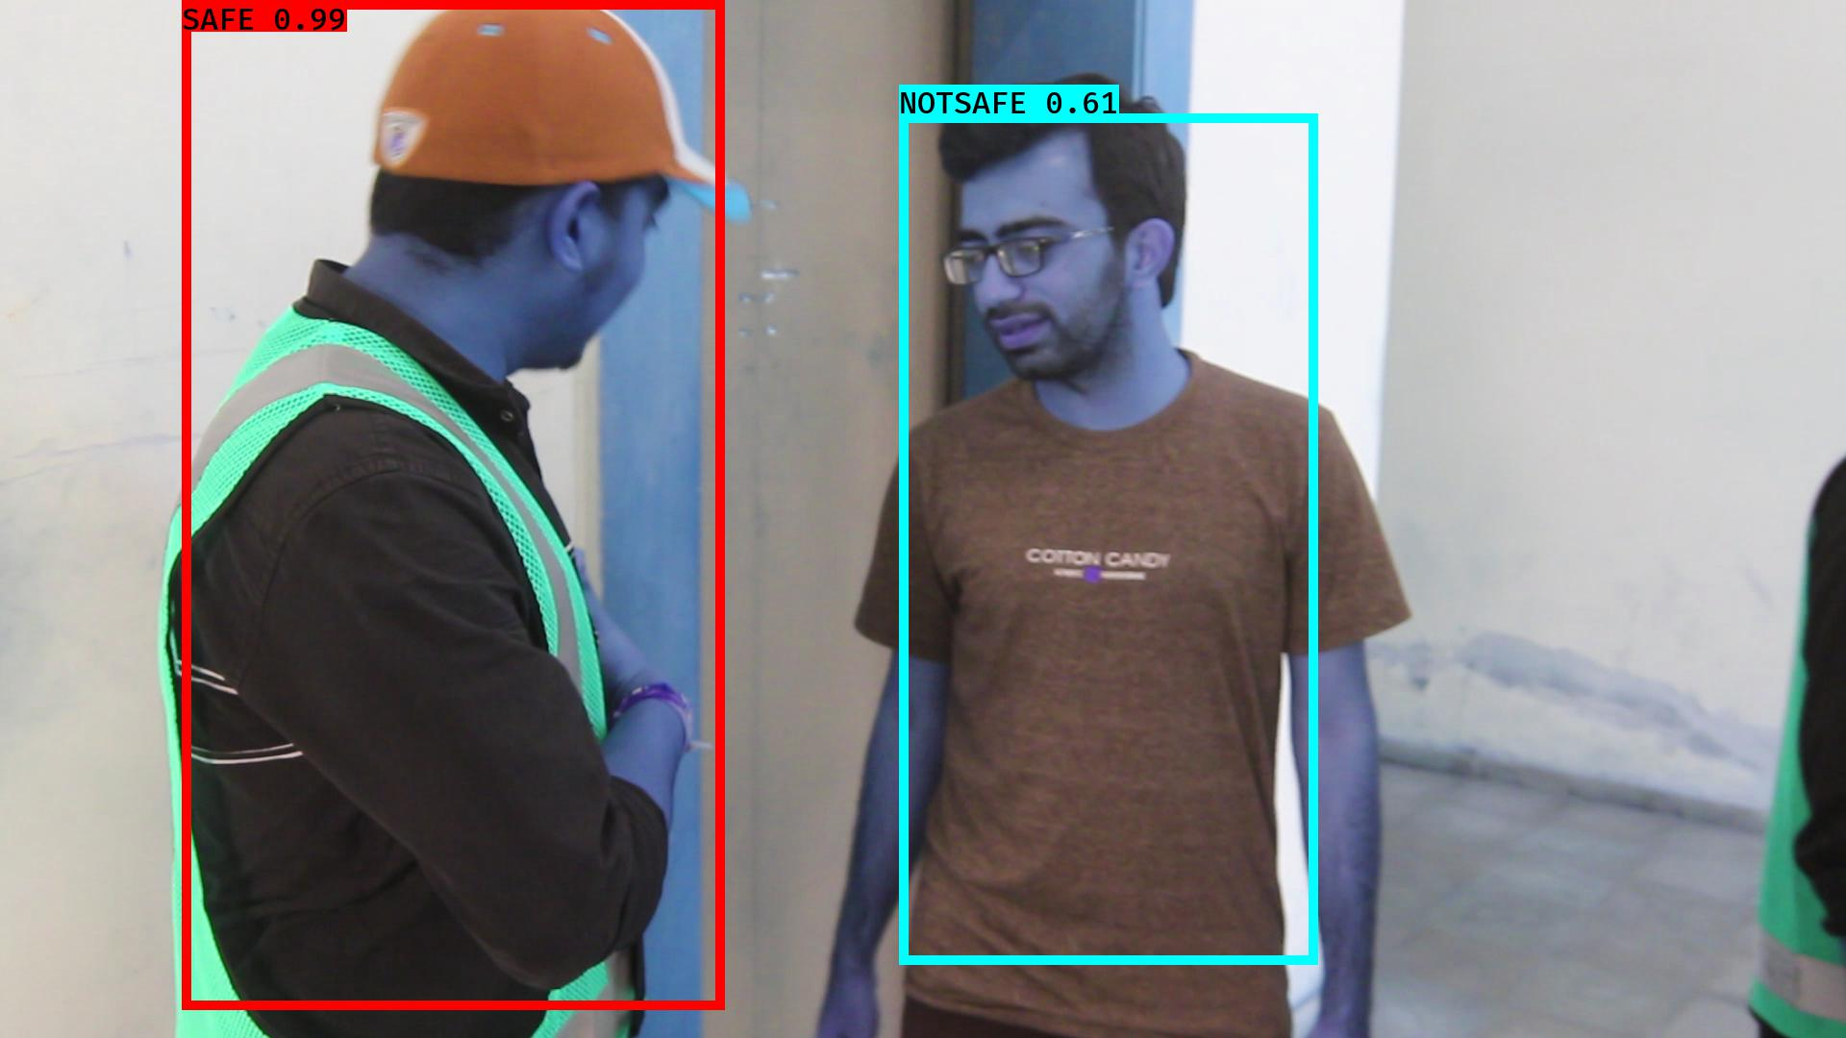

# NOTSAFE2019-06-05 20:16:40.351221.jpg

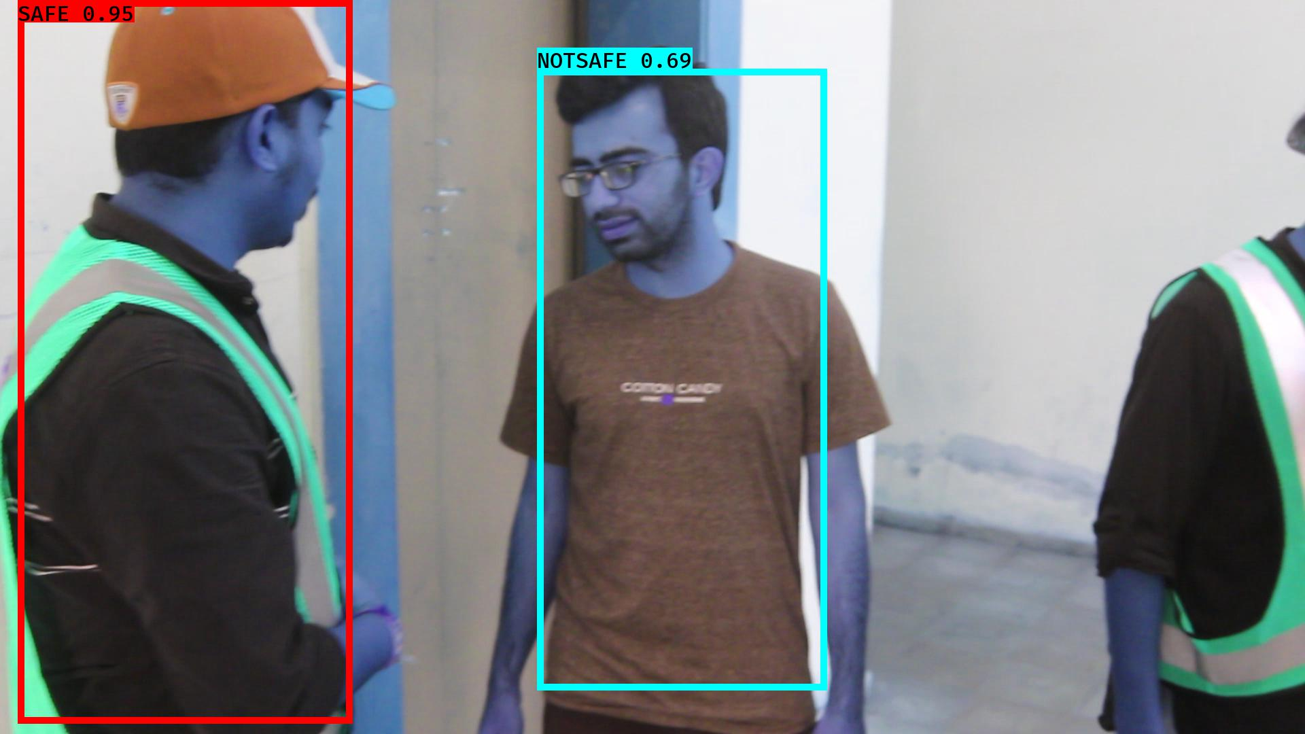

# NOTSAFE2019-06-05 20:16:49.210089.jpg

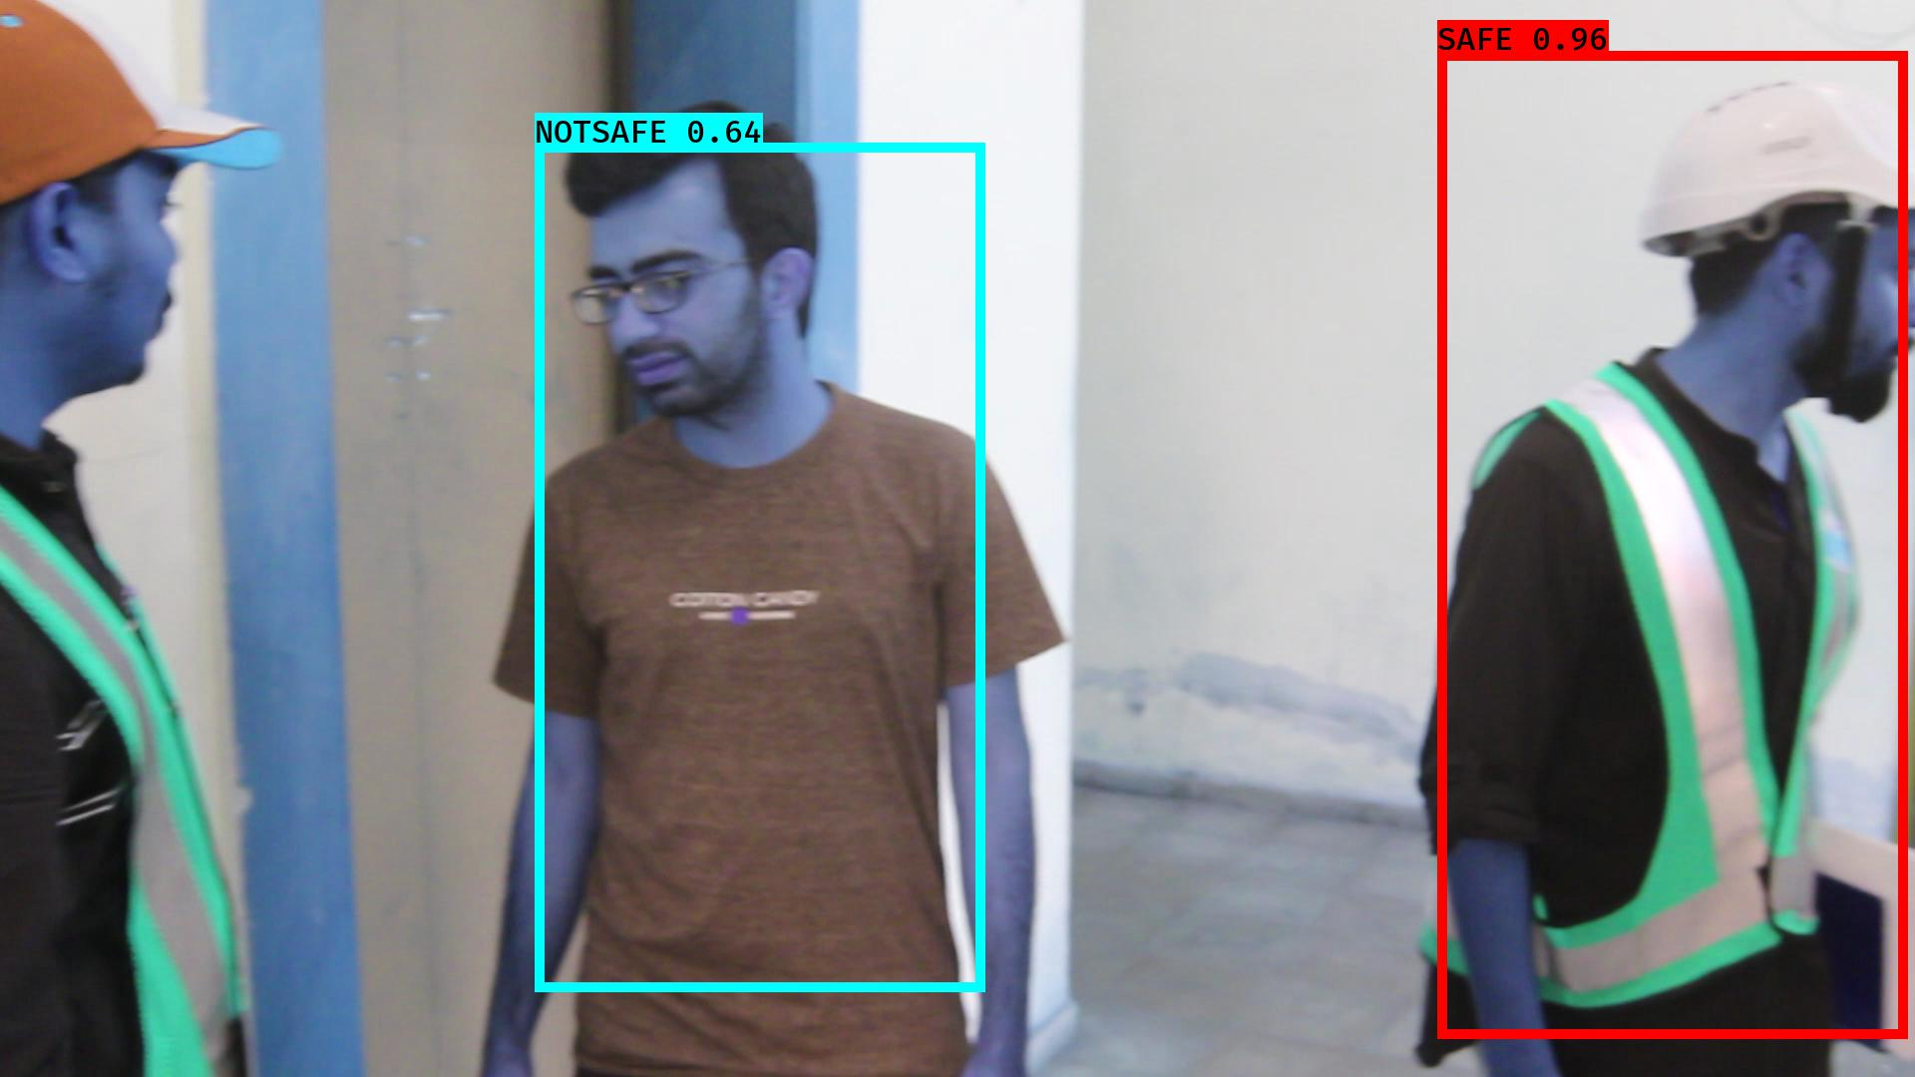

# NOTSAFE2019-06-05 20:16:48.620984.jpg

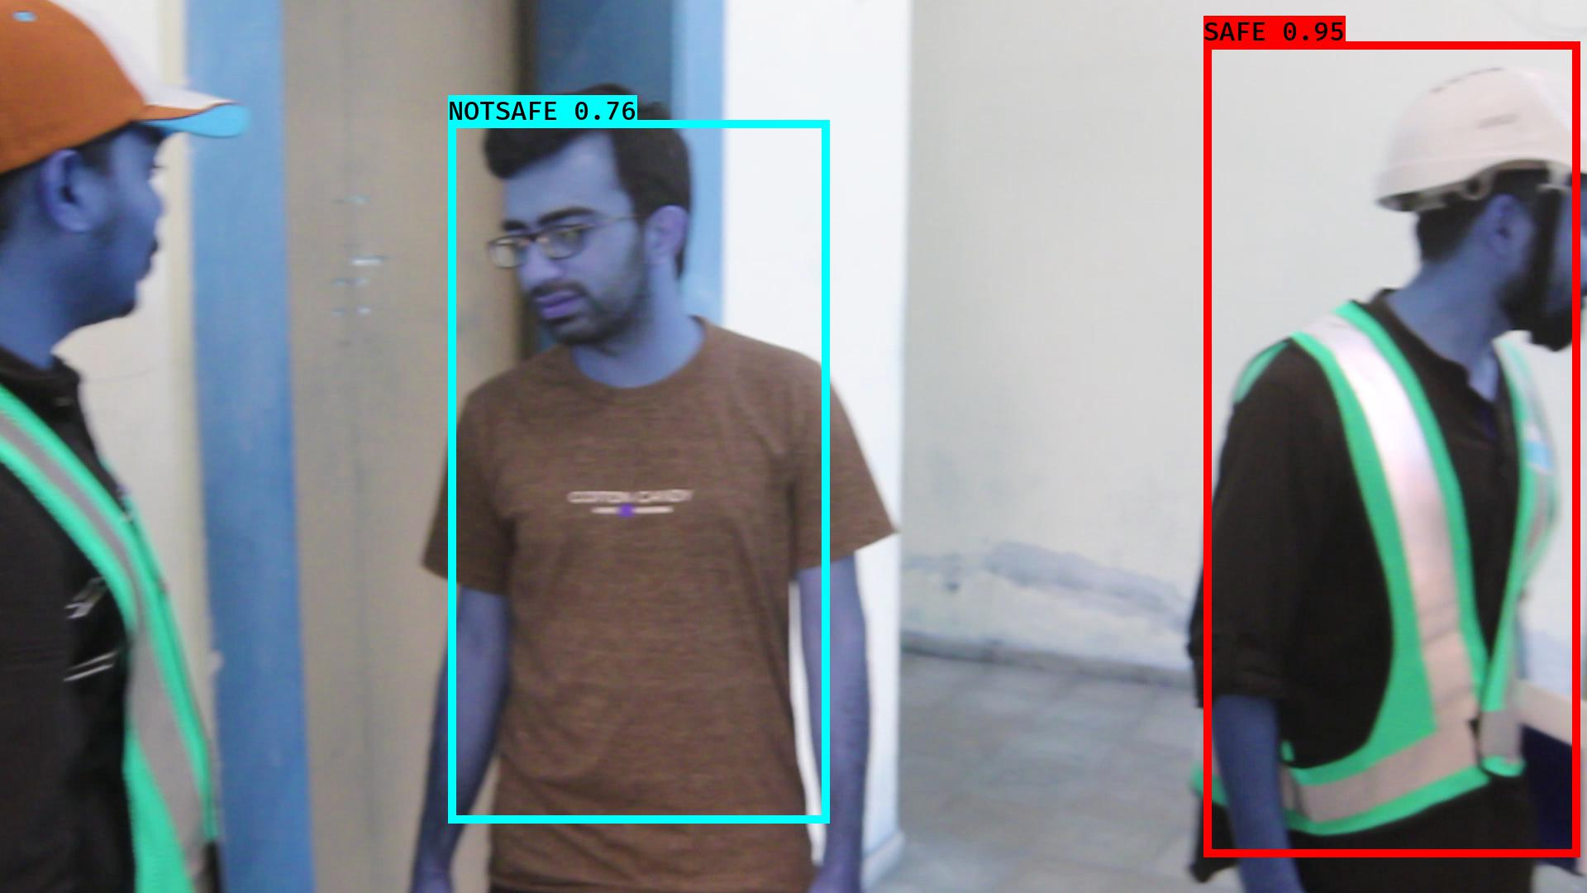

# NOTSAFE2019-06-05 20:16:33.233595.jpg

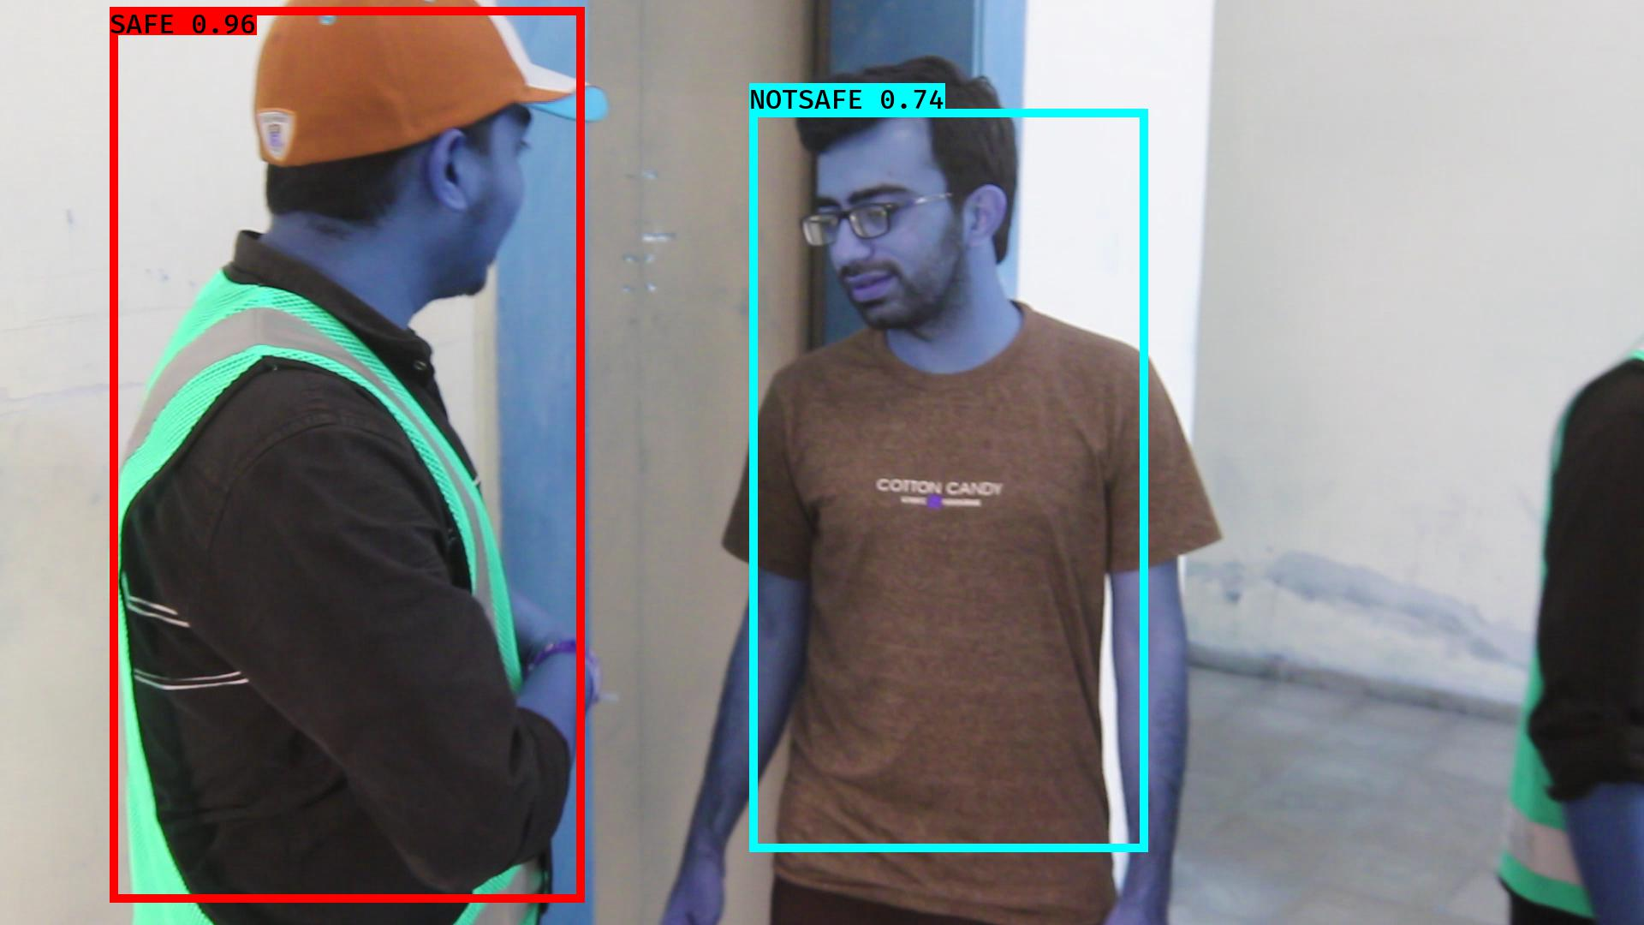

# NOTSAFE2019-06-05 20:16:51.567248.jpg

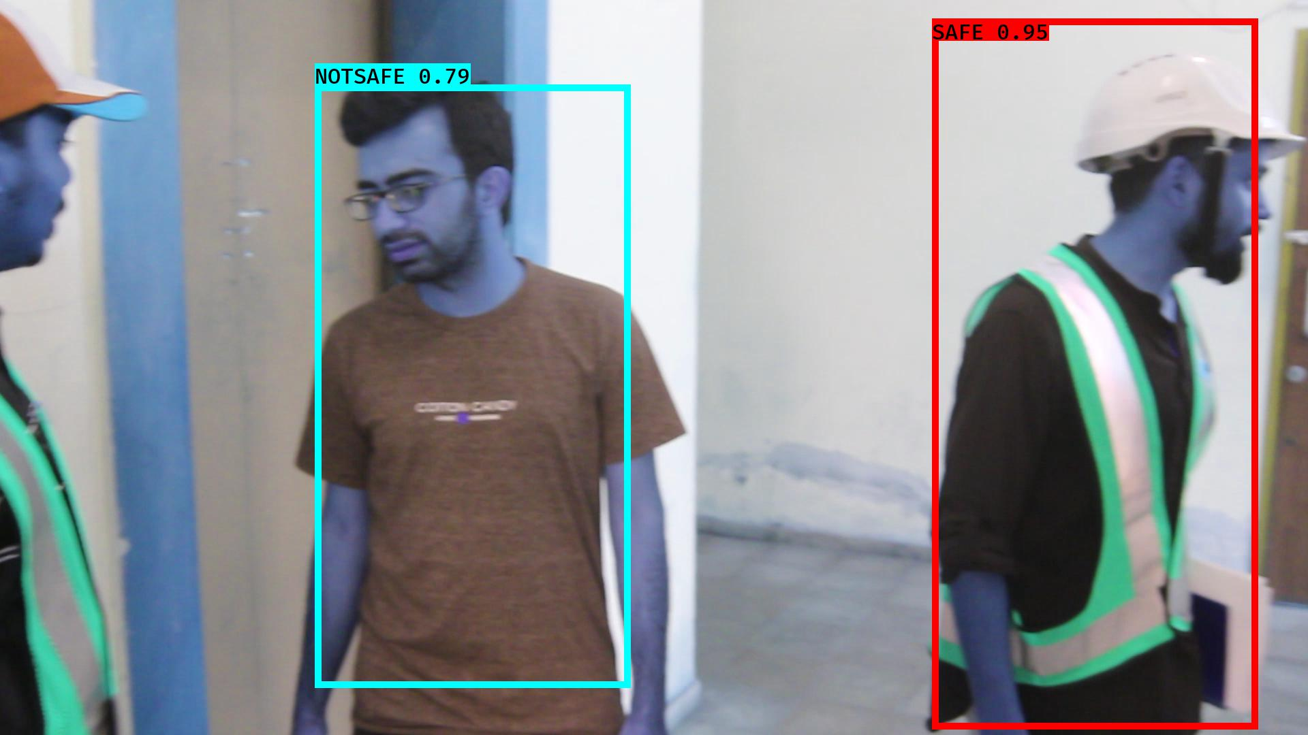

# NOTSAFE2019-06-05 20:16:42.716312.jpg

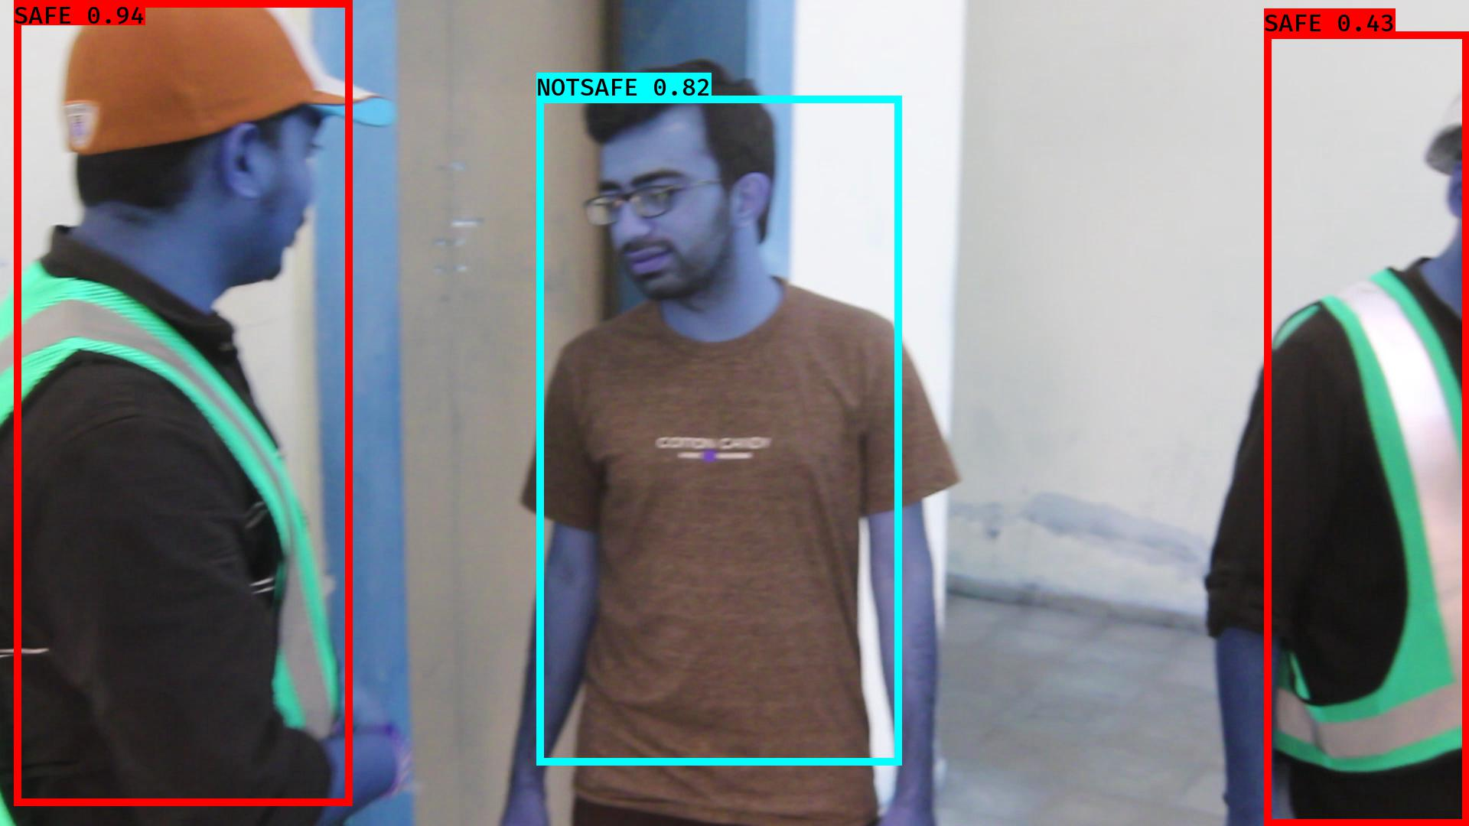

# NOTSAFE2019-06-05 20:16:26.136951.jpg

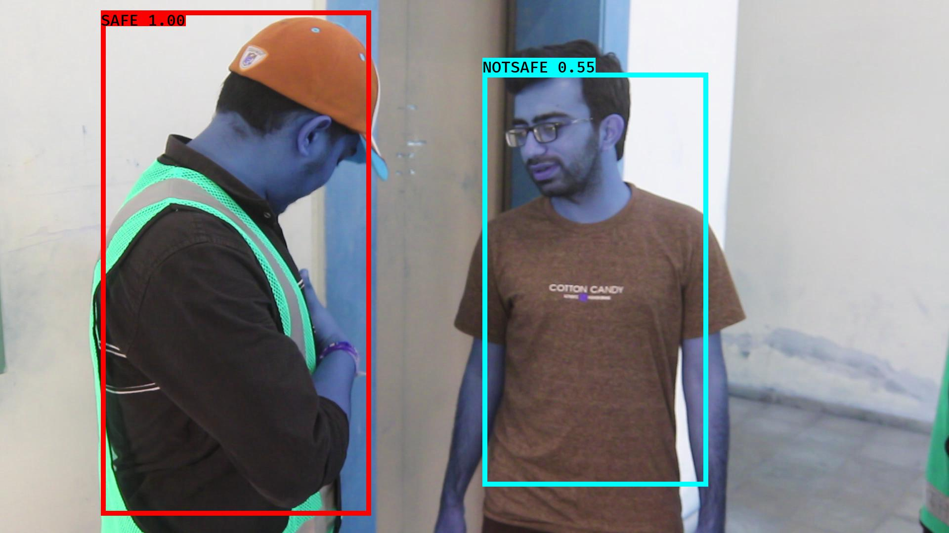

# NOTSAFE2019-06-05 20:16:56.371993.jpg

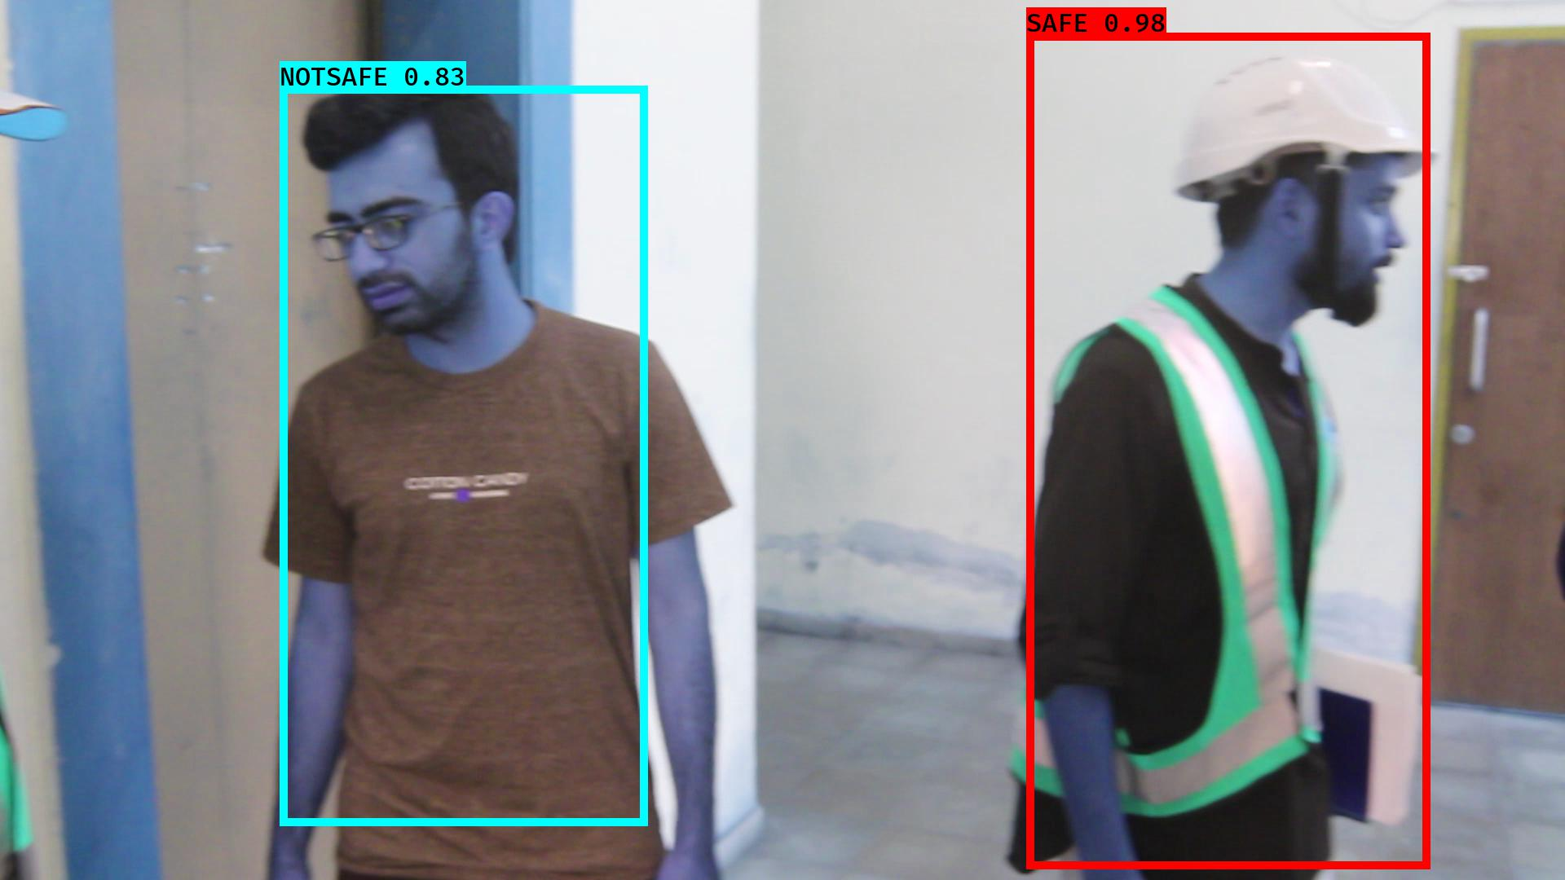

# NOTSAFE2019-06-05 20:16:18.591379.jpg

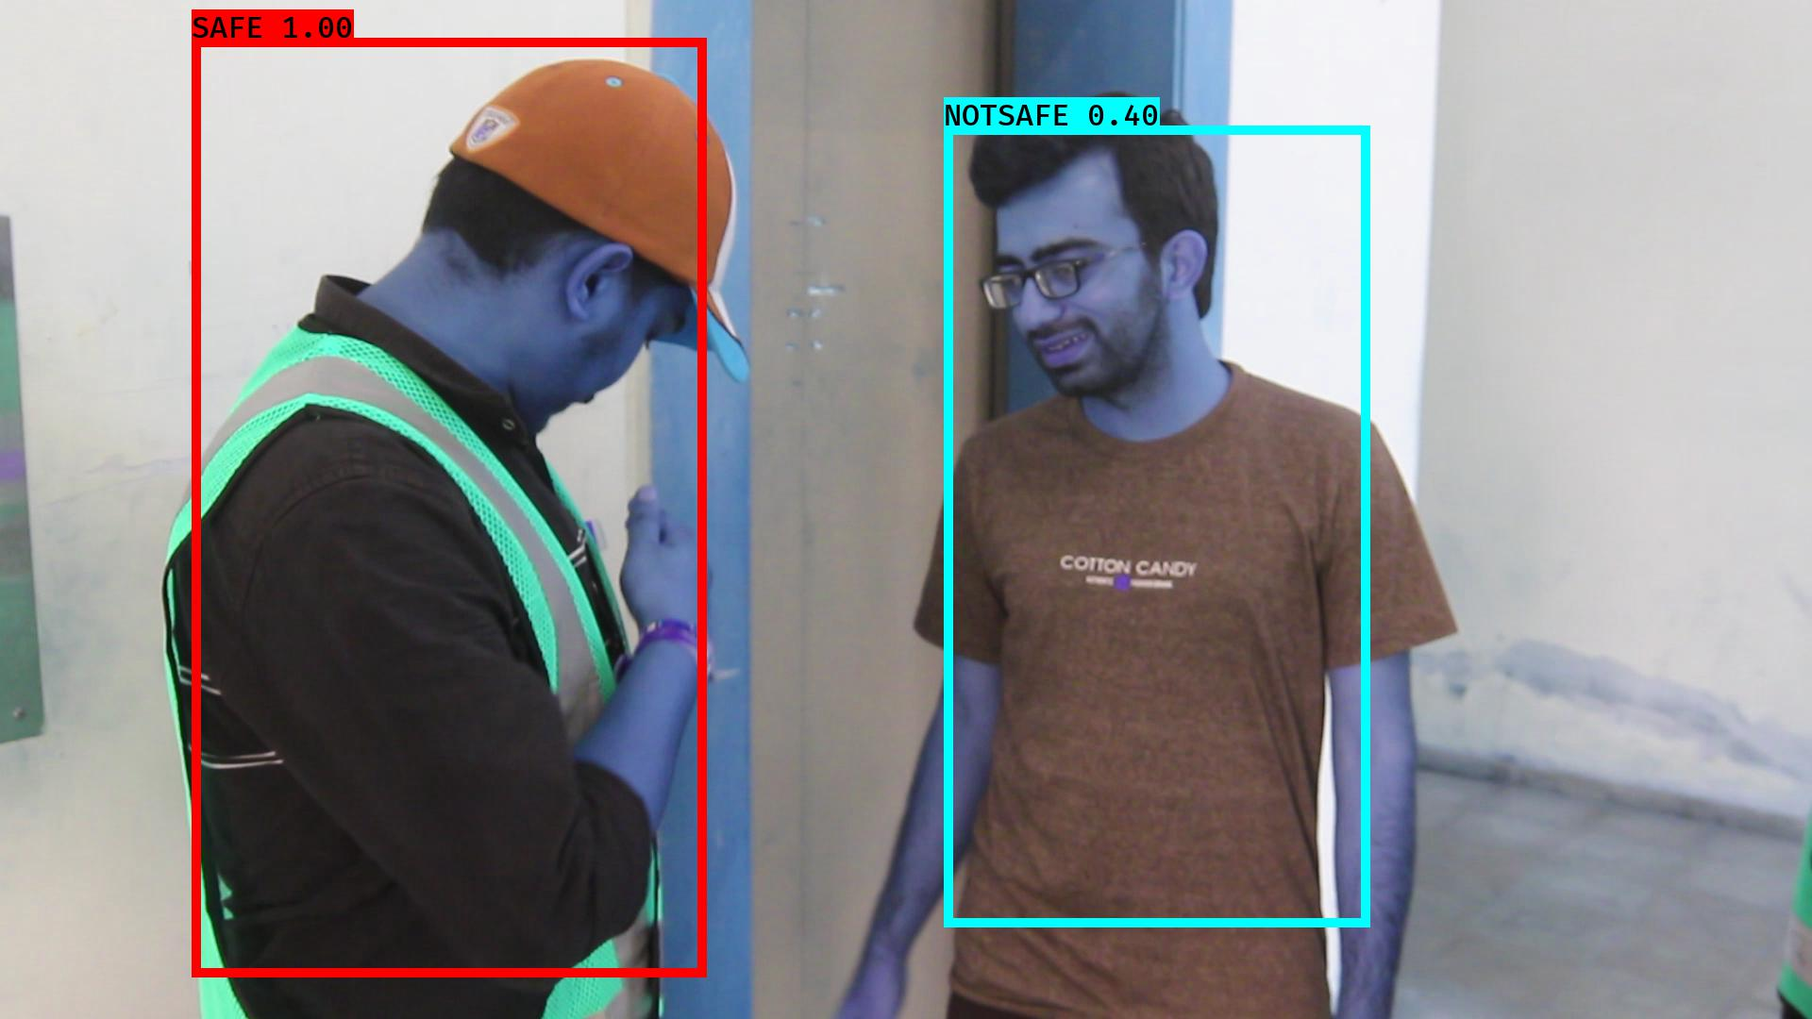

# NOTSAFE2019-06-05 20:16:49.800519.jpg

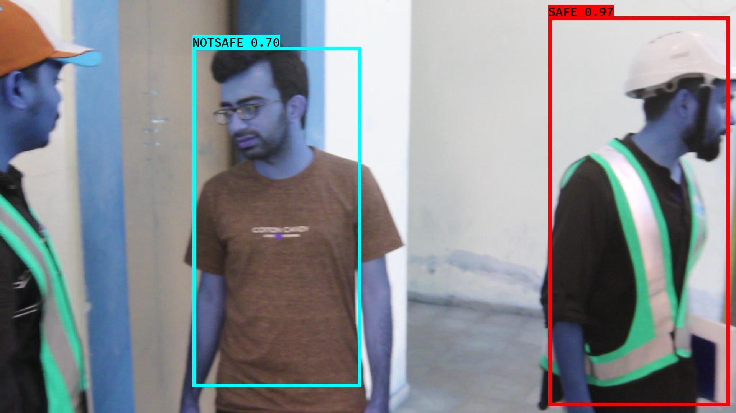

# NOTSAFE2019-06-05 20:16:27.915151.jpg

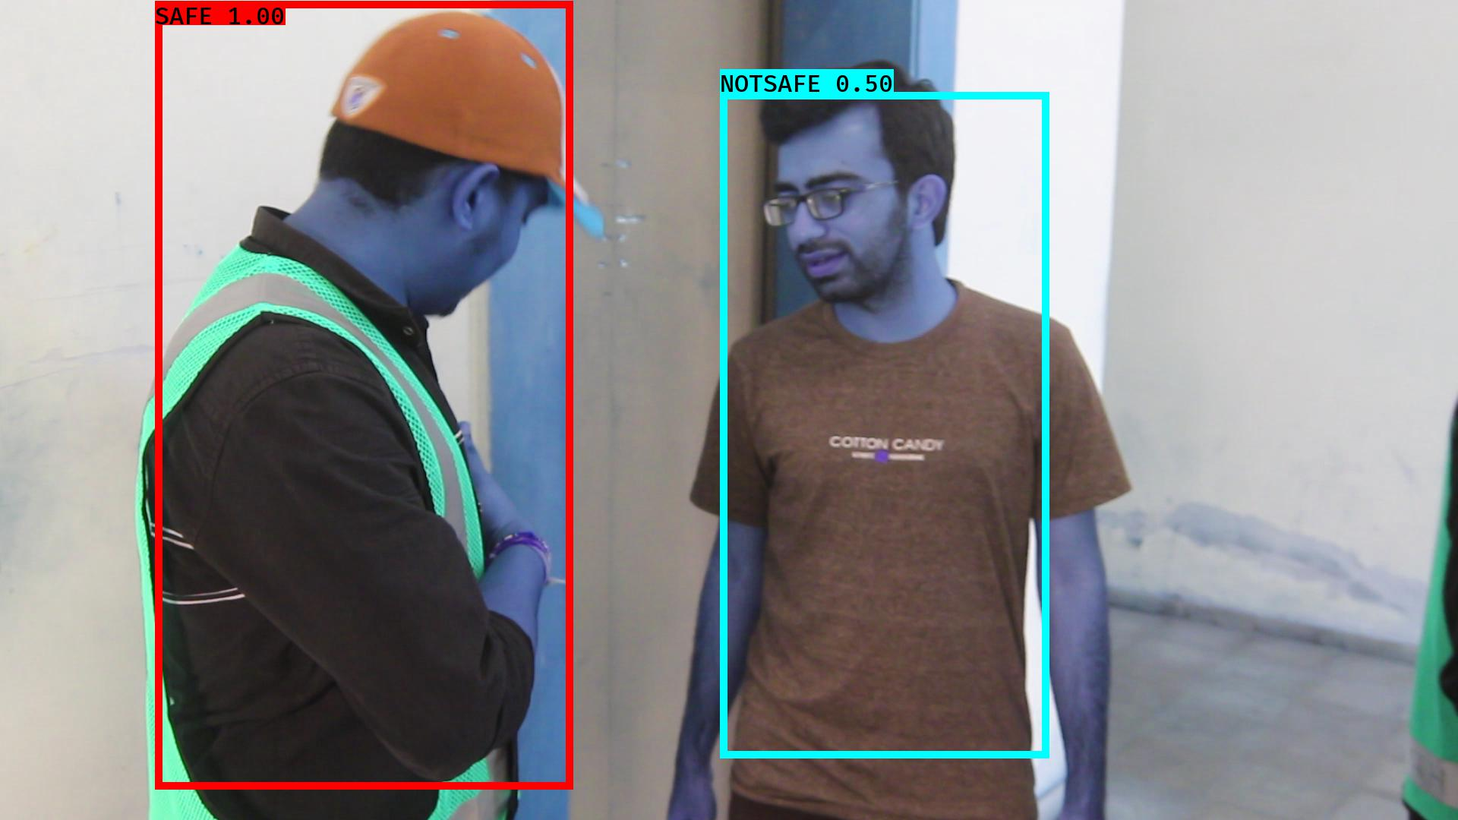

# NOTSAFE2019-06-05 20:16:28.501709.jpg

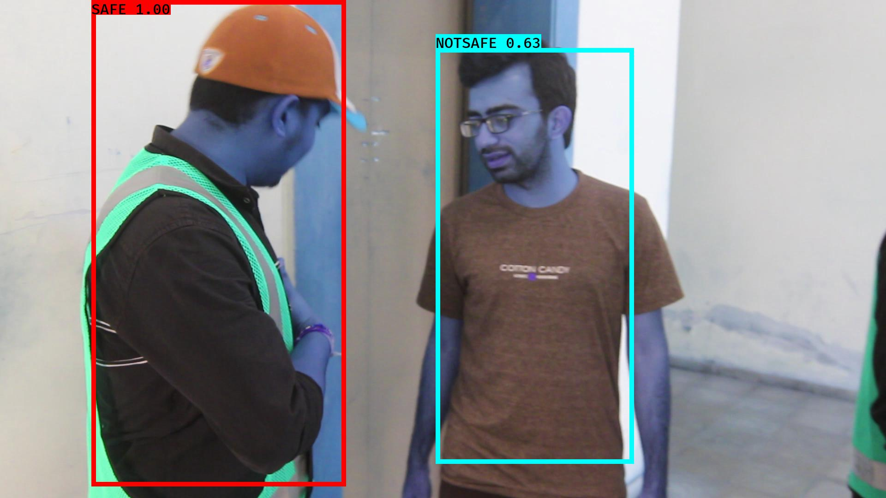

# NOTSAFE2019-06-05 20:16:37.394104.jpg

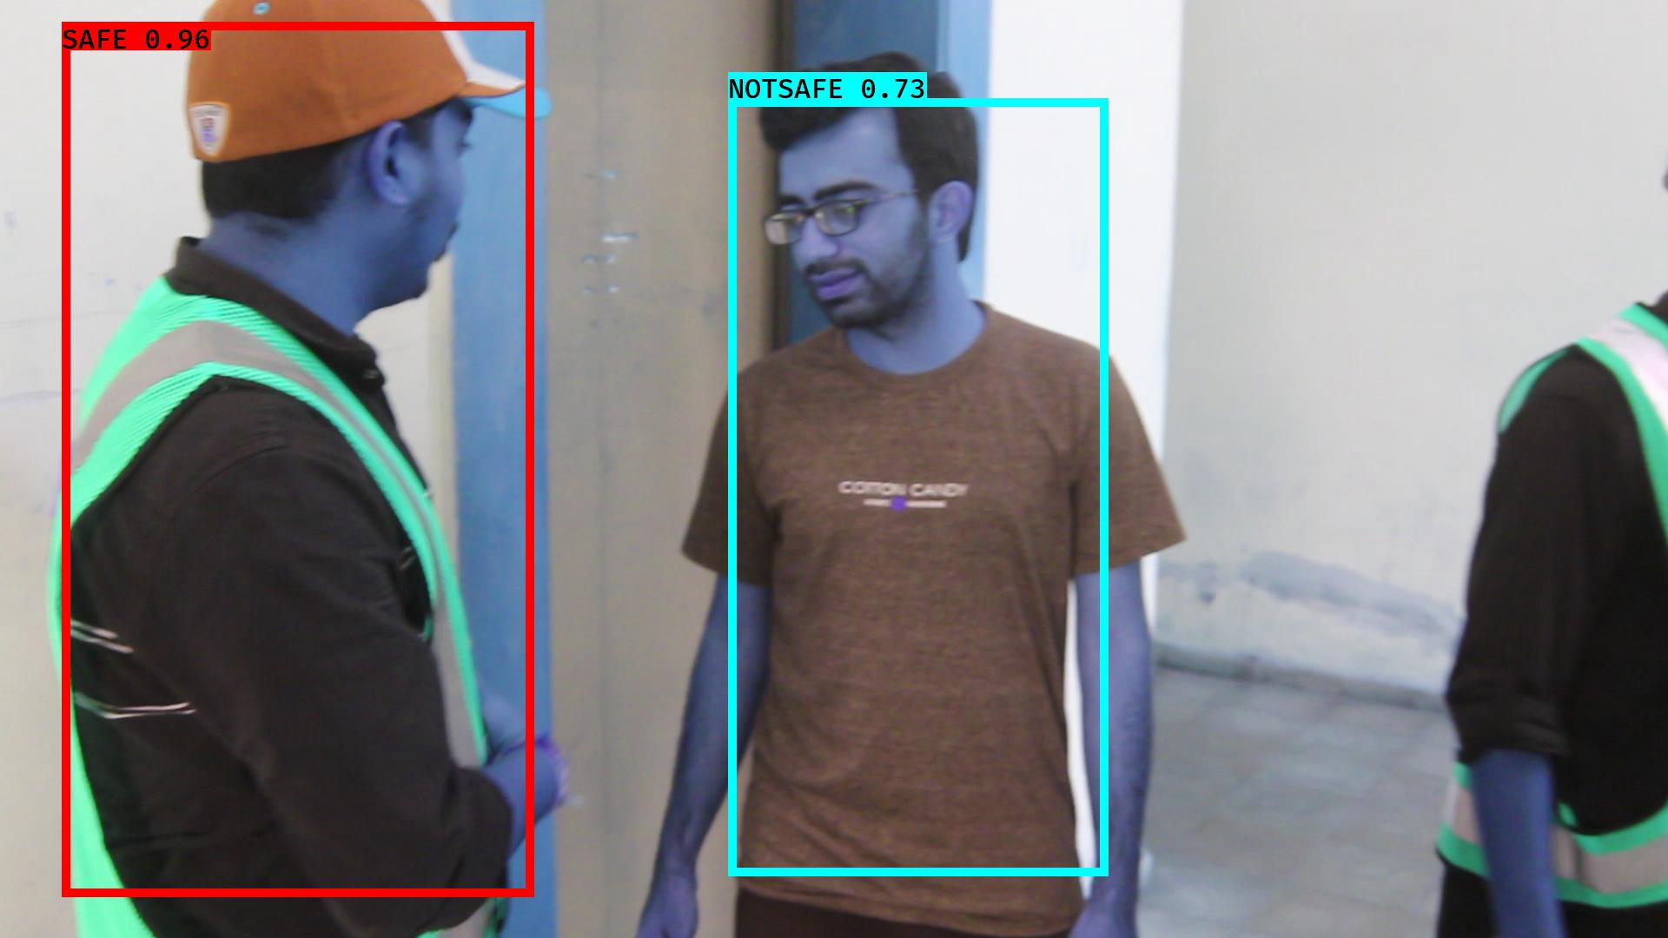

# NOTSAFE2019-06-05 20:16:06.849706.jpg

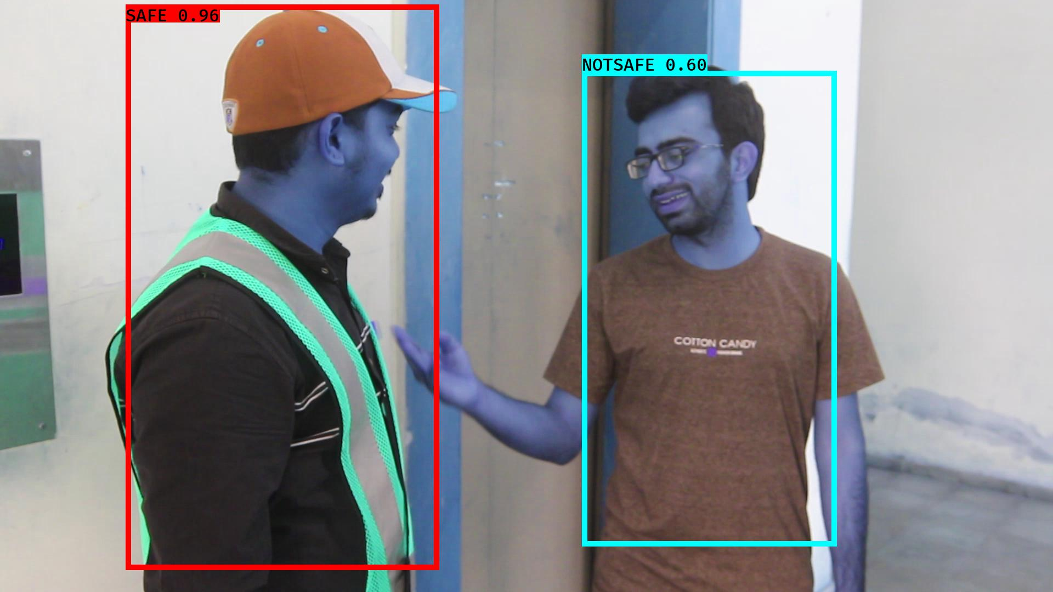

# NOTSAFE2019-06-05 20:16:39.758916.jpg

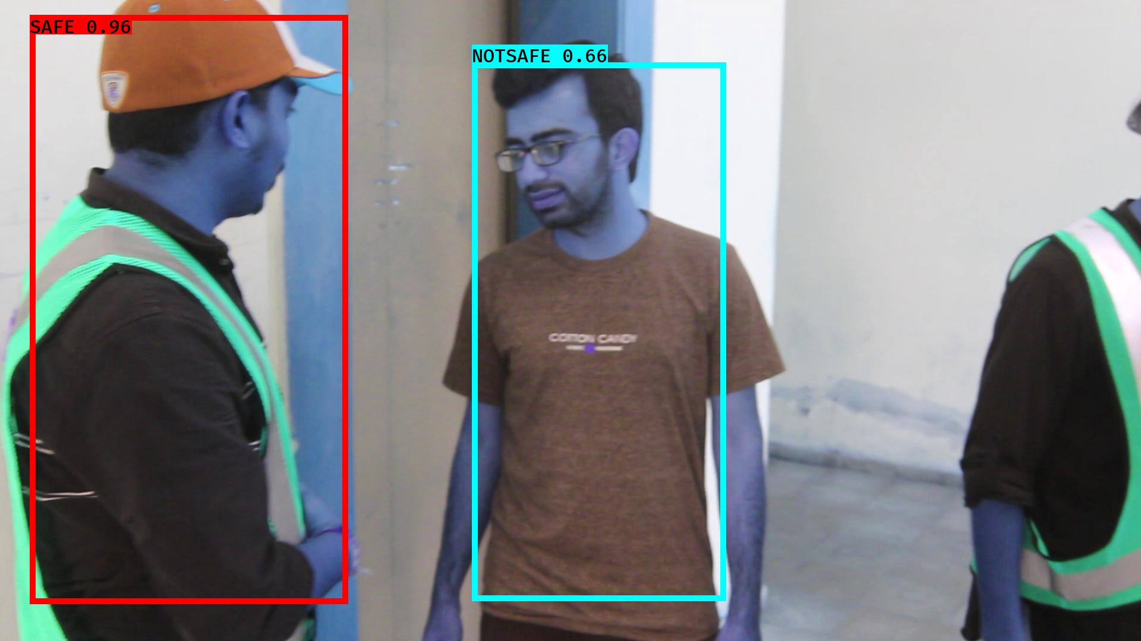

# NOTSAFE2019-06-05 20:16:32.641719.jpg

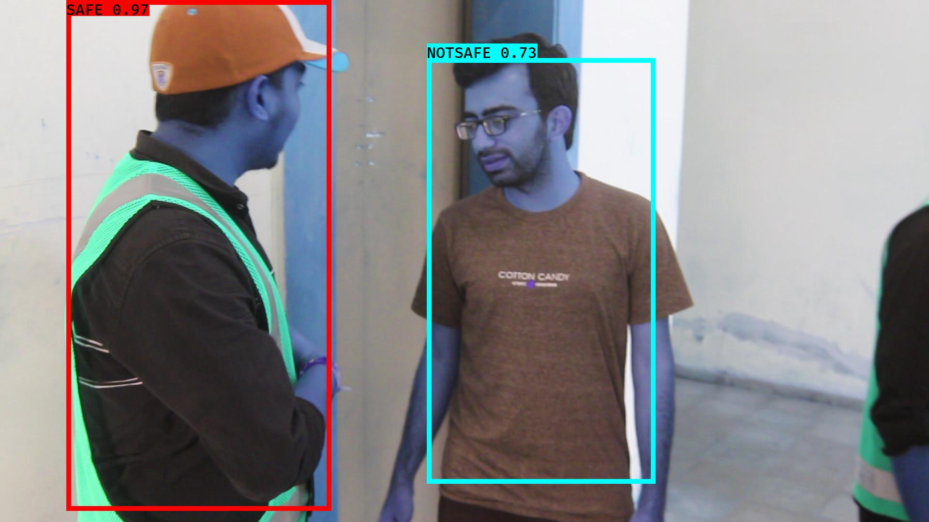

# NOTSAFE2019-06-05 20:16:12.502440.jpg

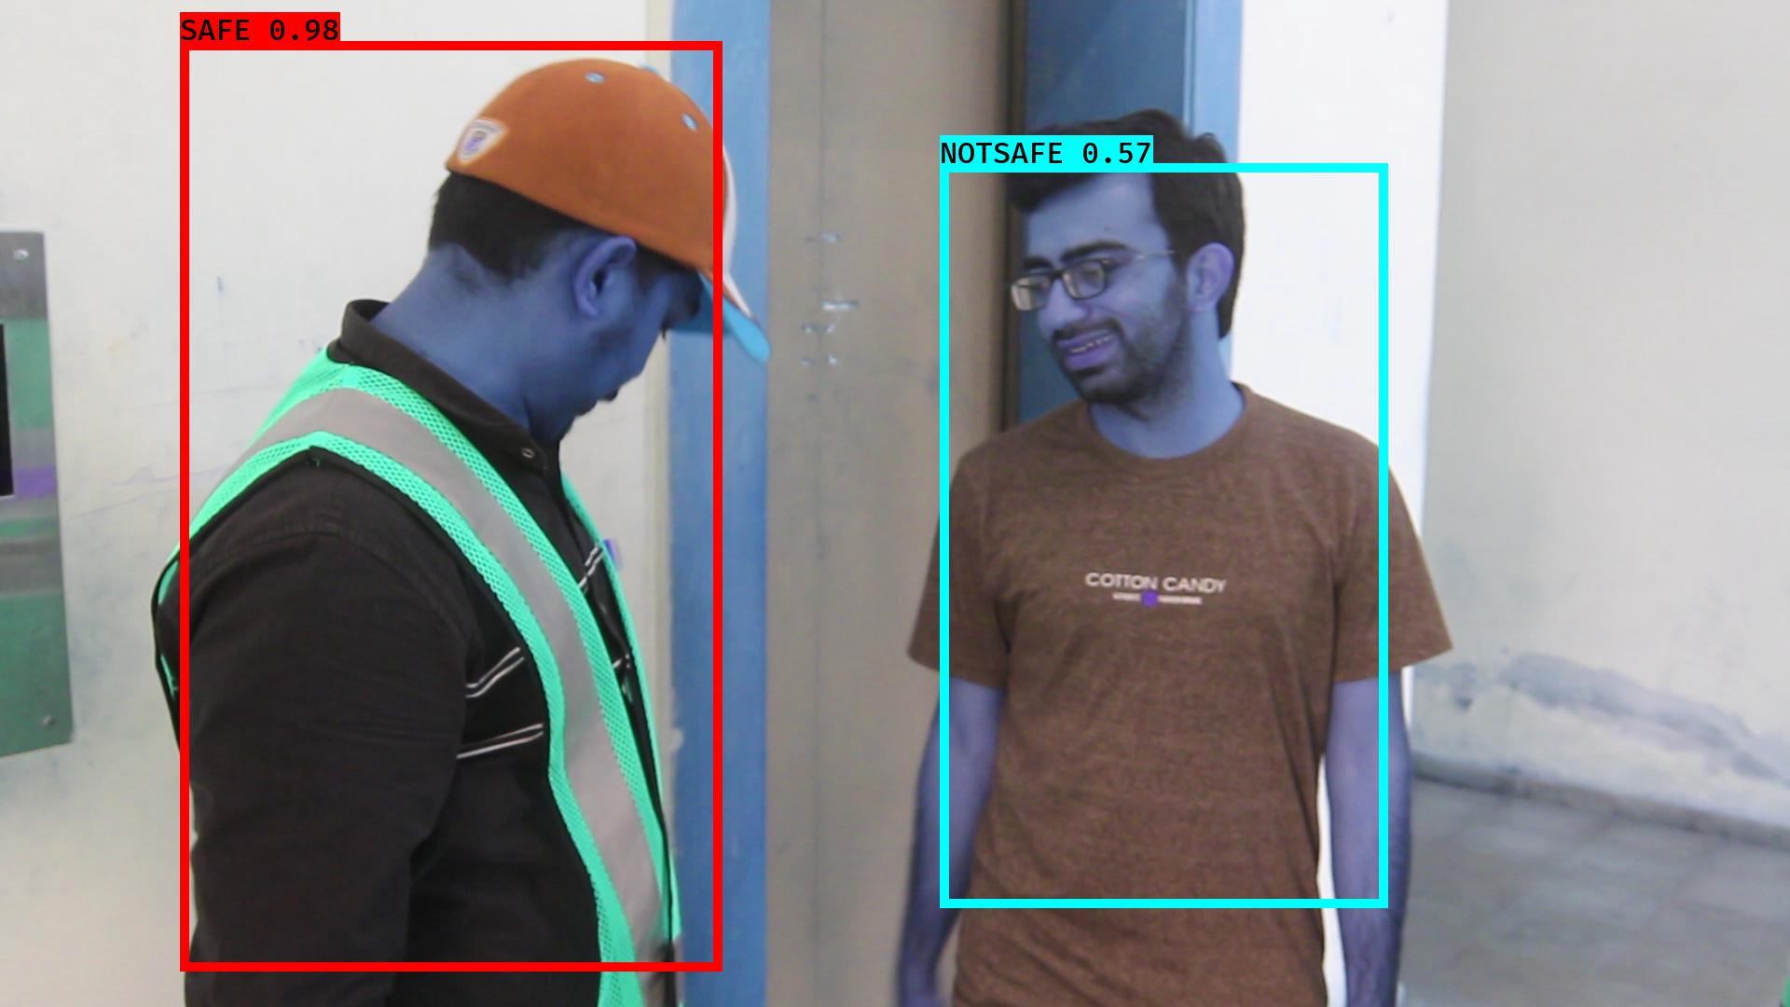

# NOTSAFE2019-06-05 20:16:14.214450.jpg

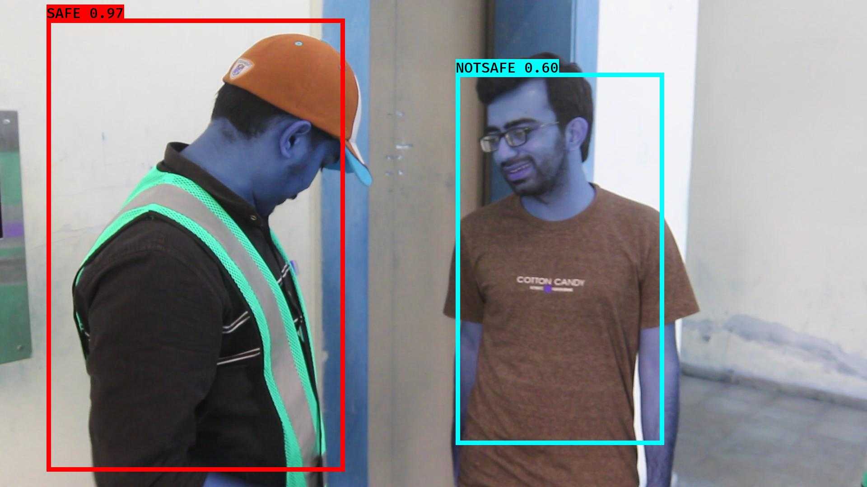

# NOTSAFE2019-06-05 20:16:21.456545.jpg

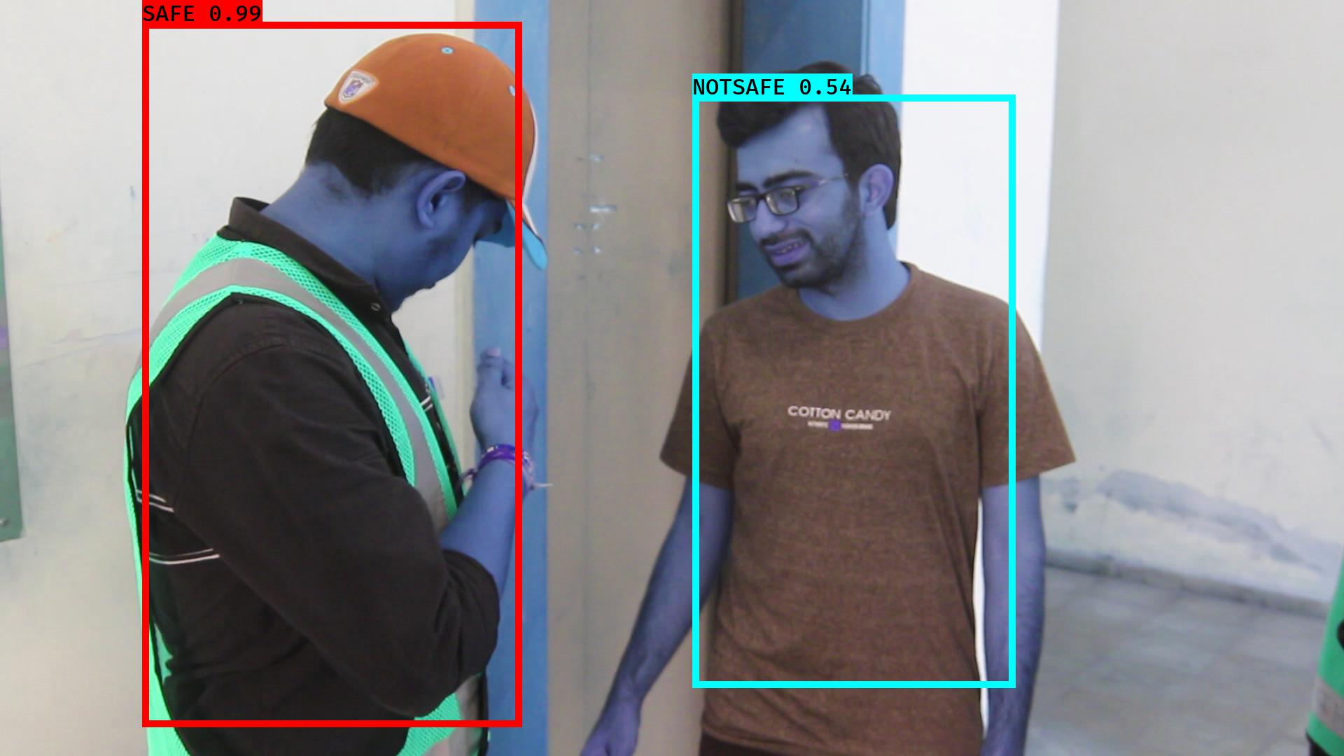

# NOTSAFE2019-06-05 20:16:45.083507.jpg

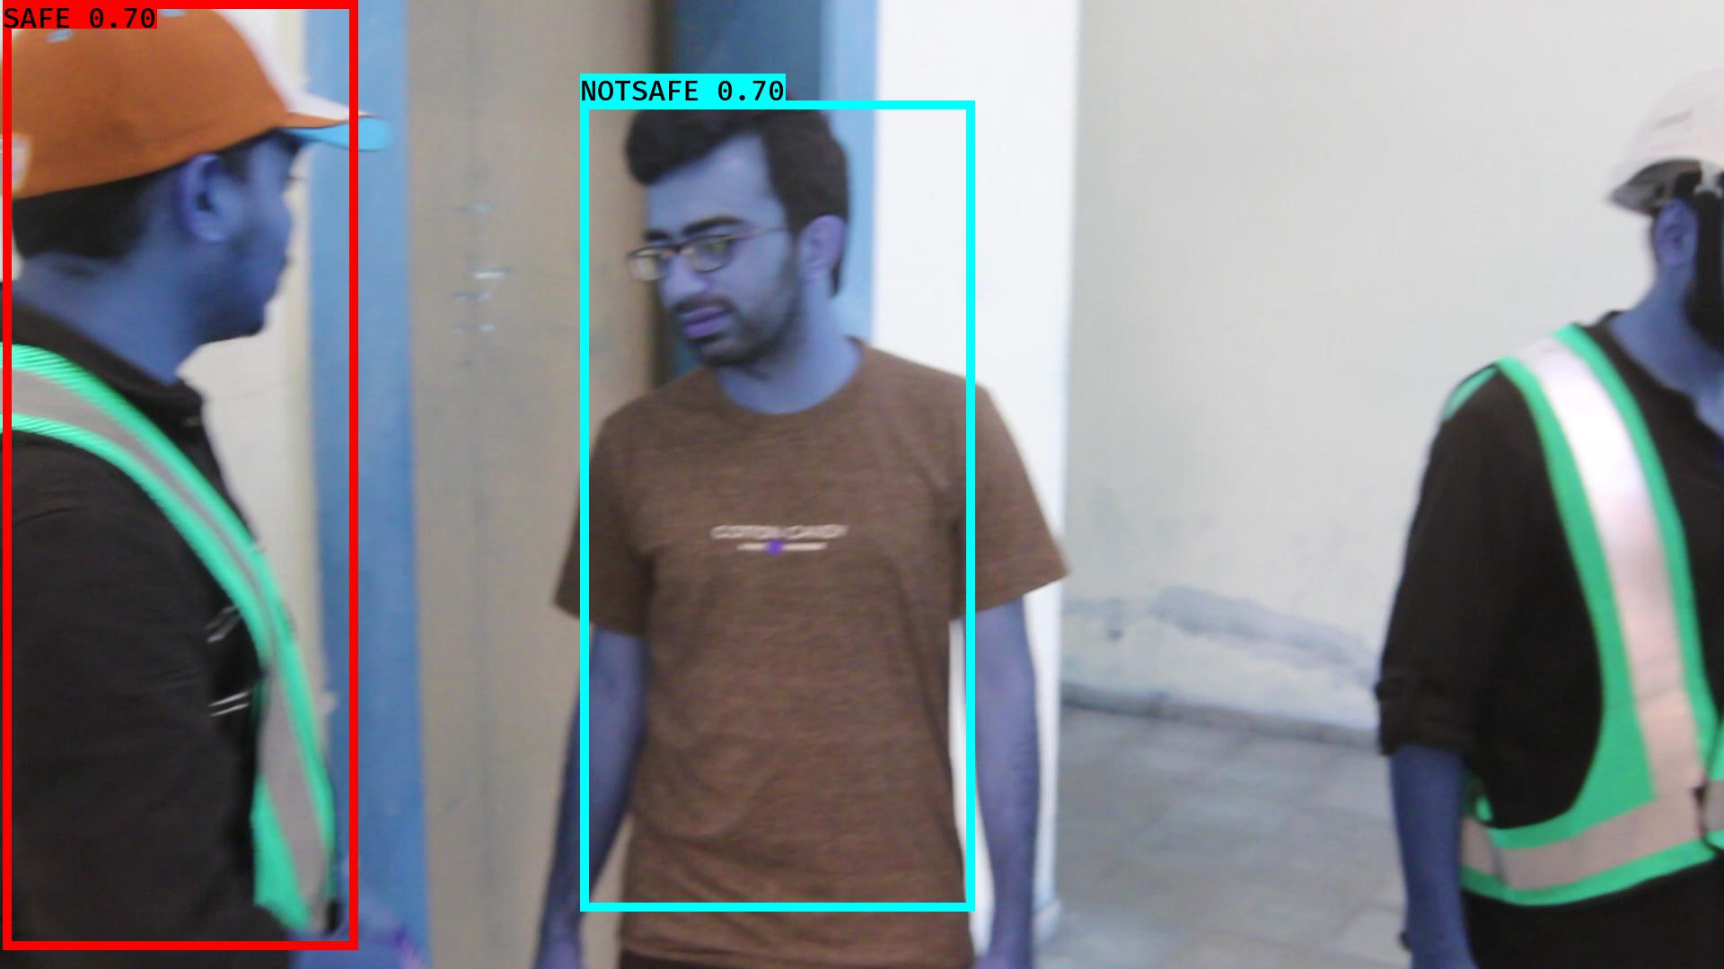

# NOTSAFE2019-06-05 20:16:14.785522.jpg

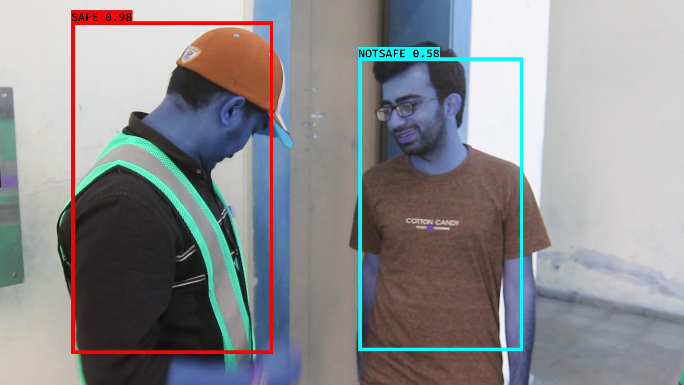

# NOTSAFE2019-06-05 20:16:24.968135.jpg

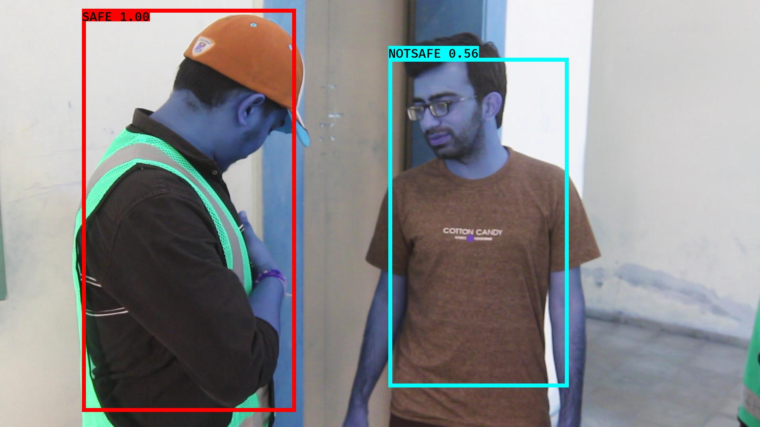

# NOTSAFE2019-06-05 20:16:00.157328.jpg

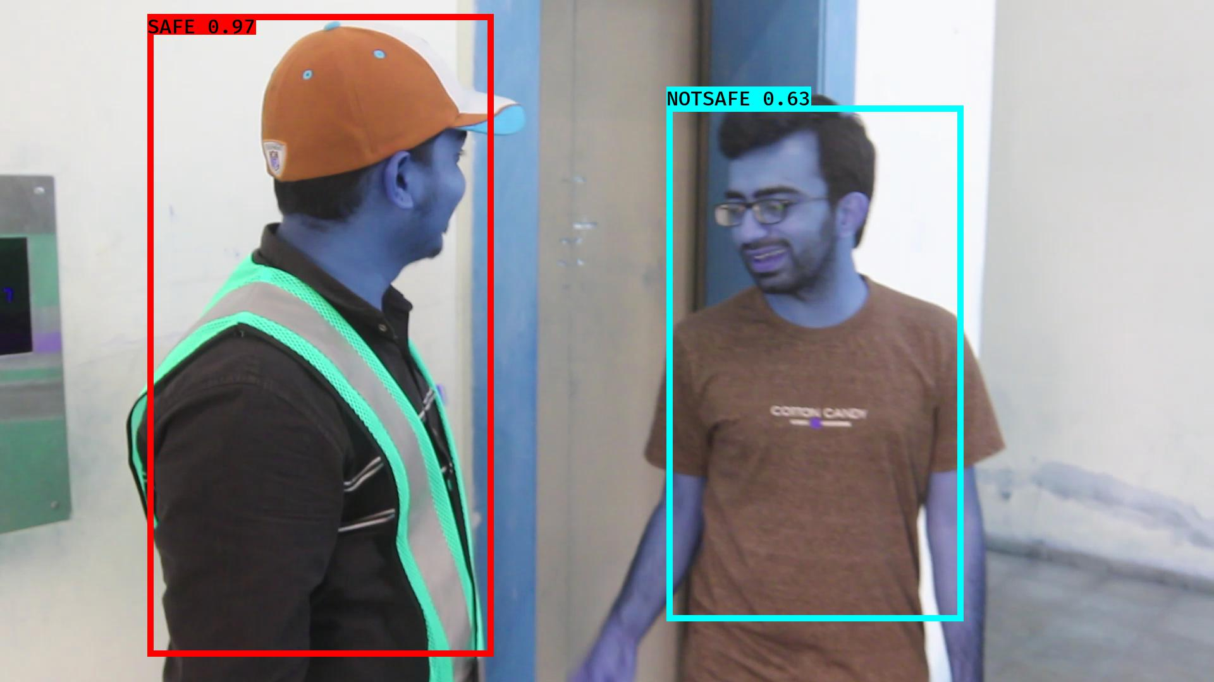

# NOTSAFE2019-06-05 20:16:36.202332.jpg

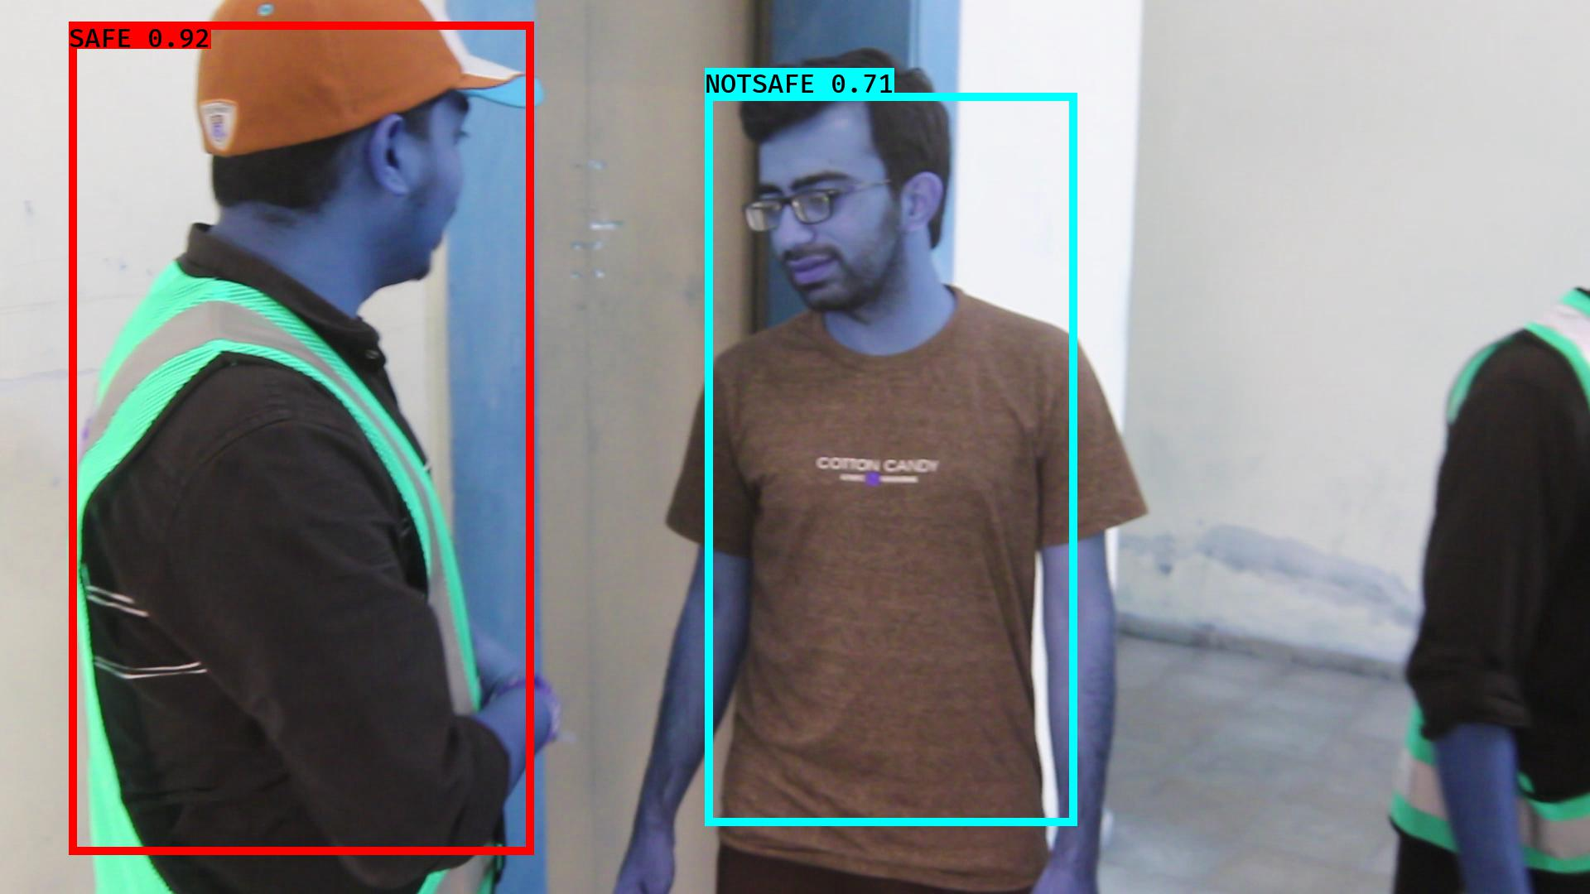

# NOTSAFE2019-06-05 20:16:34.421156.jpg

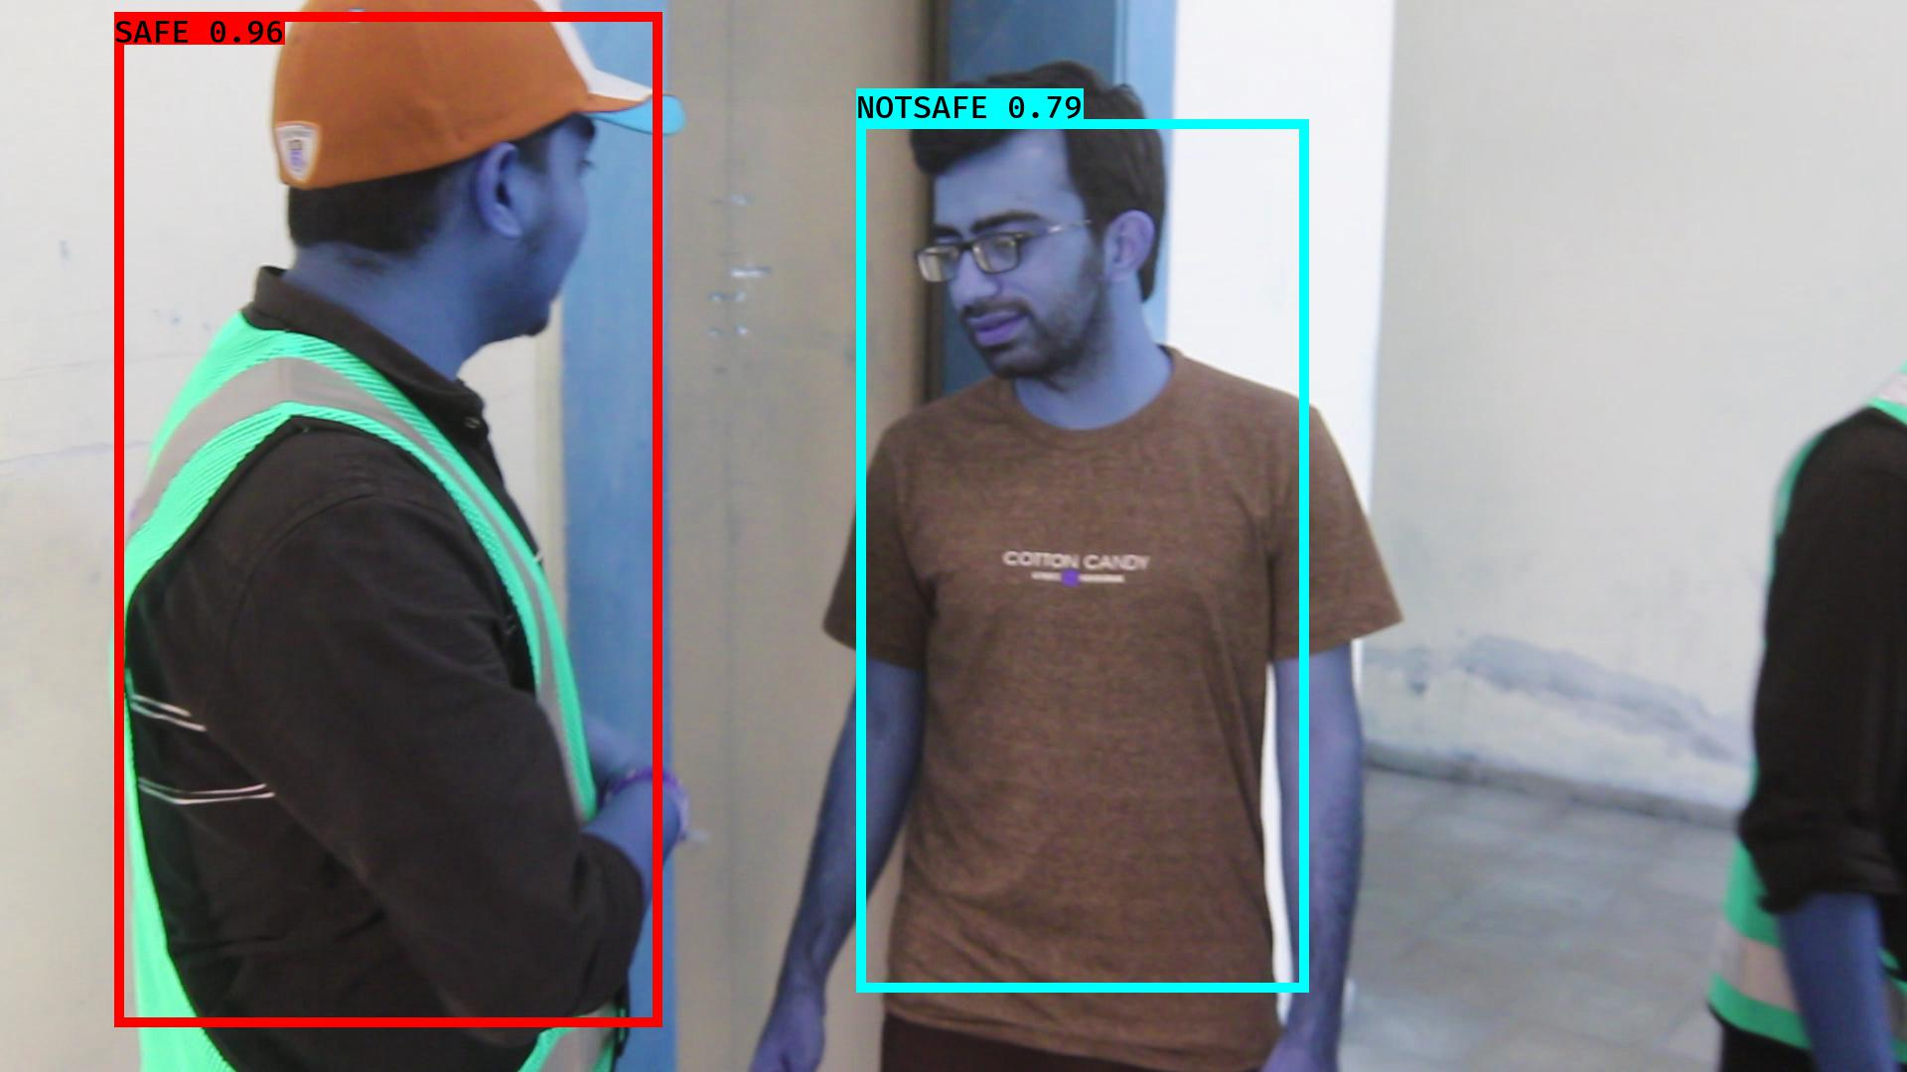

# NOTSAFE2019-06-05 20:16:23.821130.jpg

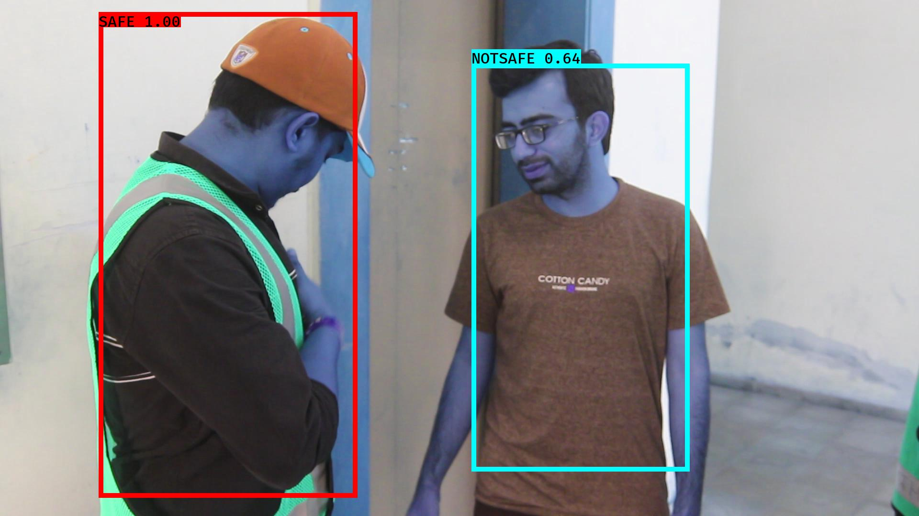

# NOTSAFE2019-06-05 20:16:27.334286.jpg

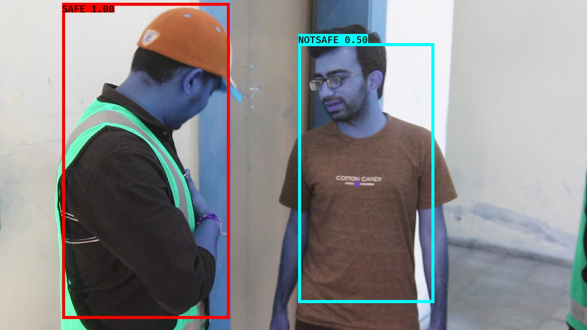

# NOTSAFE2019-06-05 20:16:26.736144.jpg

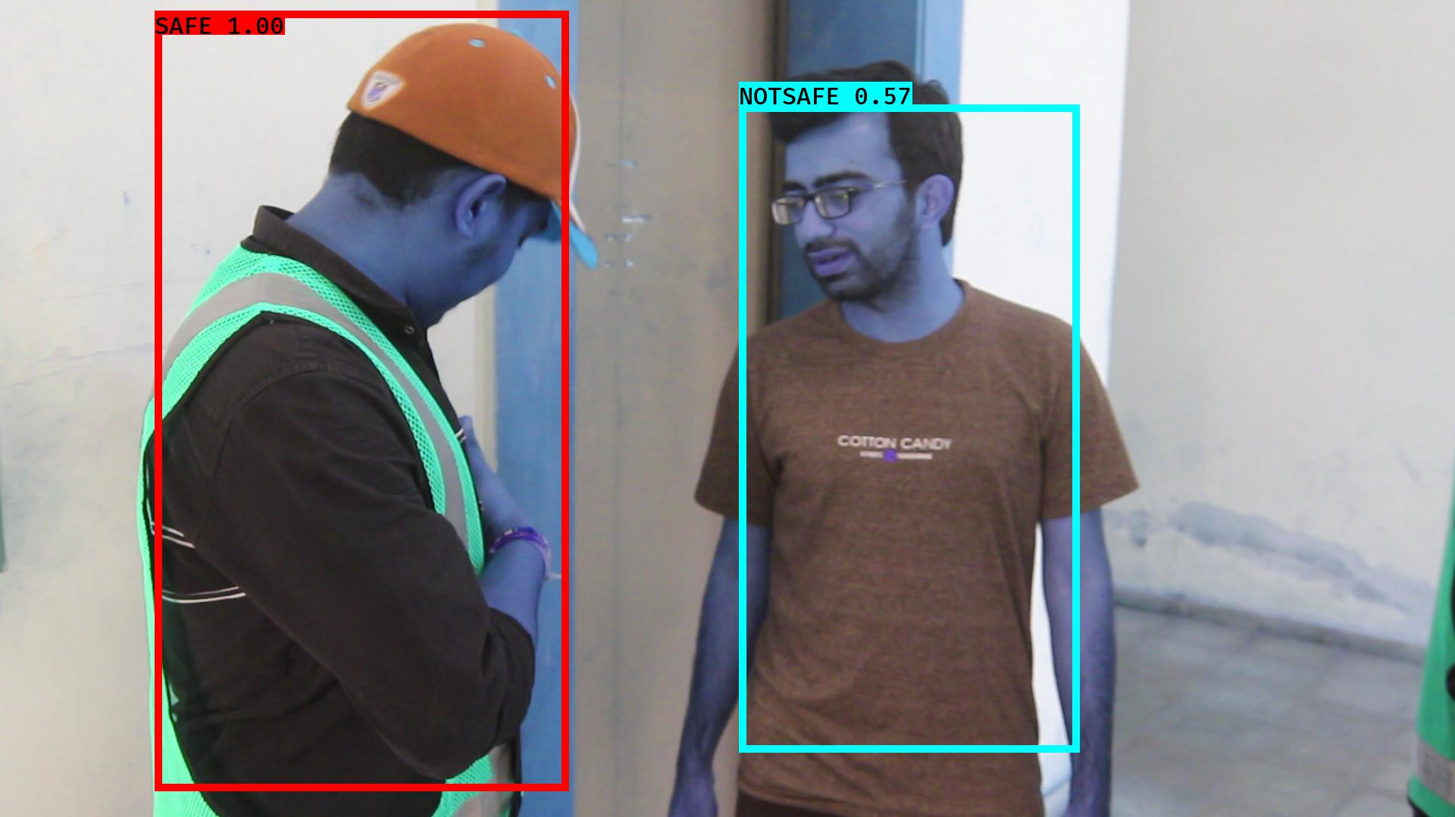

# NOTSAFE2019-06-05 20:16:45.673265.jpg

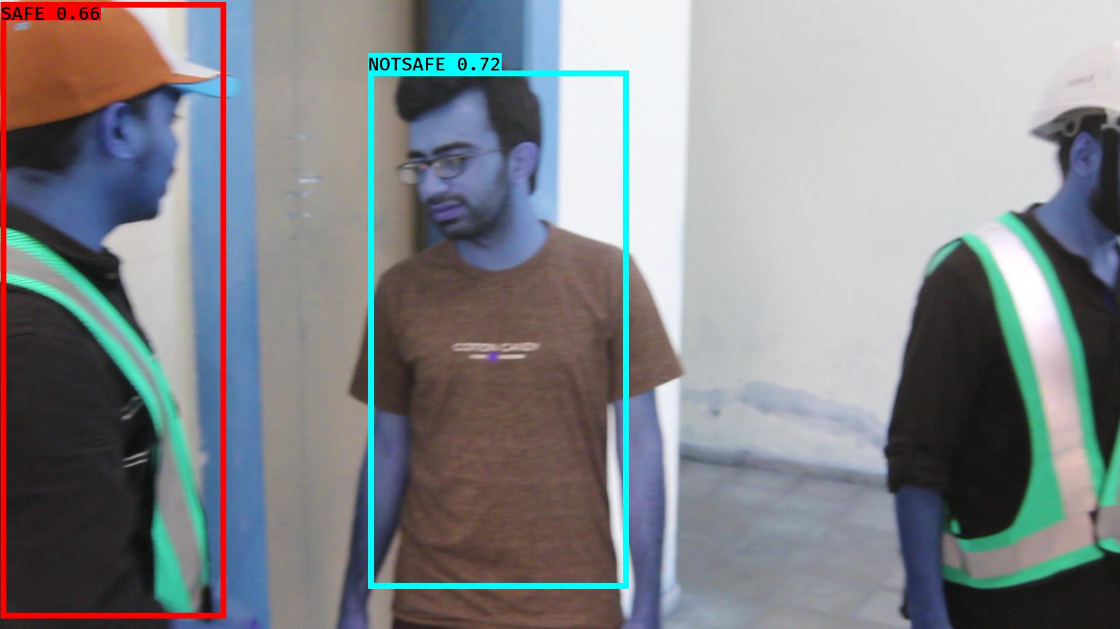

# NOTSAFE2019-06-05 20:16:19.734132.jpg

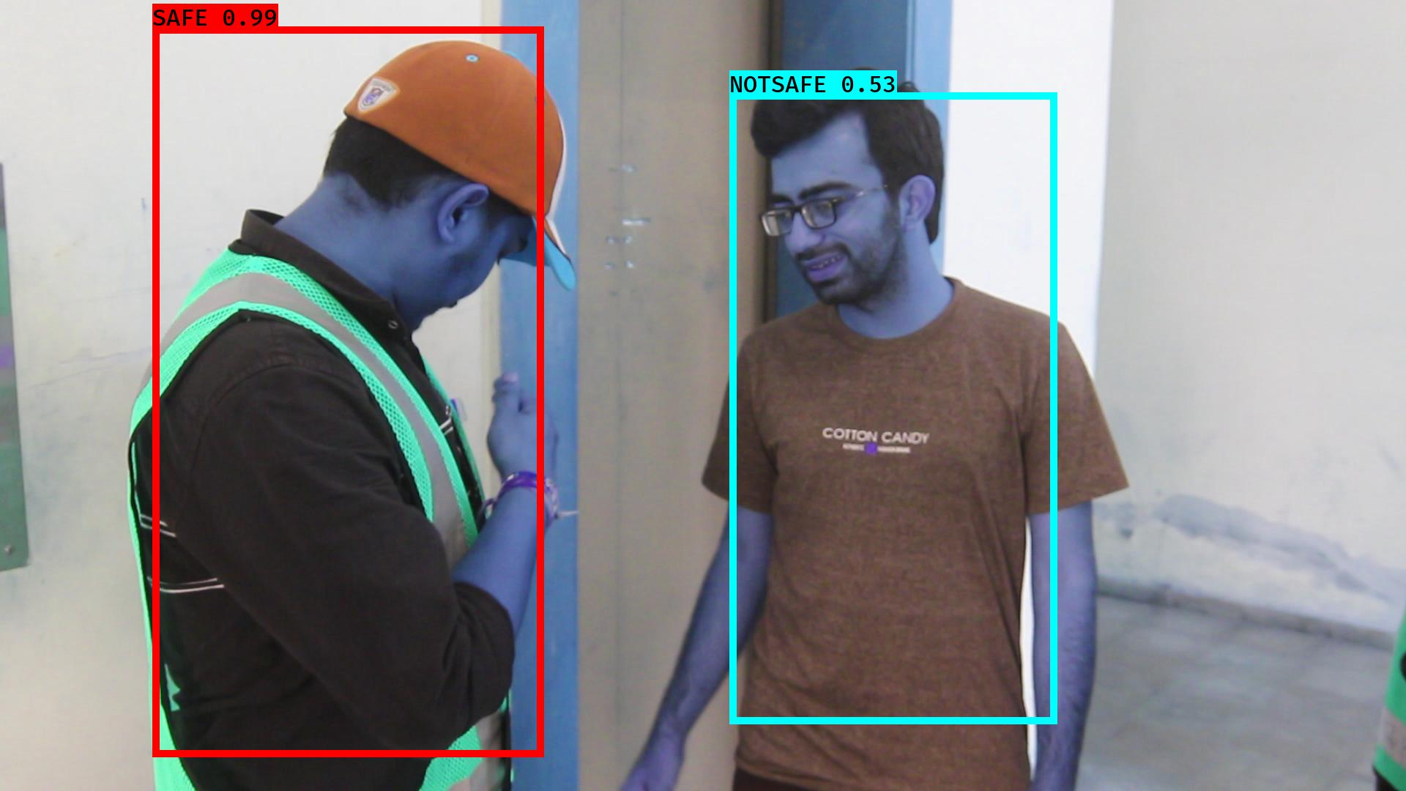

# NOTSAFE2019-06-05 20:16:32.048137.jpg

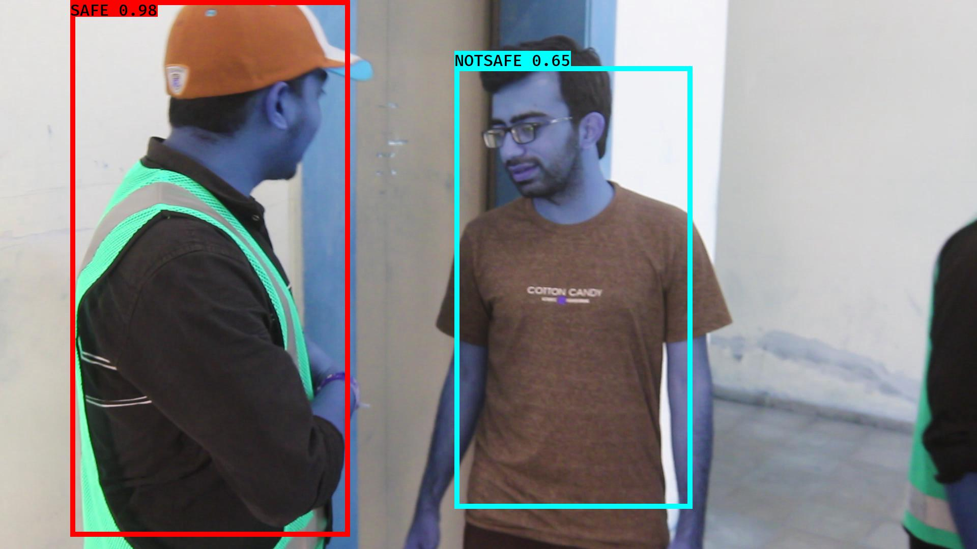

# NOTSAFE2019-06-05 20:16:16.494656.jpg

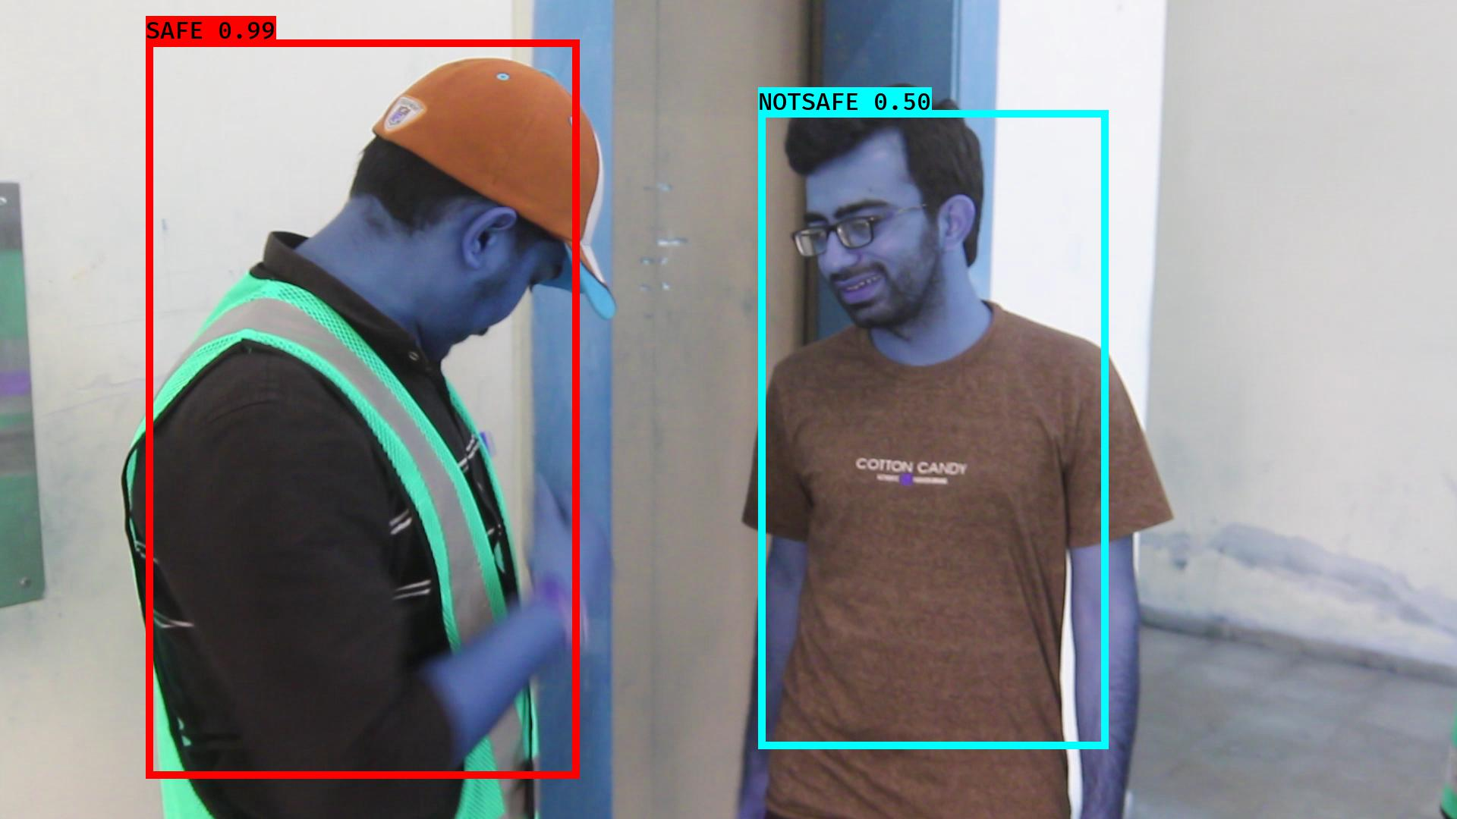

# NOTSAFE2019-06-05 20:16:43.304522.jpg

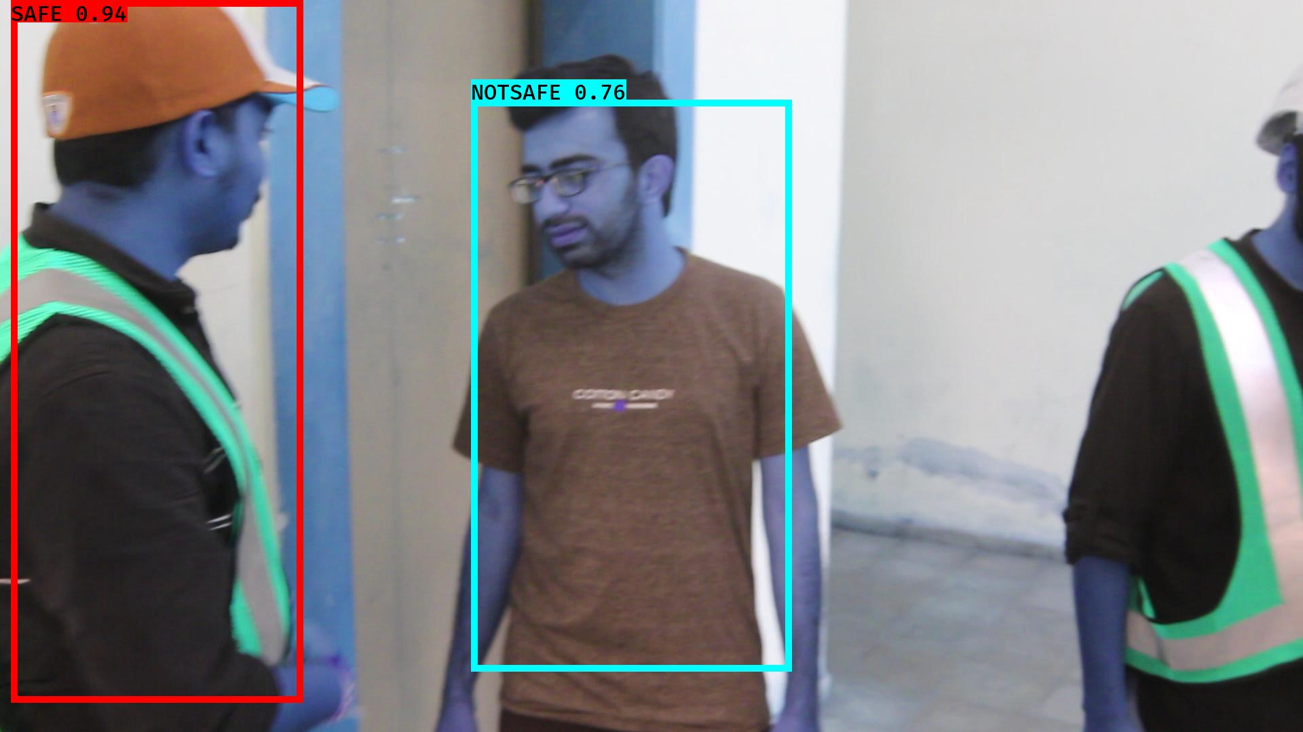

# NOTSAFE2019-06-05 20:16:08.571387.jpg

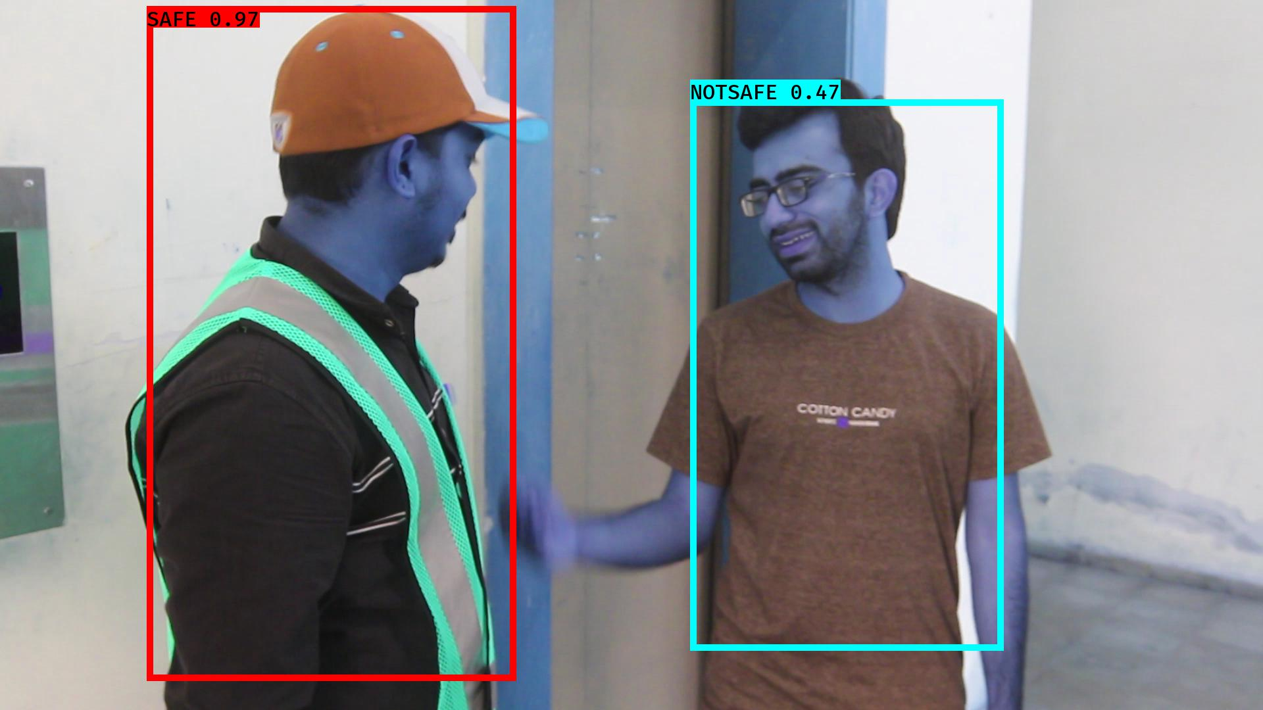

# NOTSAFE2019-06-05 20:16:23.236952.jpg

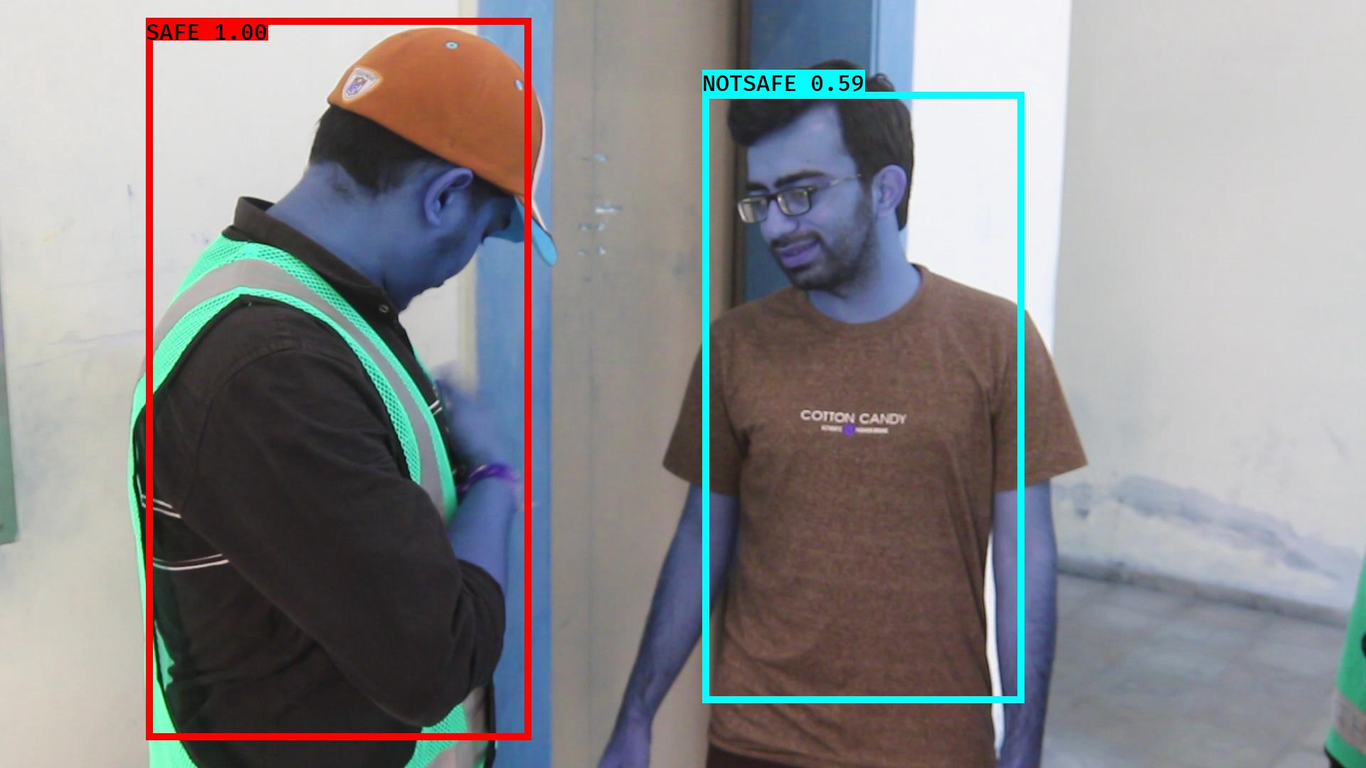

# NOTSAFE2019-06-05 20:16:10.793340.jpg

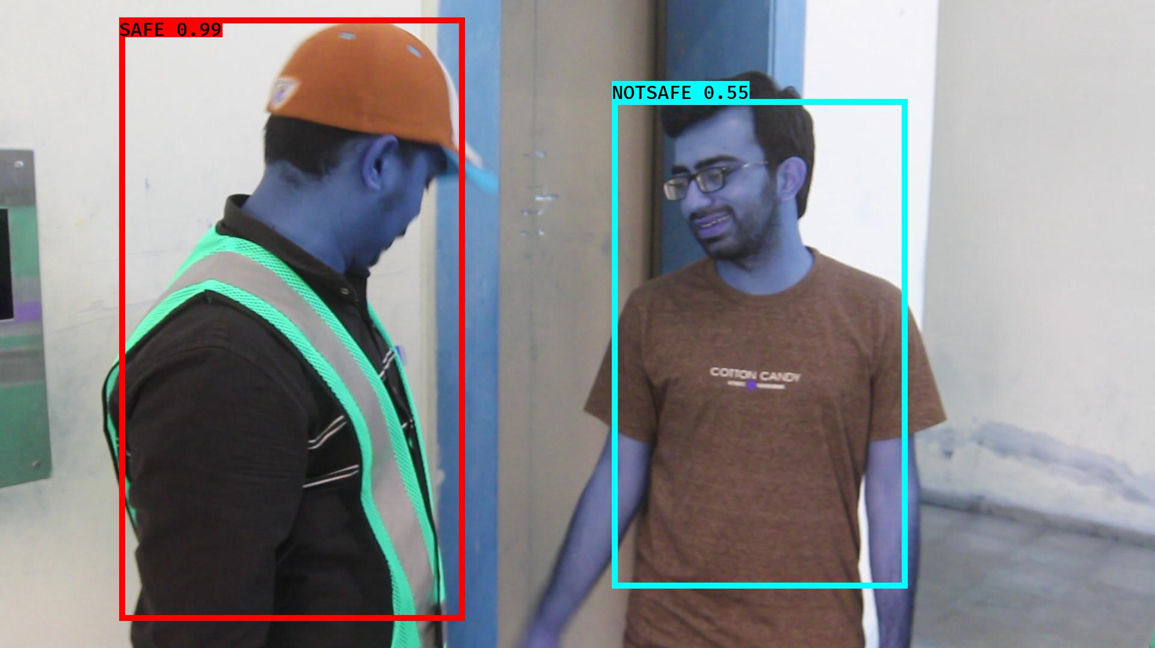

# NOTSAFE2019-06-05 20:16:44.488981.jpg

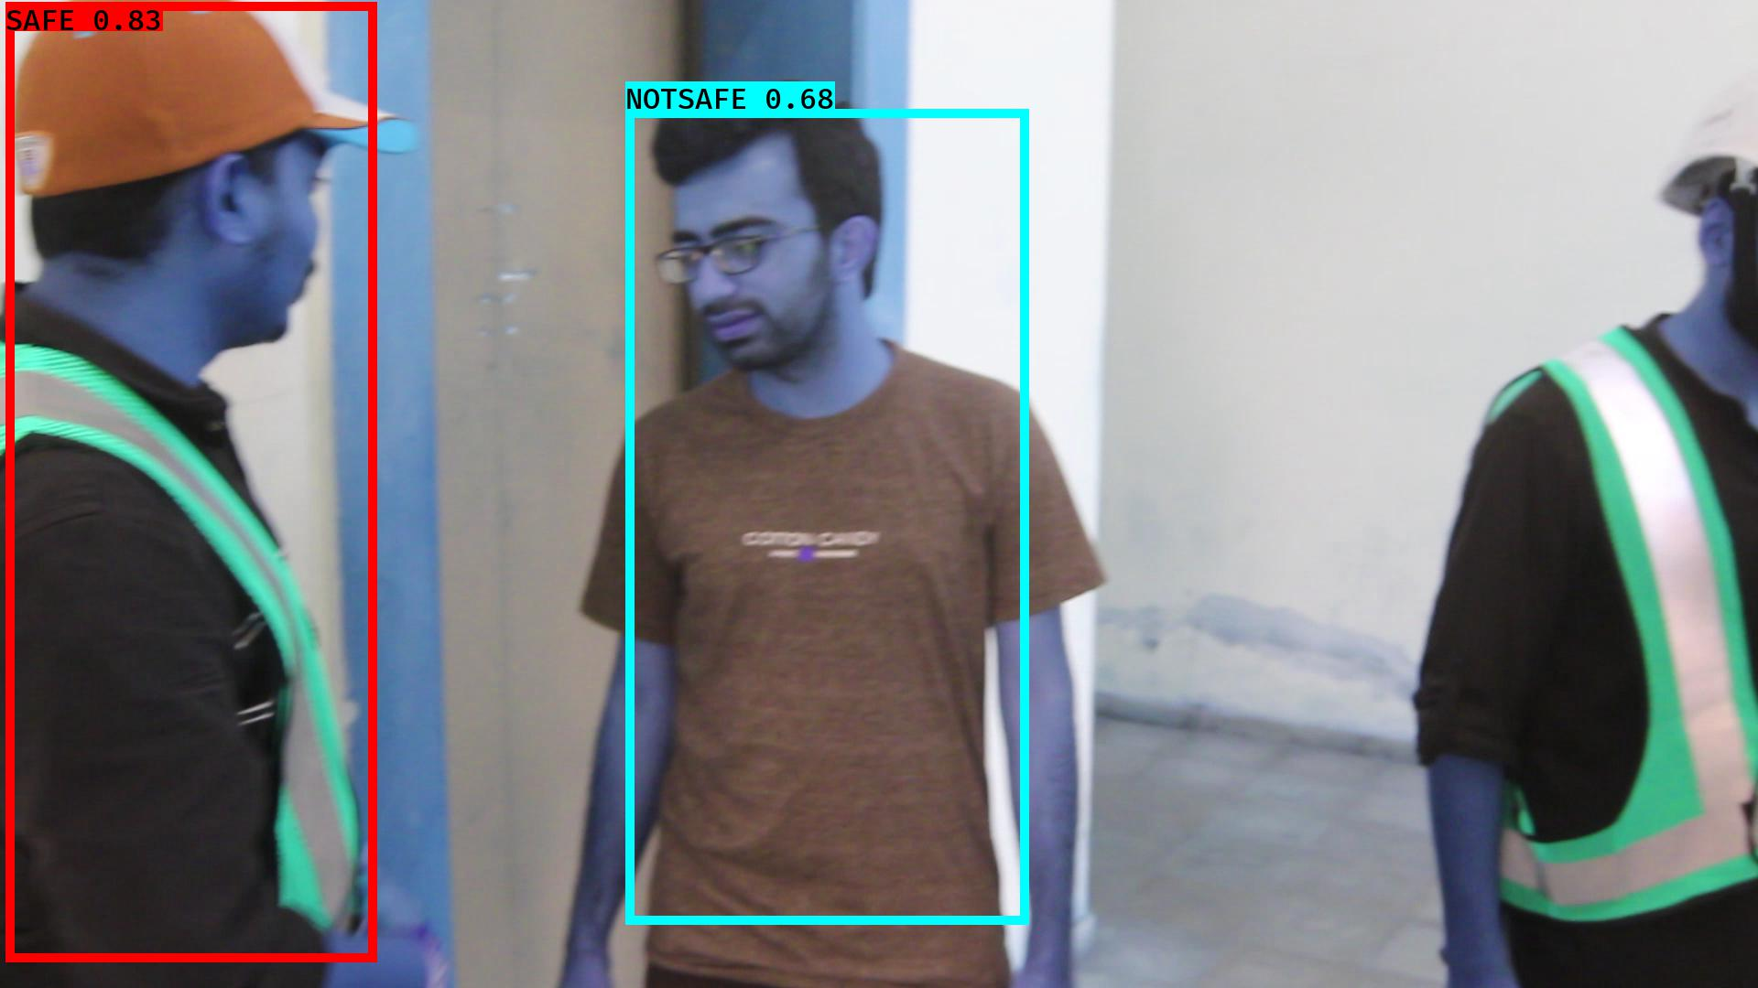

# NOTSAFE2019-06-05 20:16:55.182747.jpg

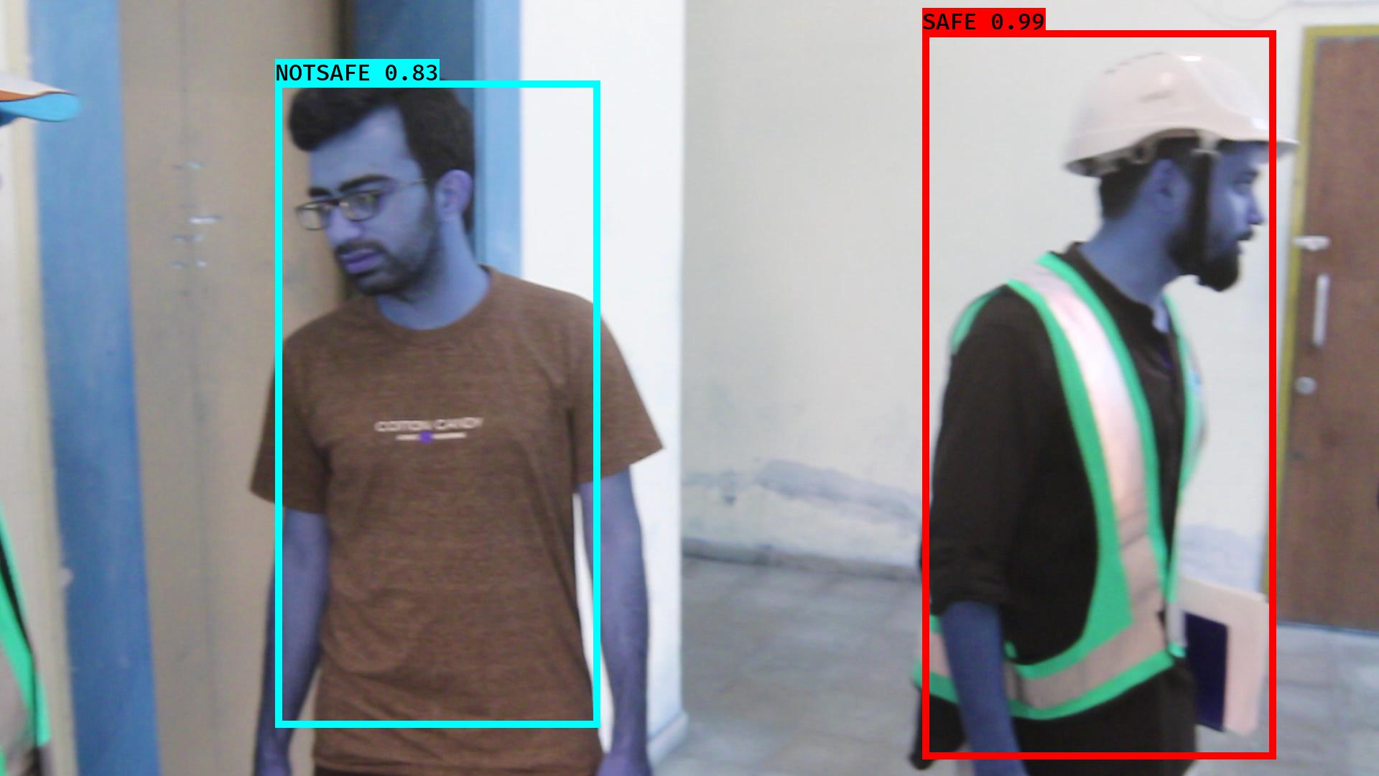

# NOTSAFE2019-06-05 20:16:11.363100.jpg

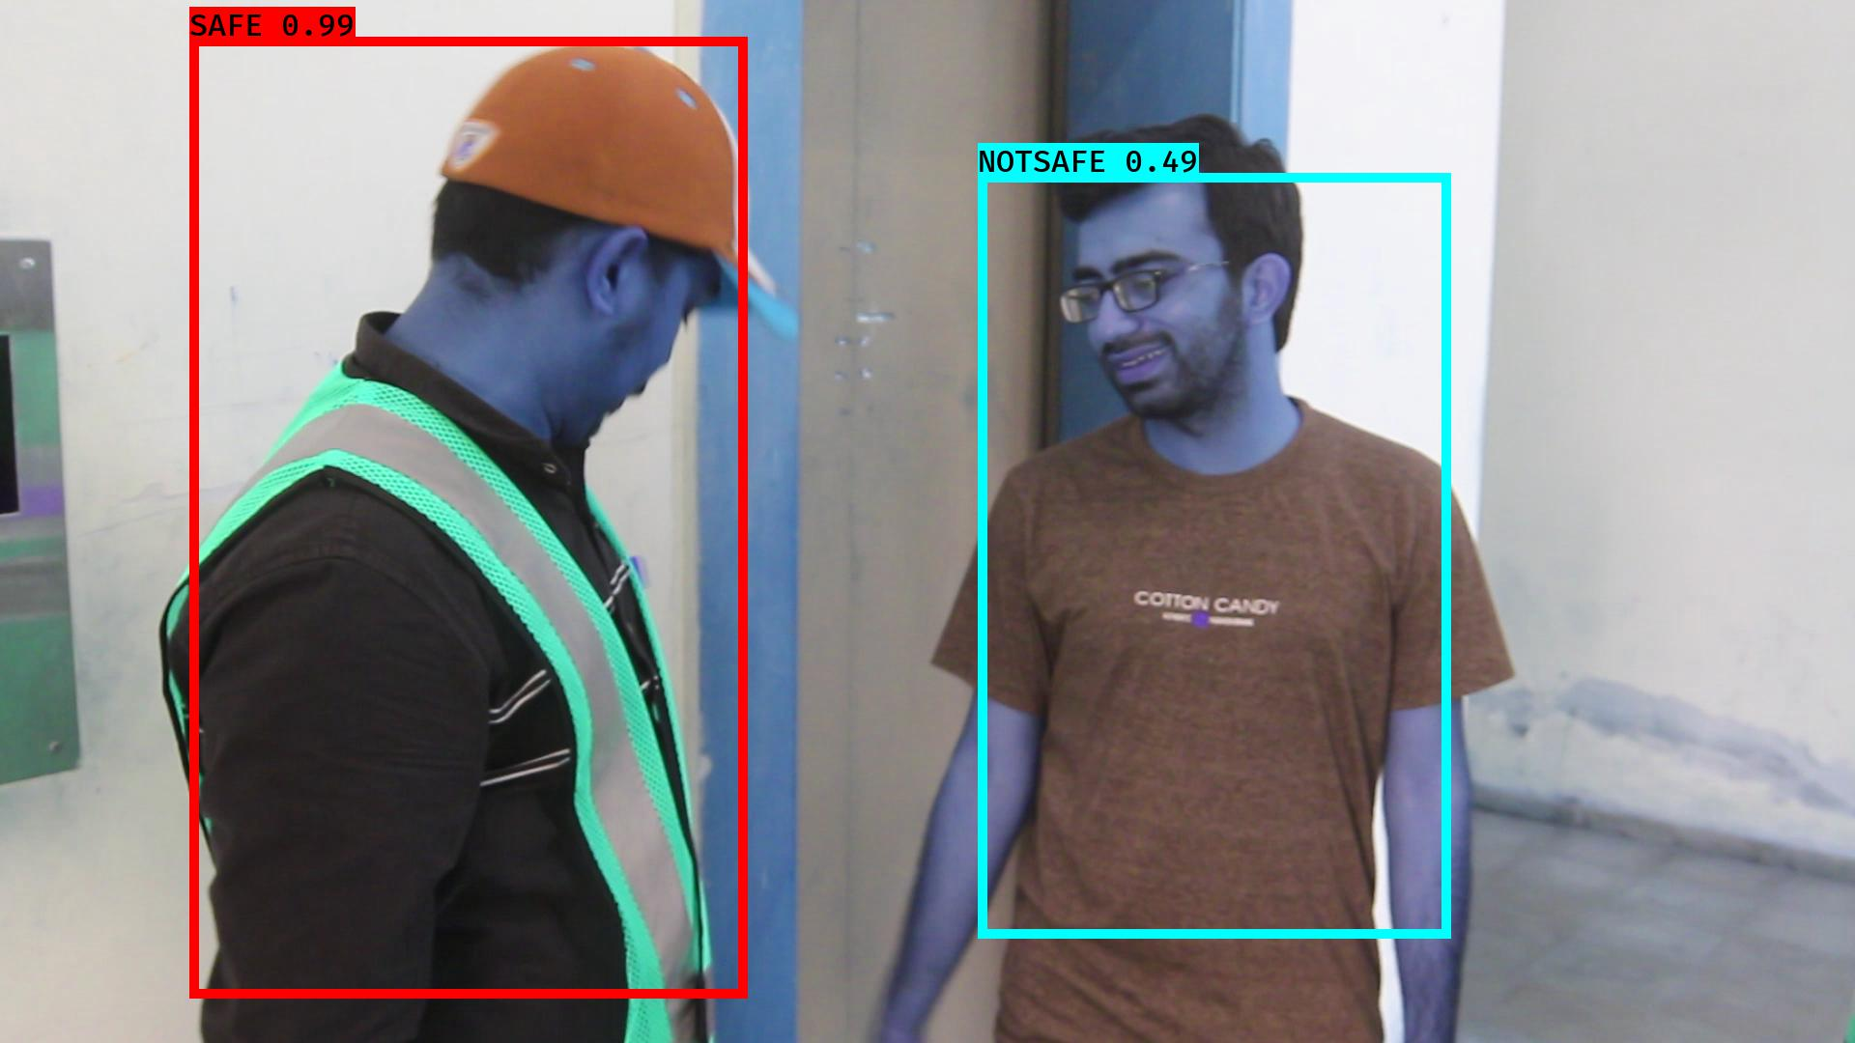

# NOTSAFE2019-06-05 20:16:22.596603.jpg

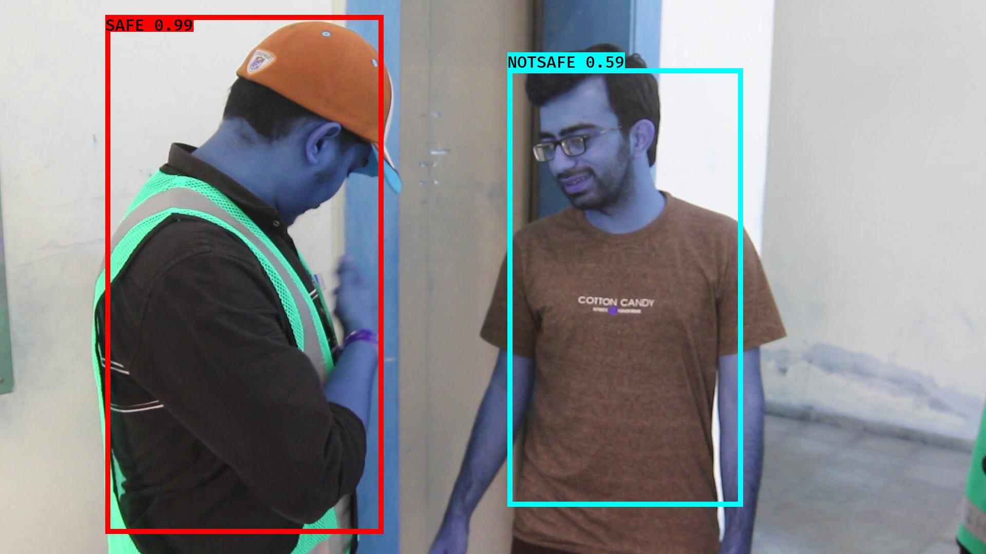

# NOTSAFE2019-06-05 20:16:31.456685.jpg

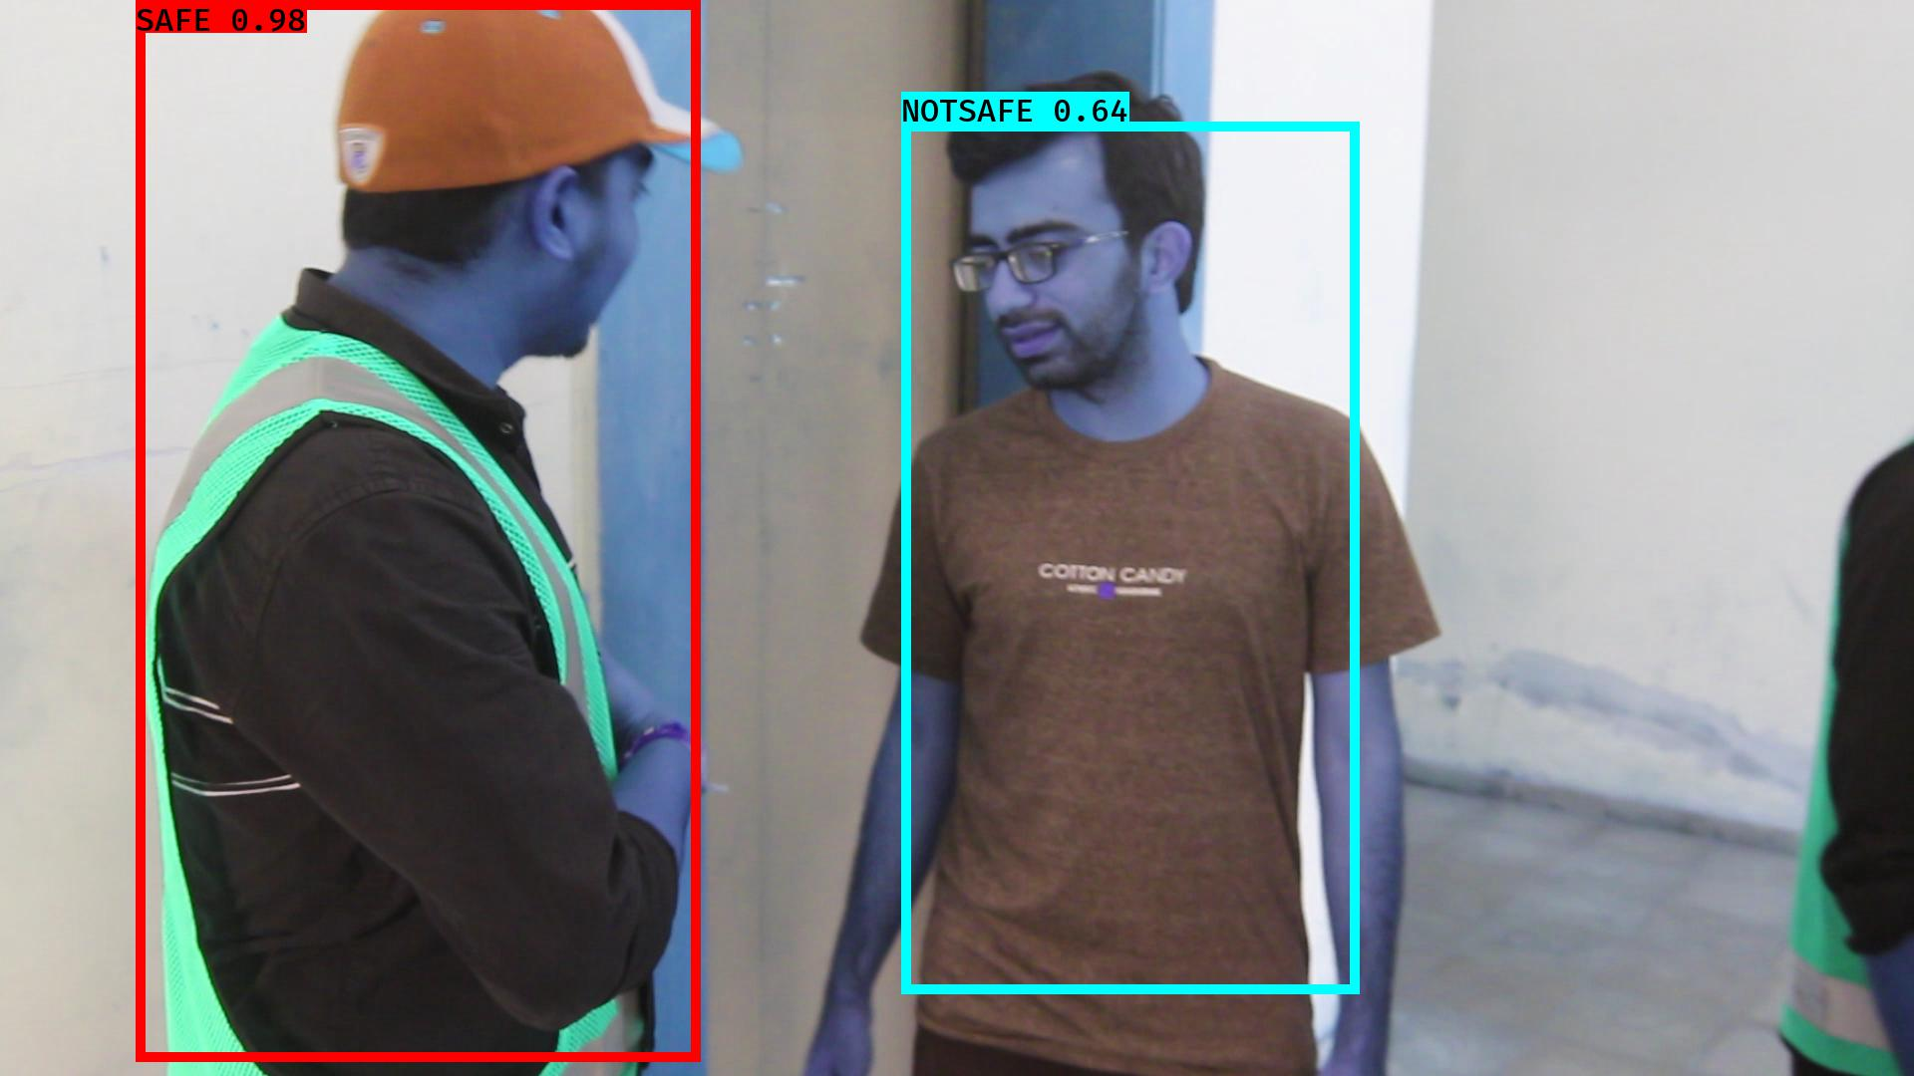

# NOTSAFE2019-06-05 20:16:43.899780.jpg

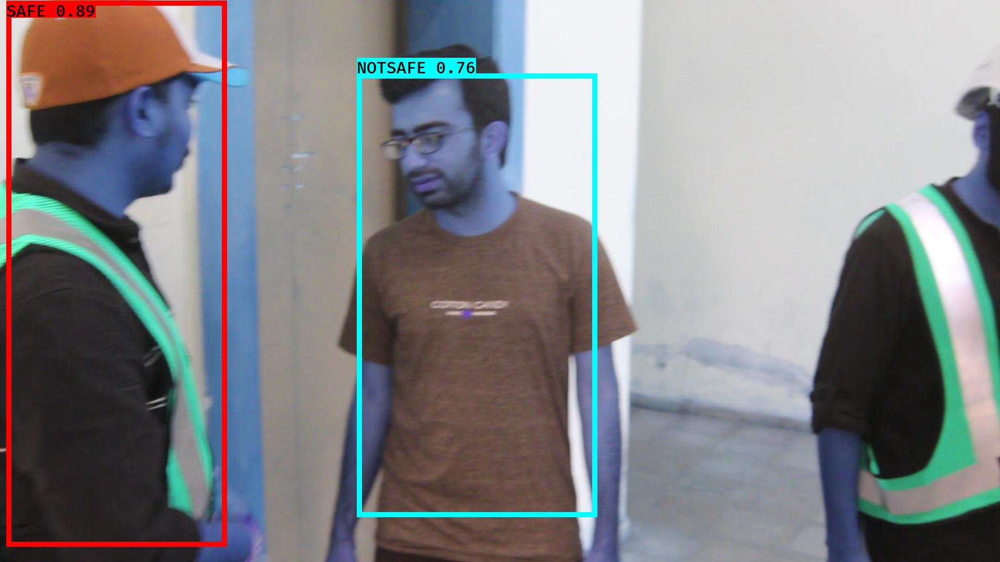

# NOTSAFE2019-06-05 20:16:02.895201.jpg

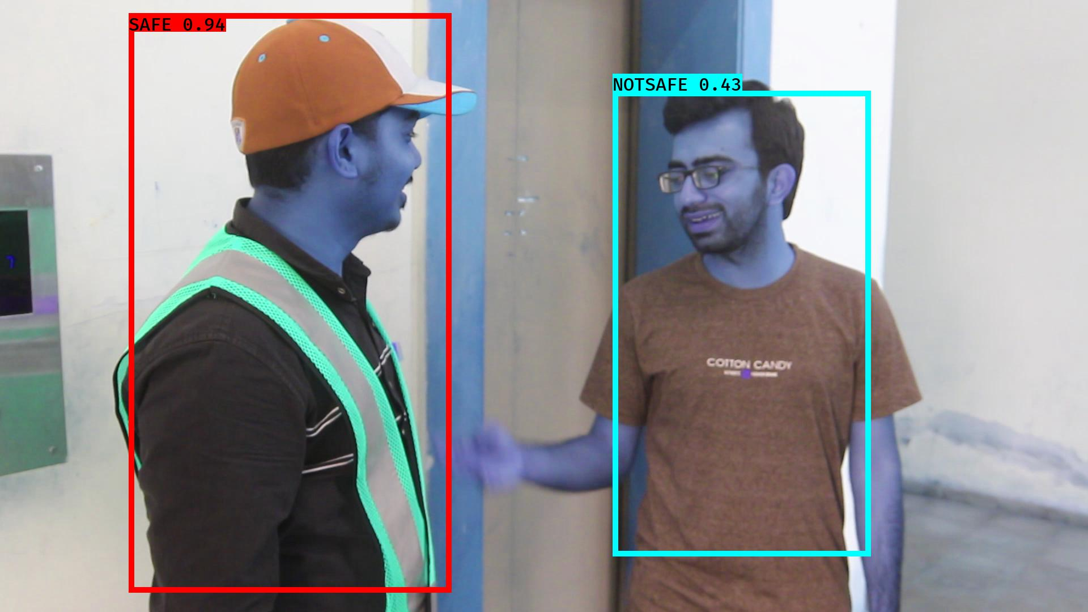

# NOTSAFE2019-06-05 20:16:54.571403.jpg

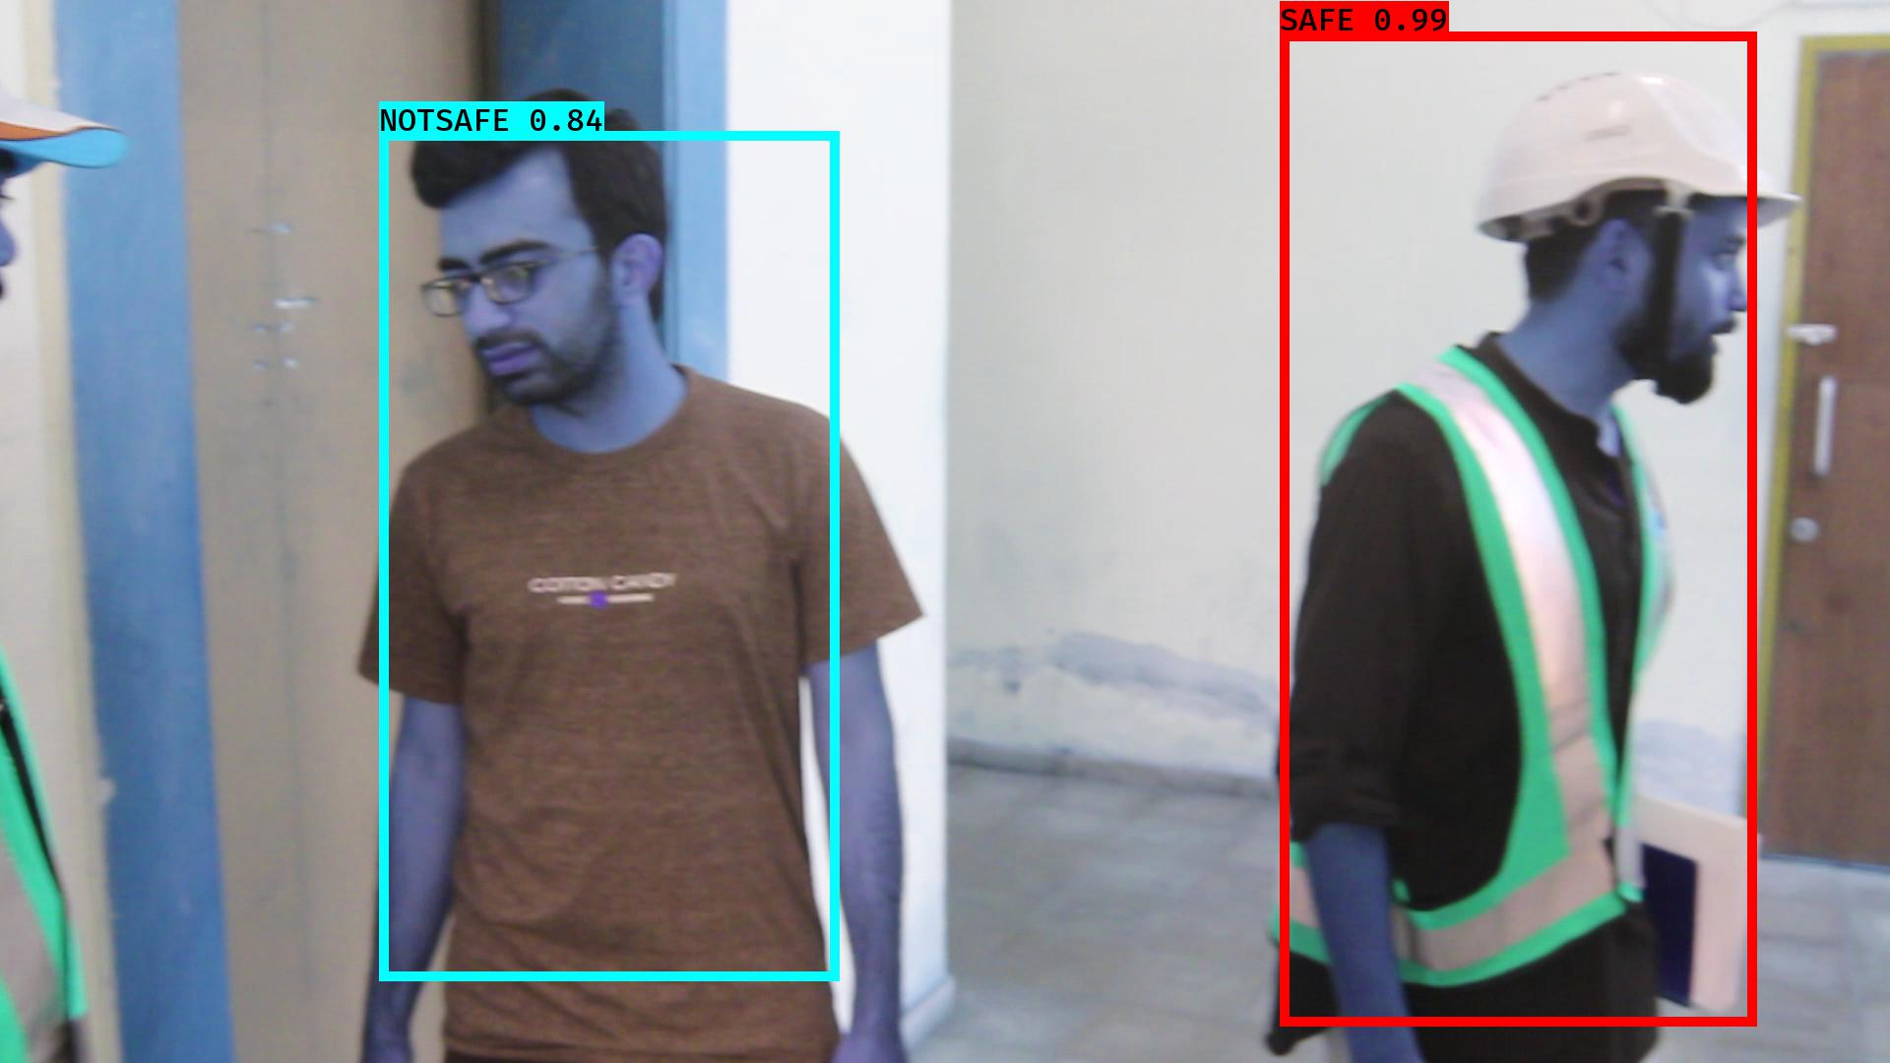

# NOTSAFE2019-06-05 20:16:37.989762.jpg

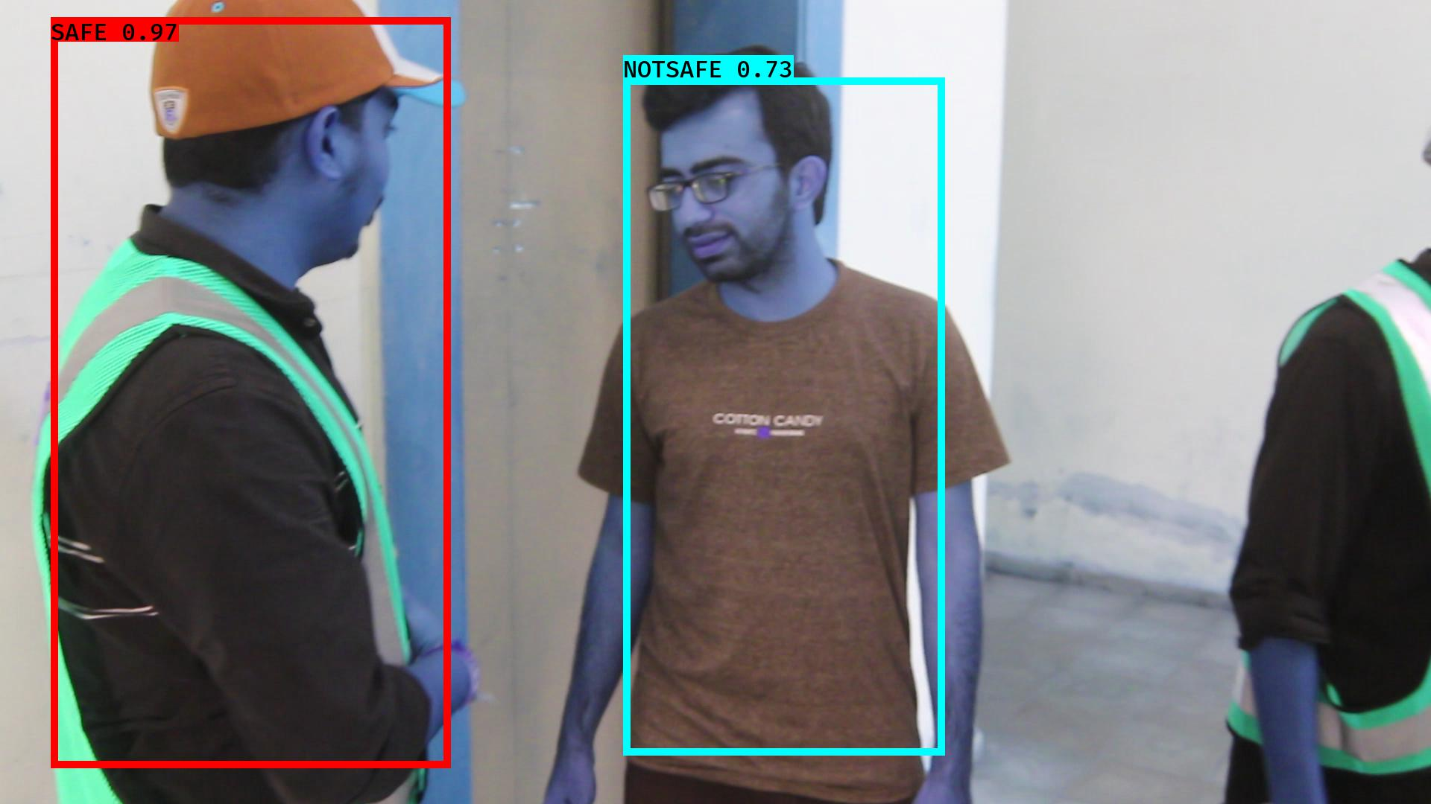

# NOTSAFE2019-06-05 20:16:48.033107.jpg

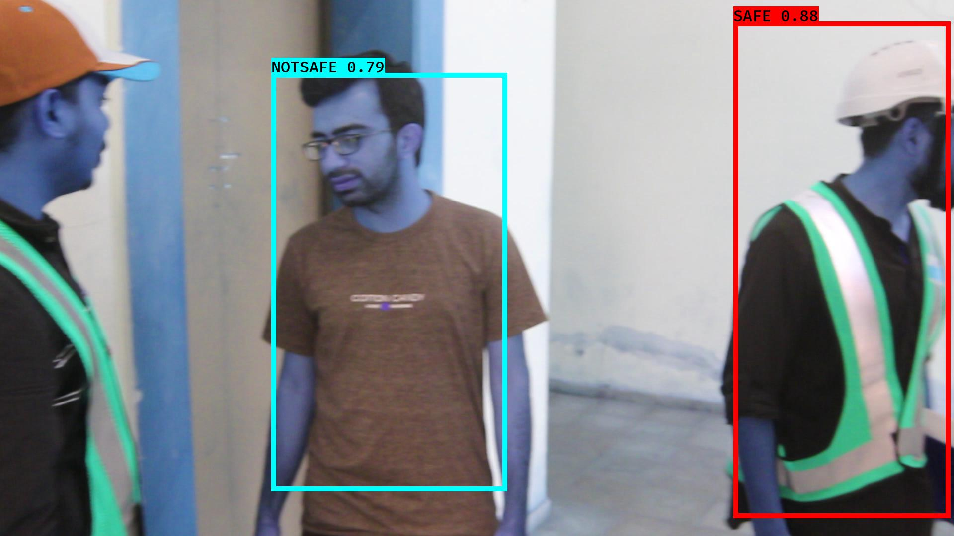

# NOTSAFE2019-06-05 20:16:36.803747.jpg

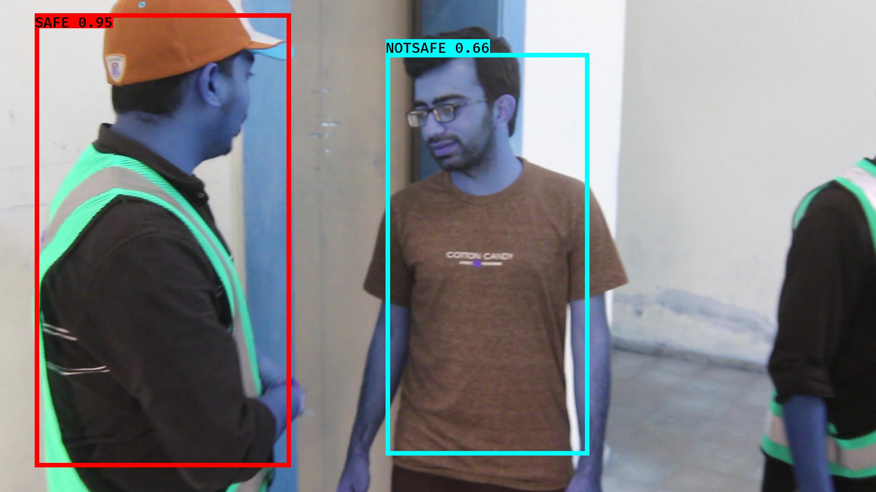

# NOTSAFE2019-06-05 20:16:19.163964.jpg

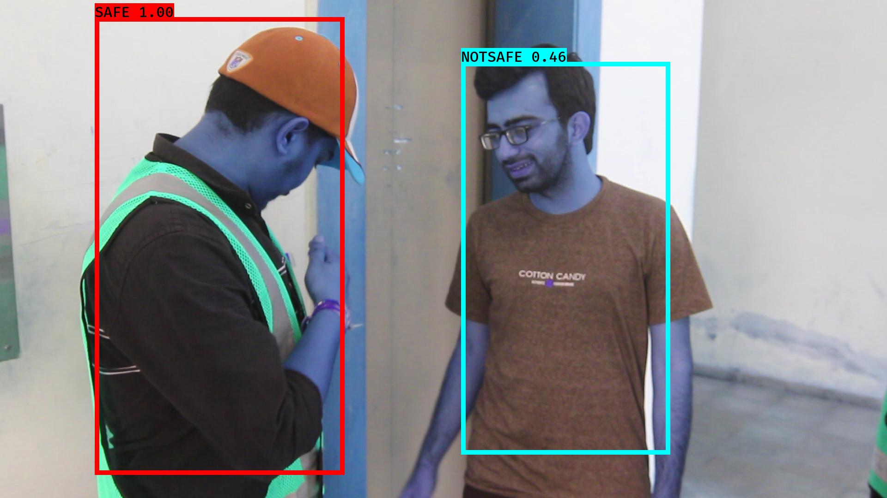

# NOTSAFE2019-06-05 20:16:52.765070.jpg

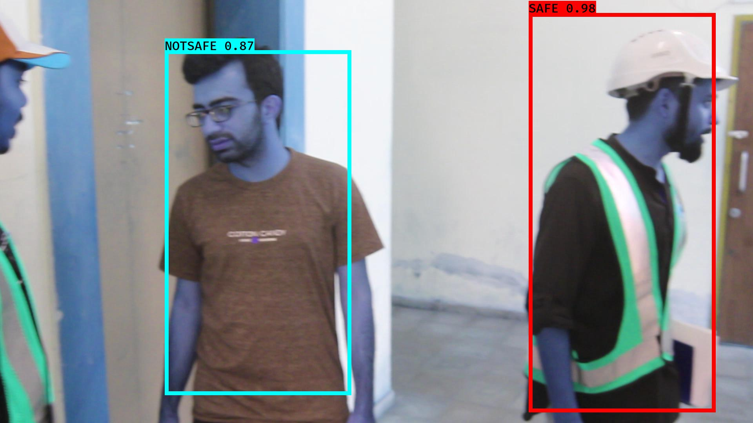

# NOTSAFE2019-06-05 20:16:35.611110.jpg

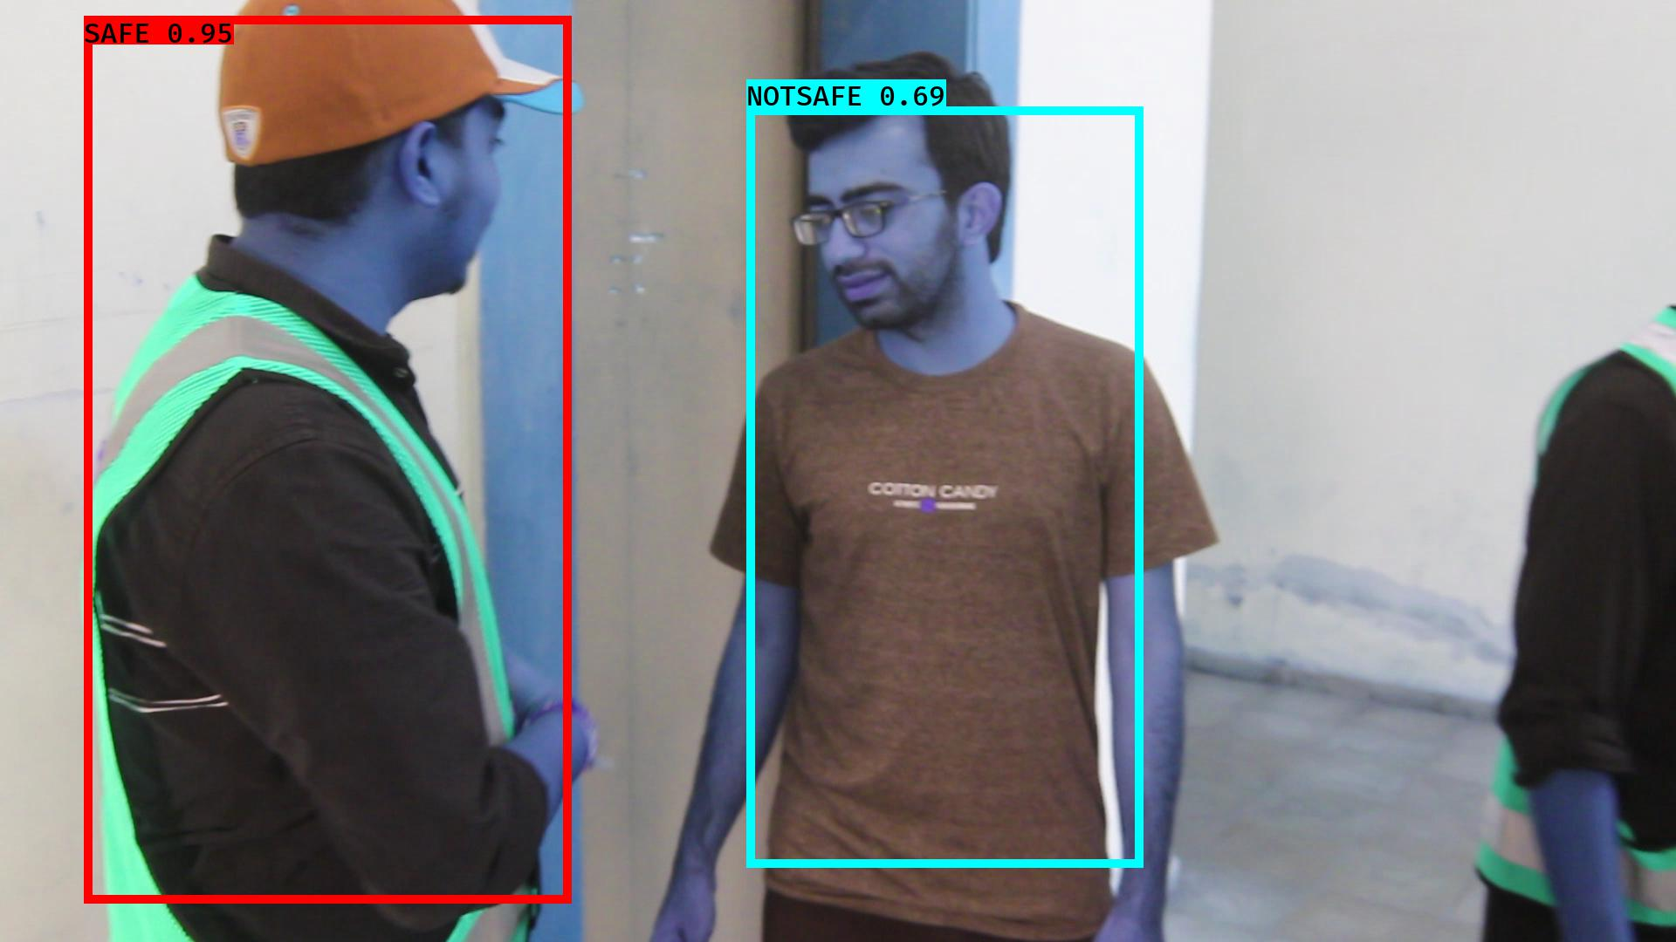

# NOTSAFE2019-06-05 20:16:09.148319.jpg

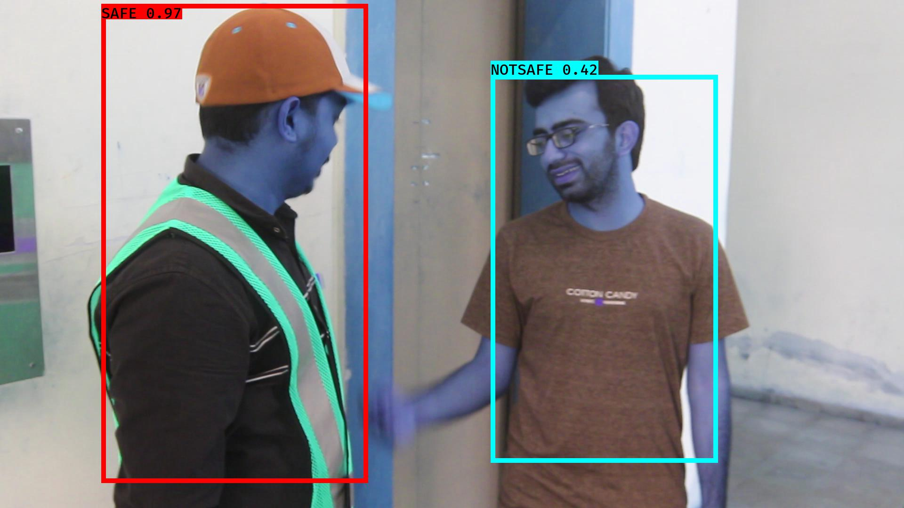

# NOTSAFE2019-06-05 20:16:50.977345.jpg

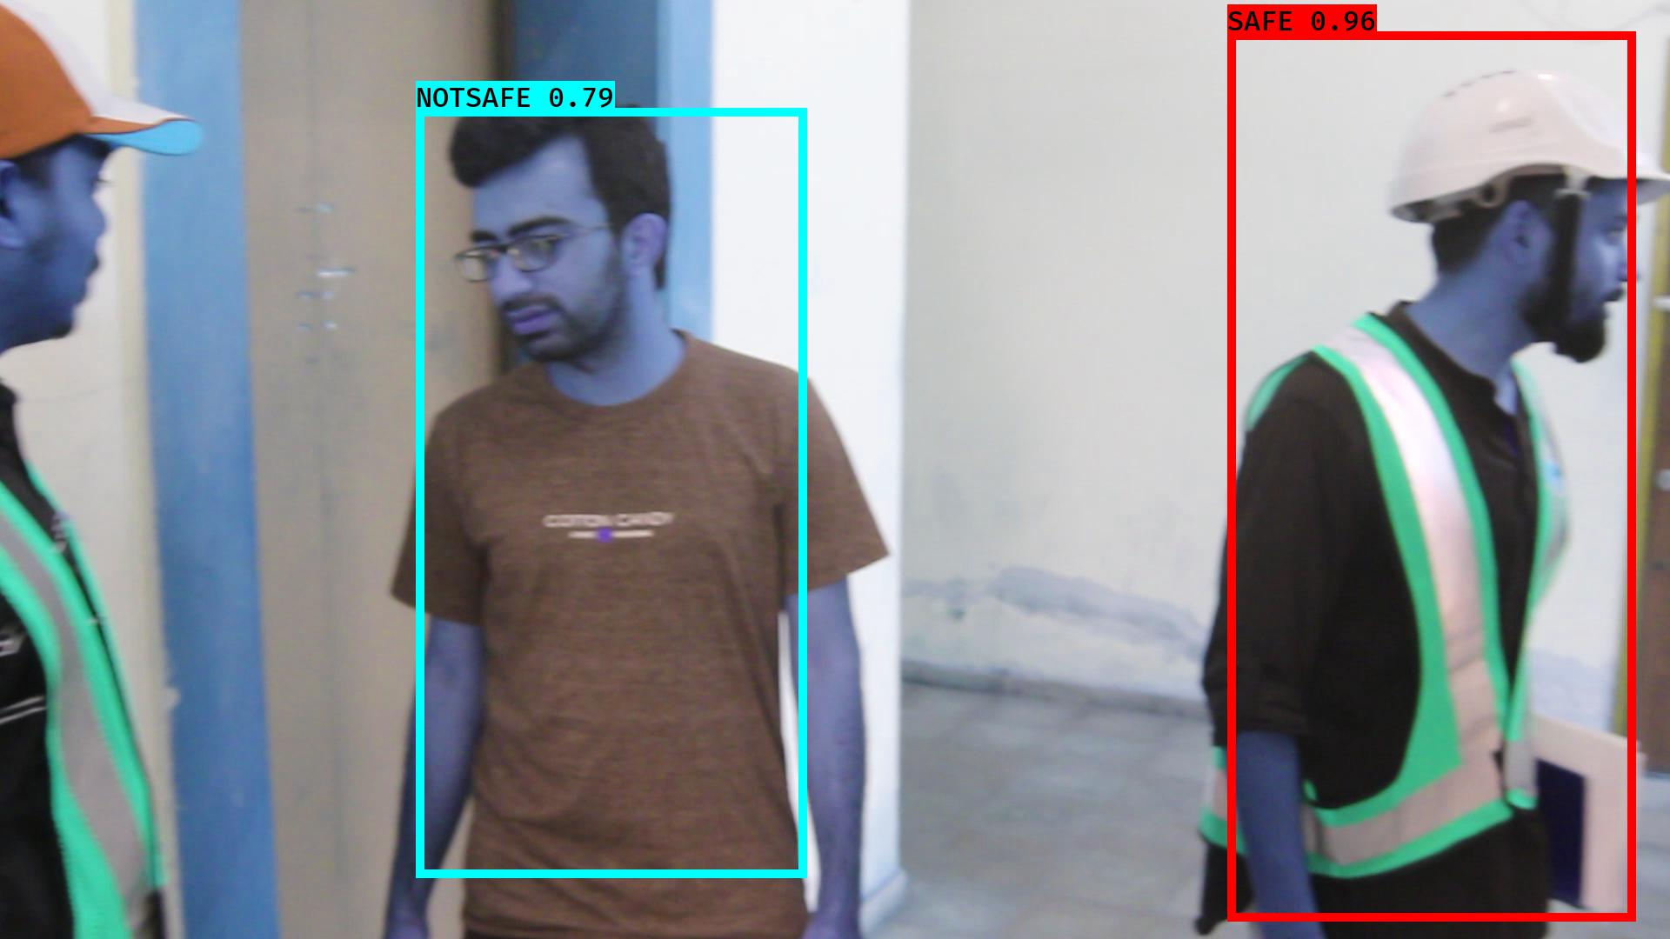

# NOTSAFE2019-06-05 20:16:03.484365.jpg

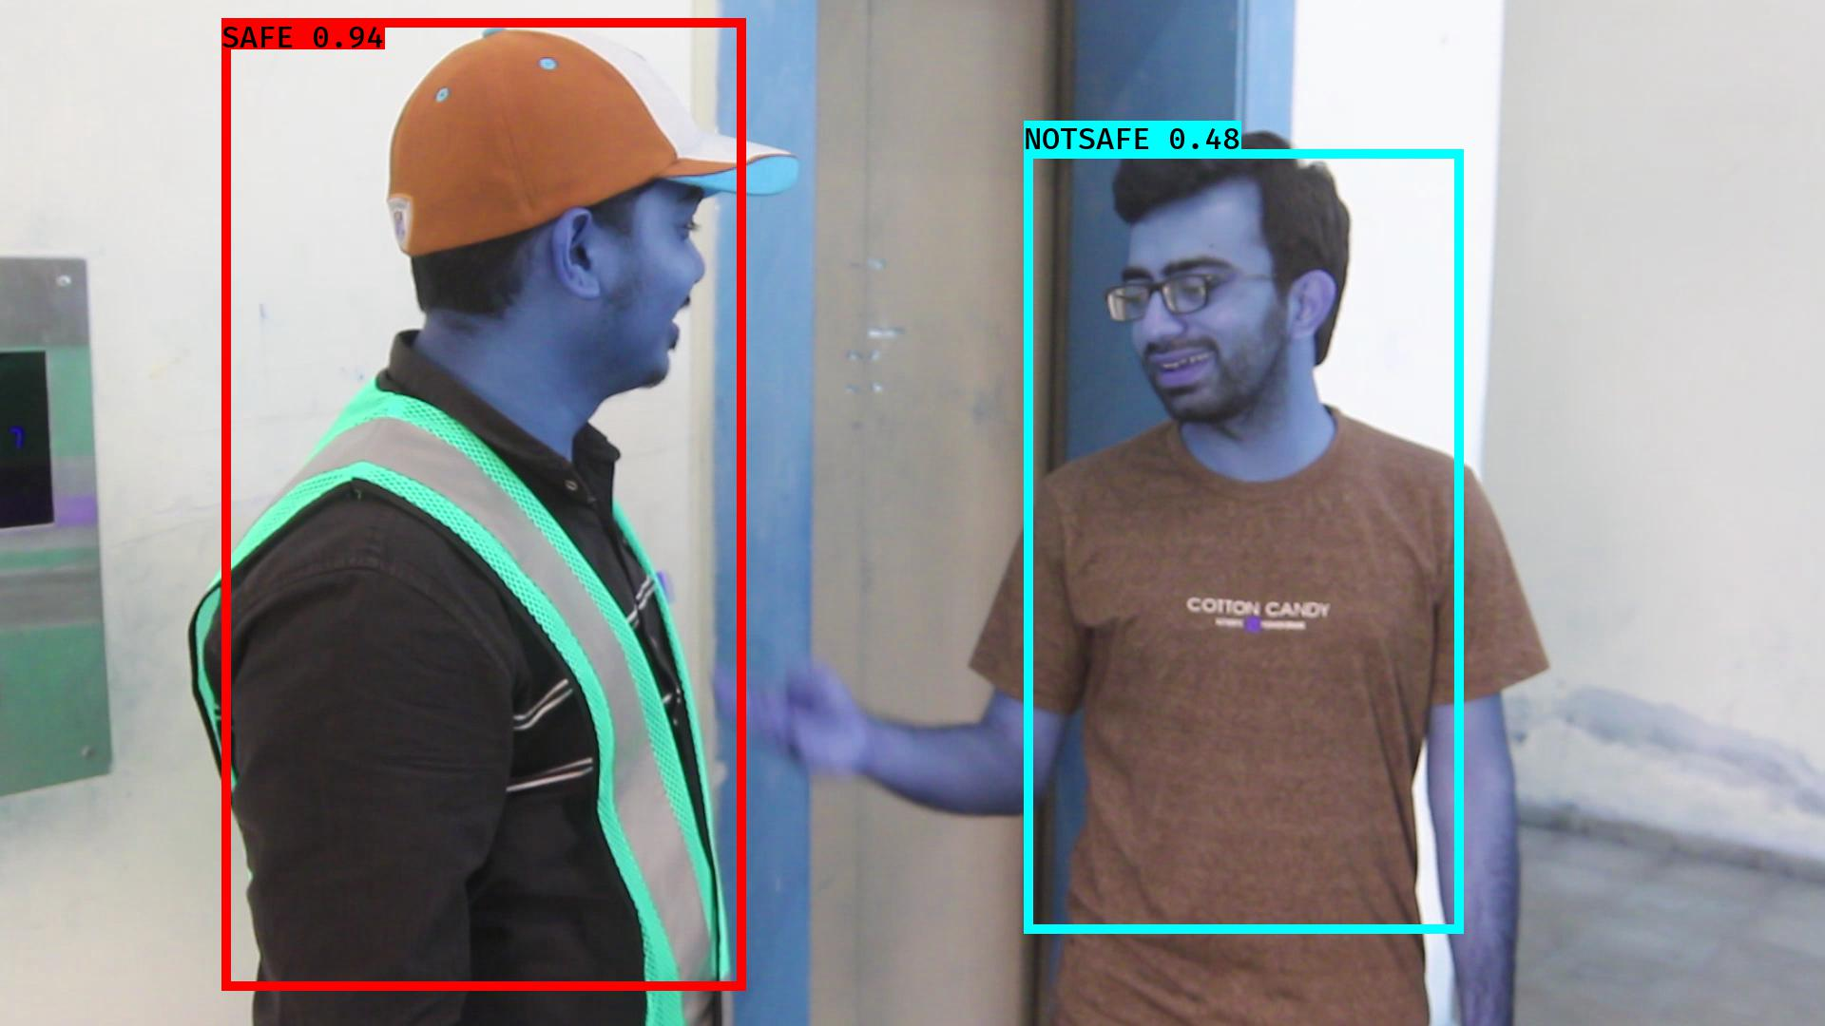

# NOTSAFE2019-06-05 20:16:46.857143.jpg

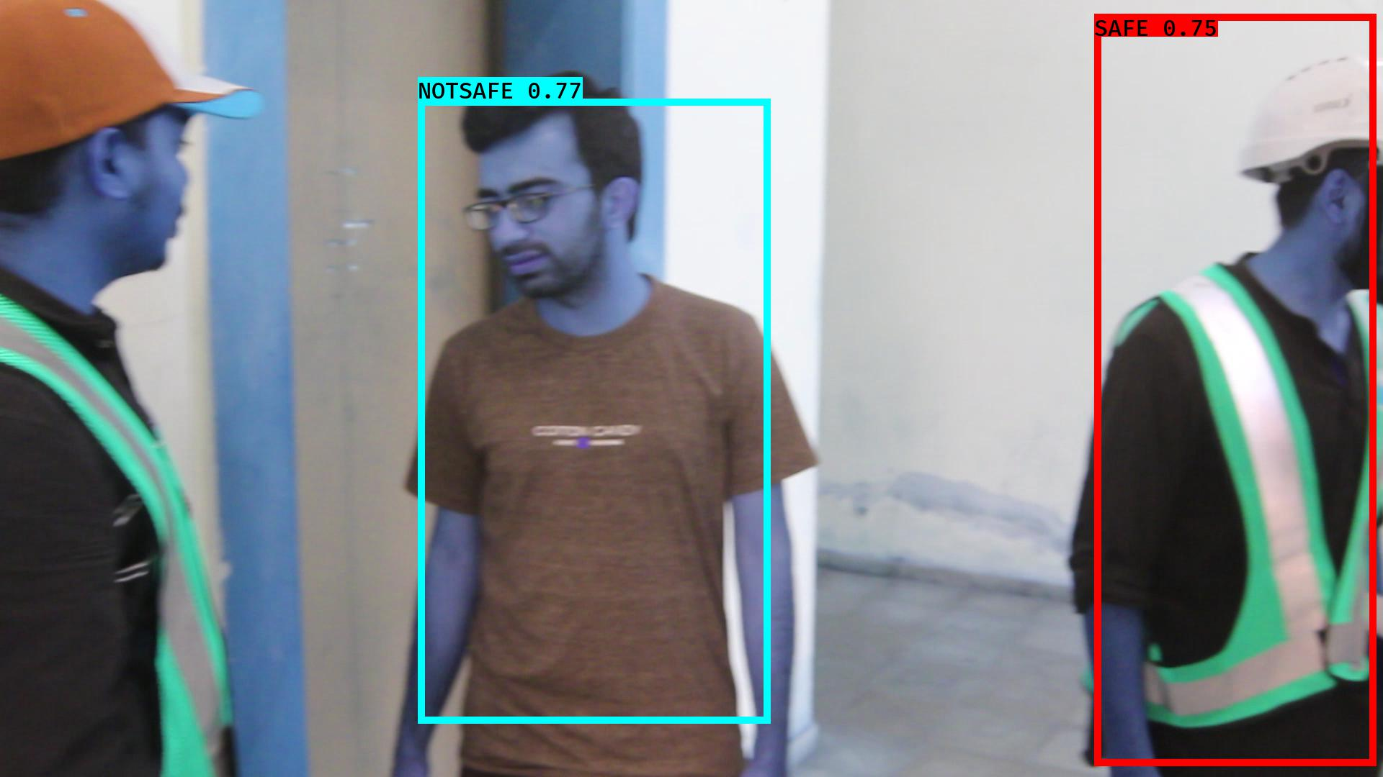

# NOTSAFE2019-06-05 20:16:30.273399.jpg

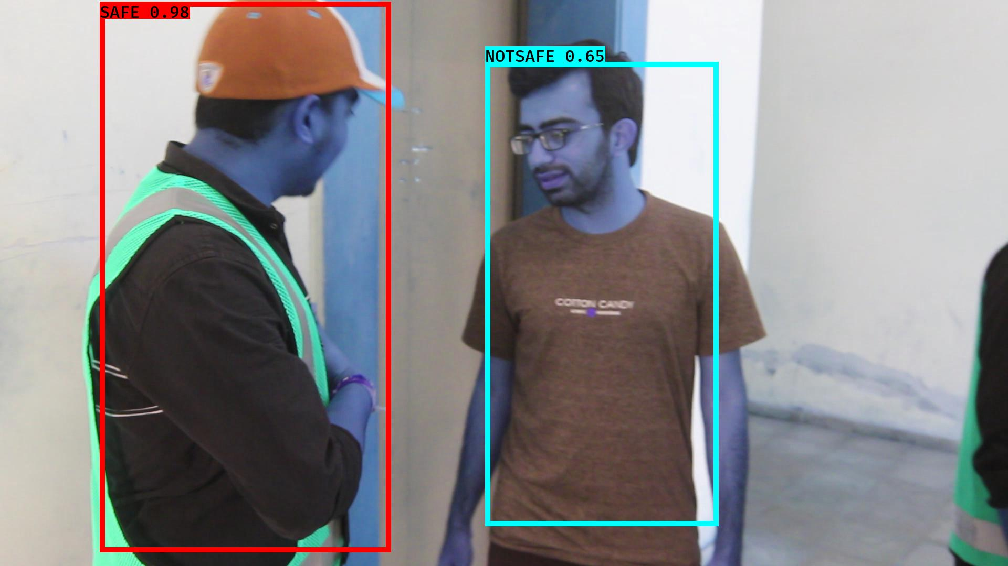

# NOTSAFE2019-06-05 20:16:40.941679.jpg

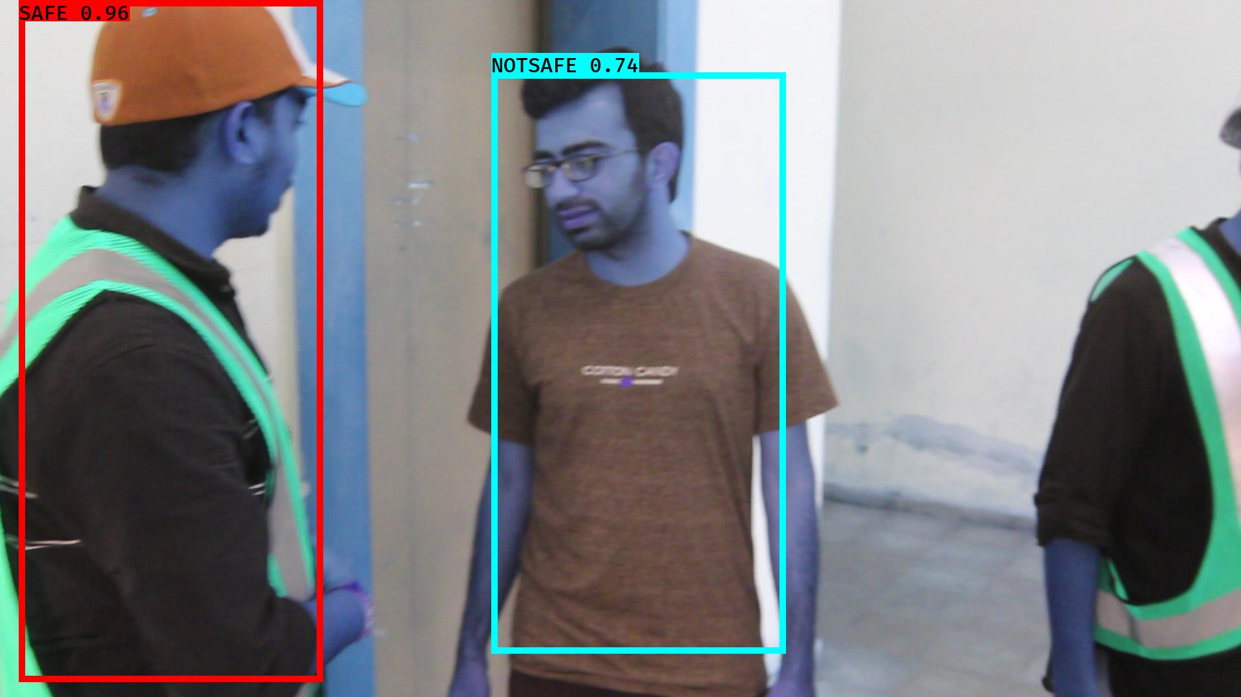

# NOTSAFE2019-06-05 20:16:52.170371.jpg

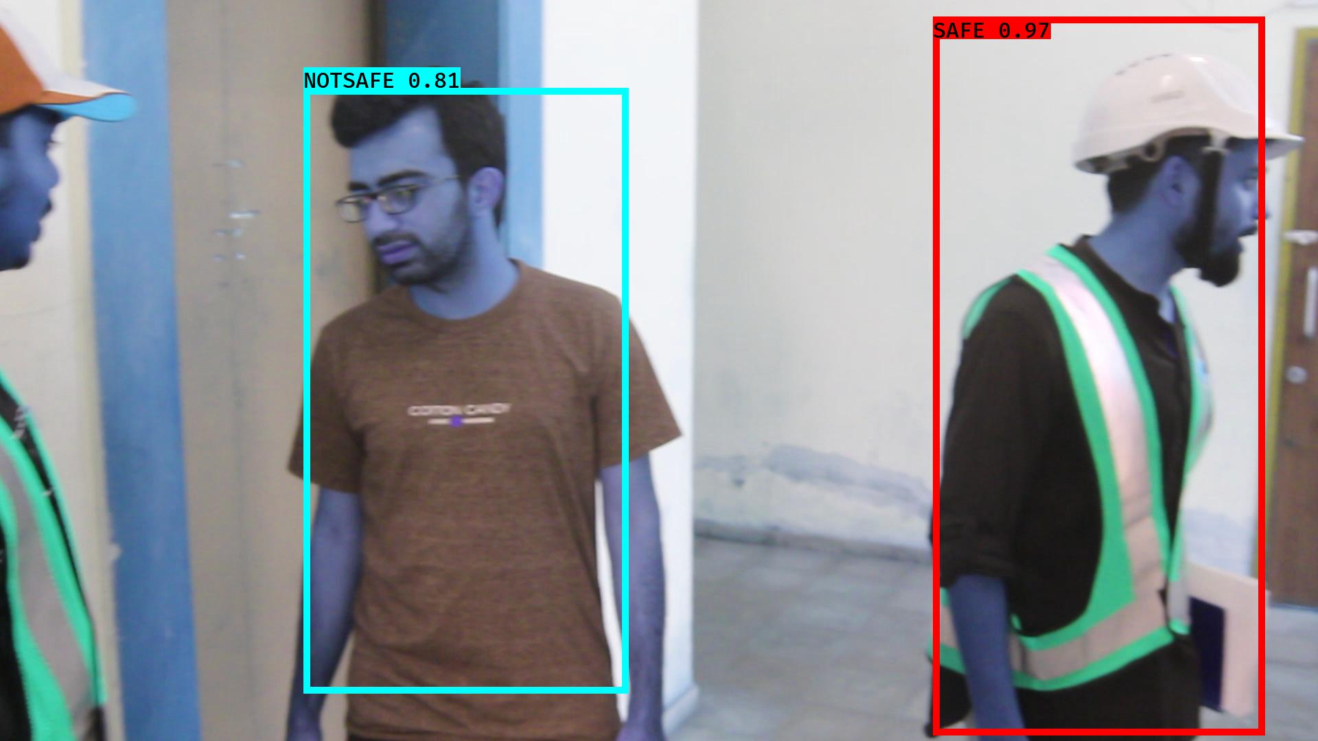

# NOTSAFE2019-06-05 20:16:35.008791.jpg

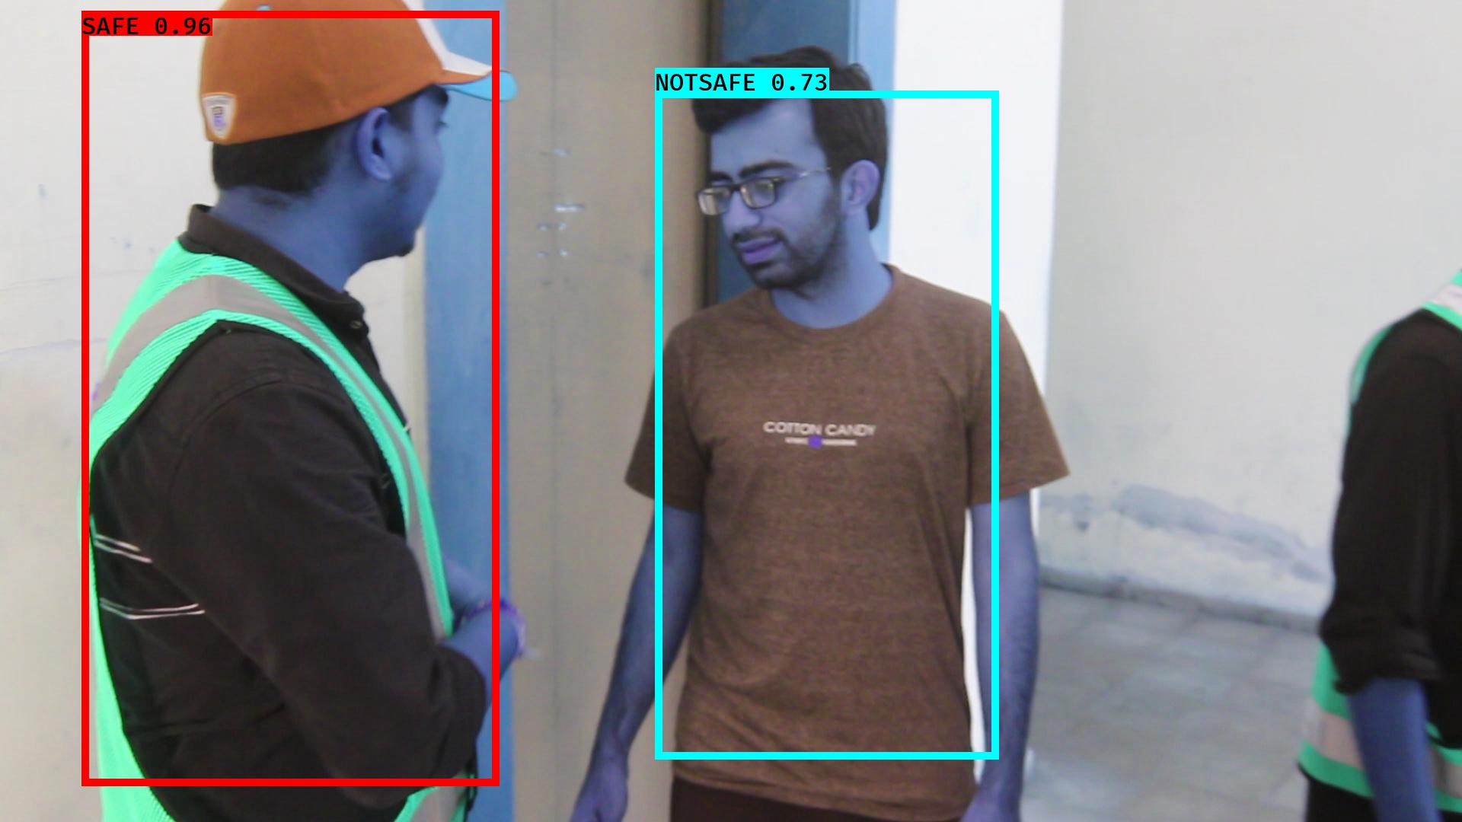

# NOTSAFE2019-06-05 20:16:15.357538.jpg

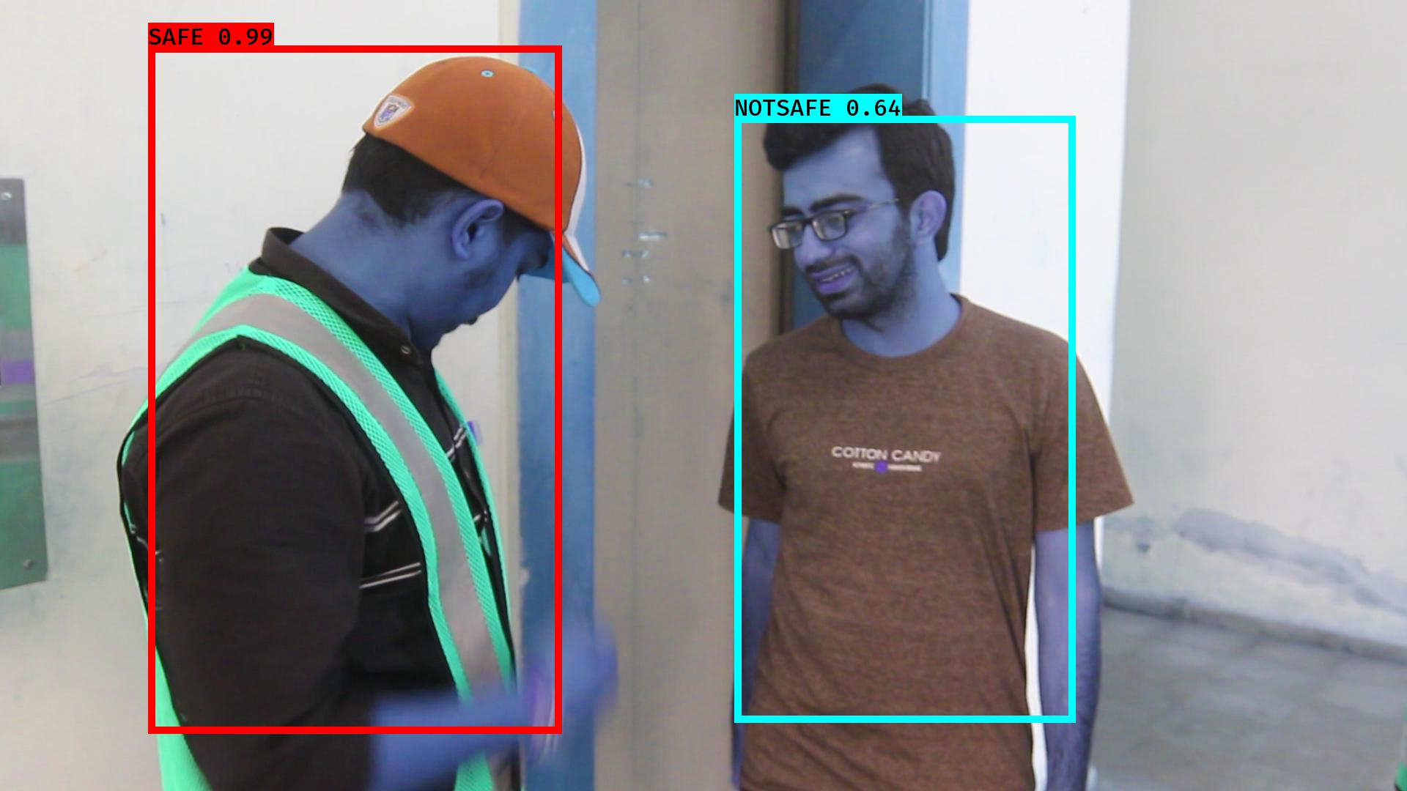

# NOTSAFE2019-06-05 20:16:20.312270.jpg

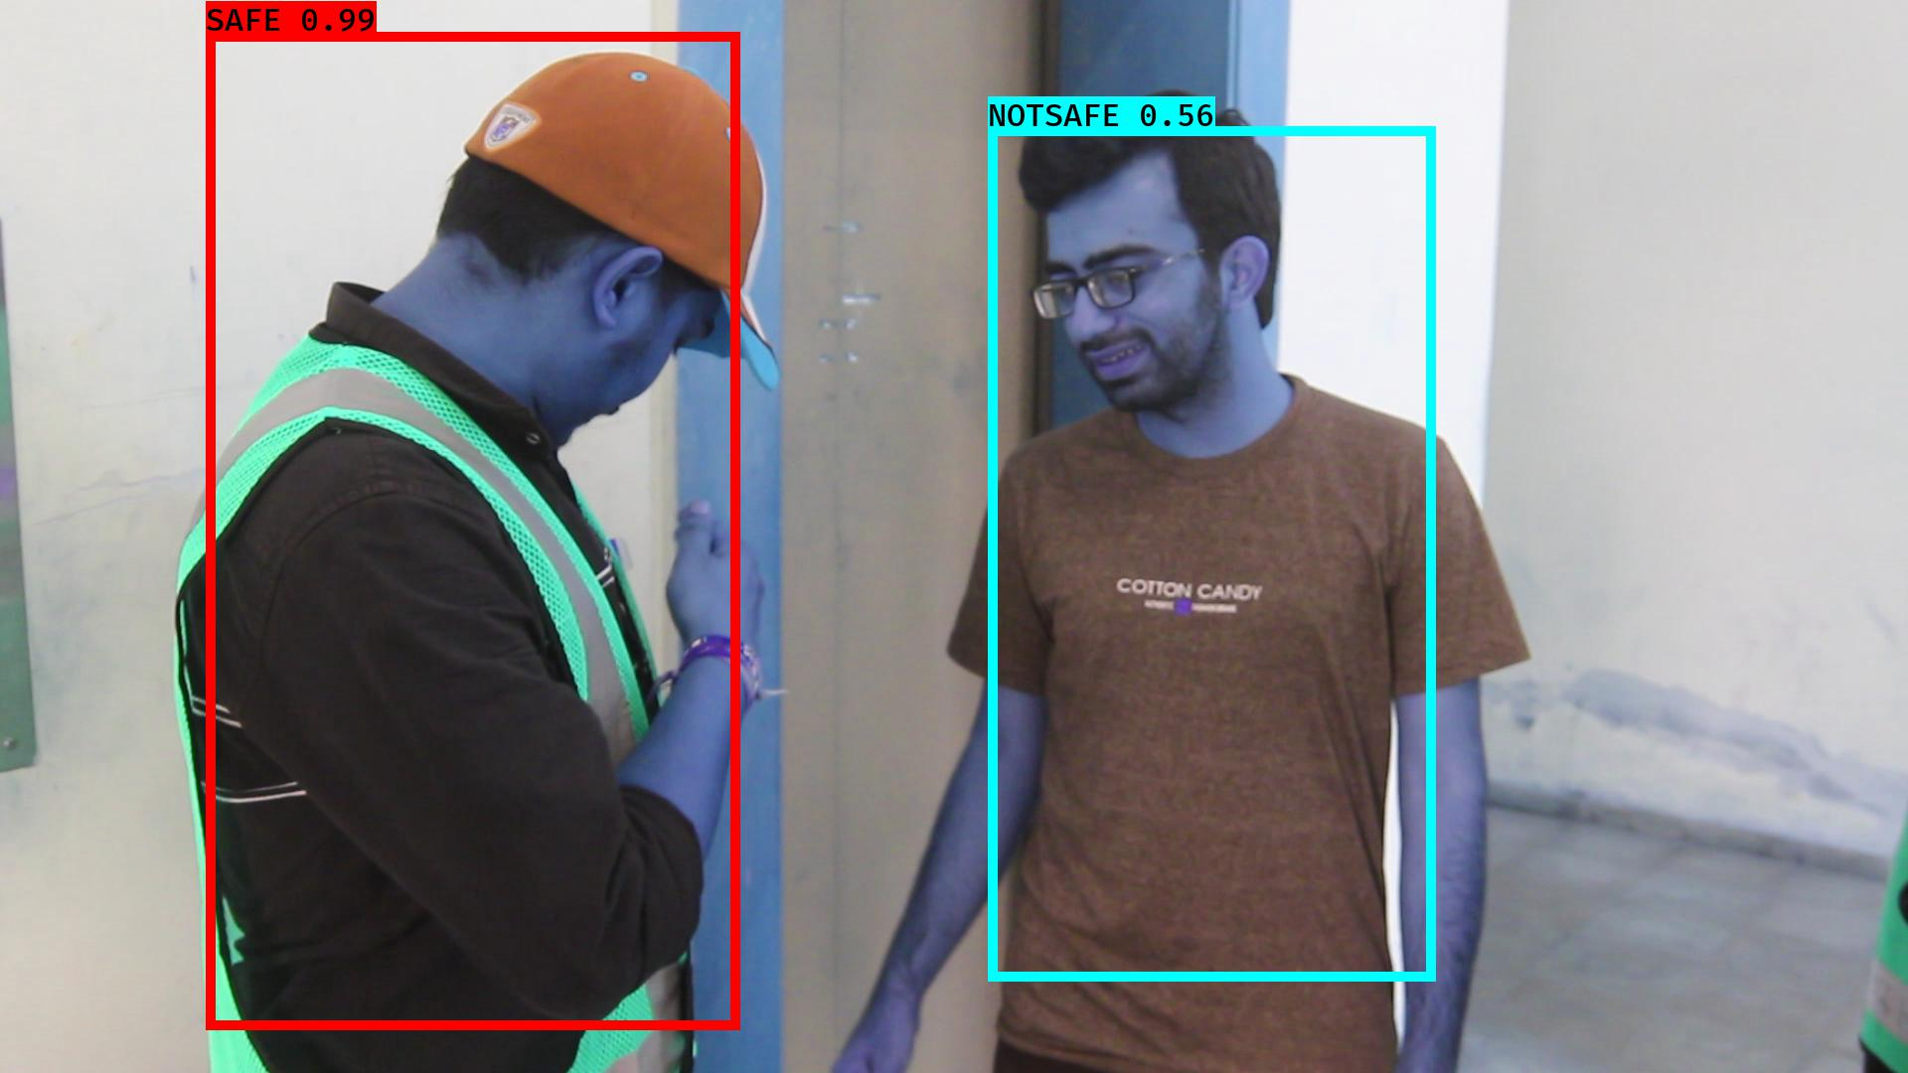

# NOTSAFE2019-06-05 20:16:53.349477.jpg

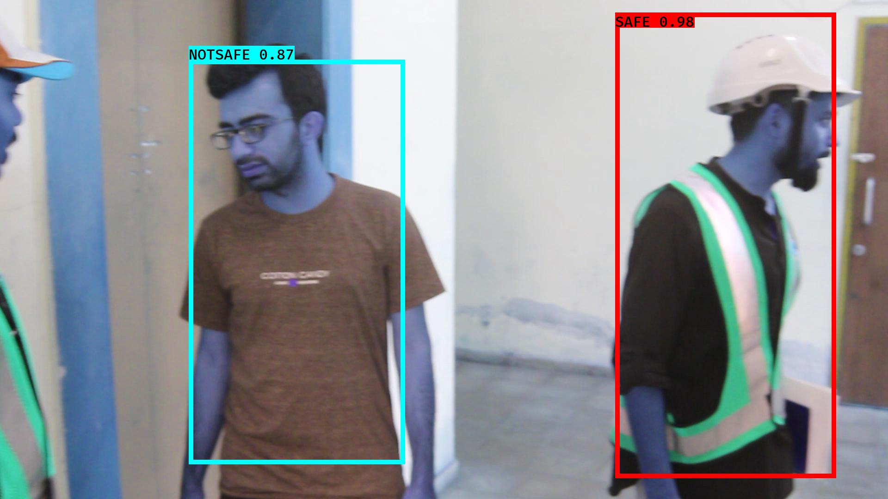

# NOTSAFE2019-06-05 20:16:39.170483.jpg

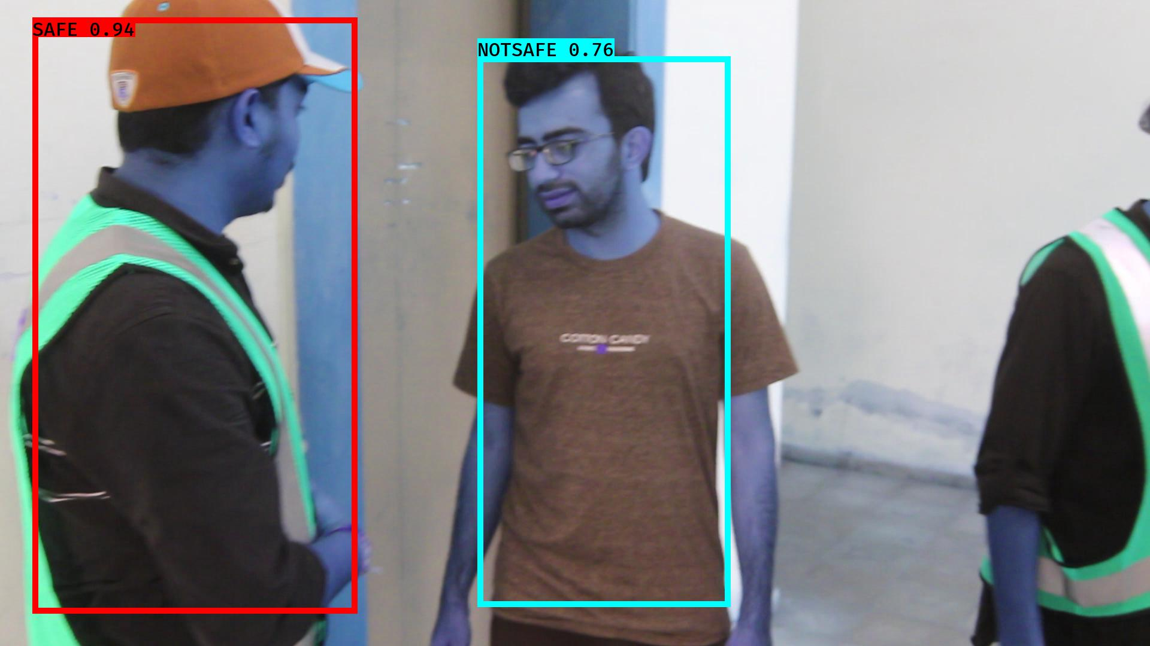

# NOTSAFE2019-06-05 20:16:41.533955.jpg

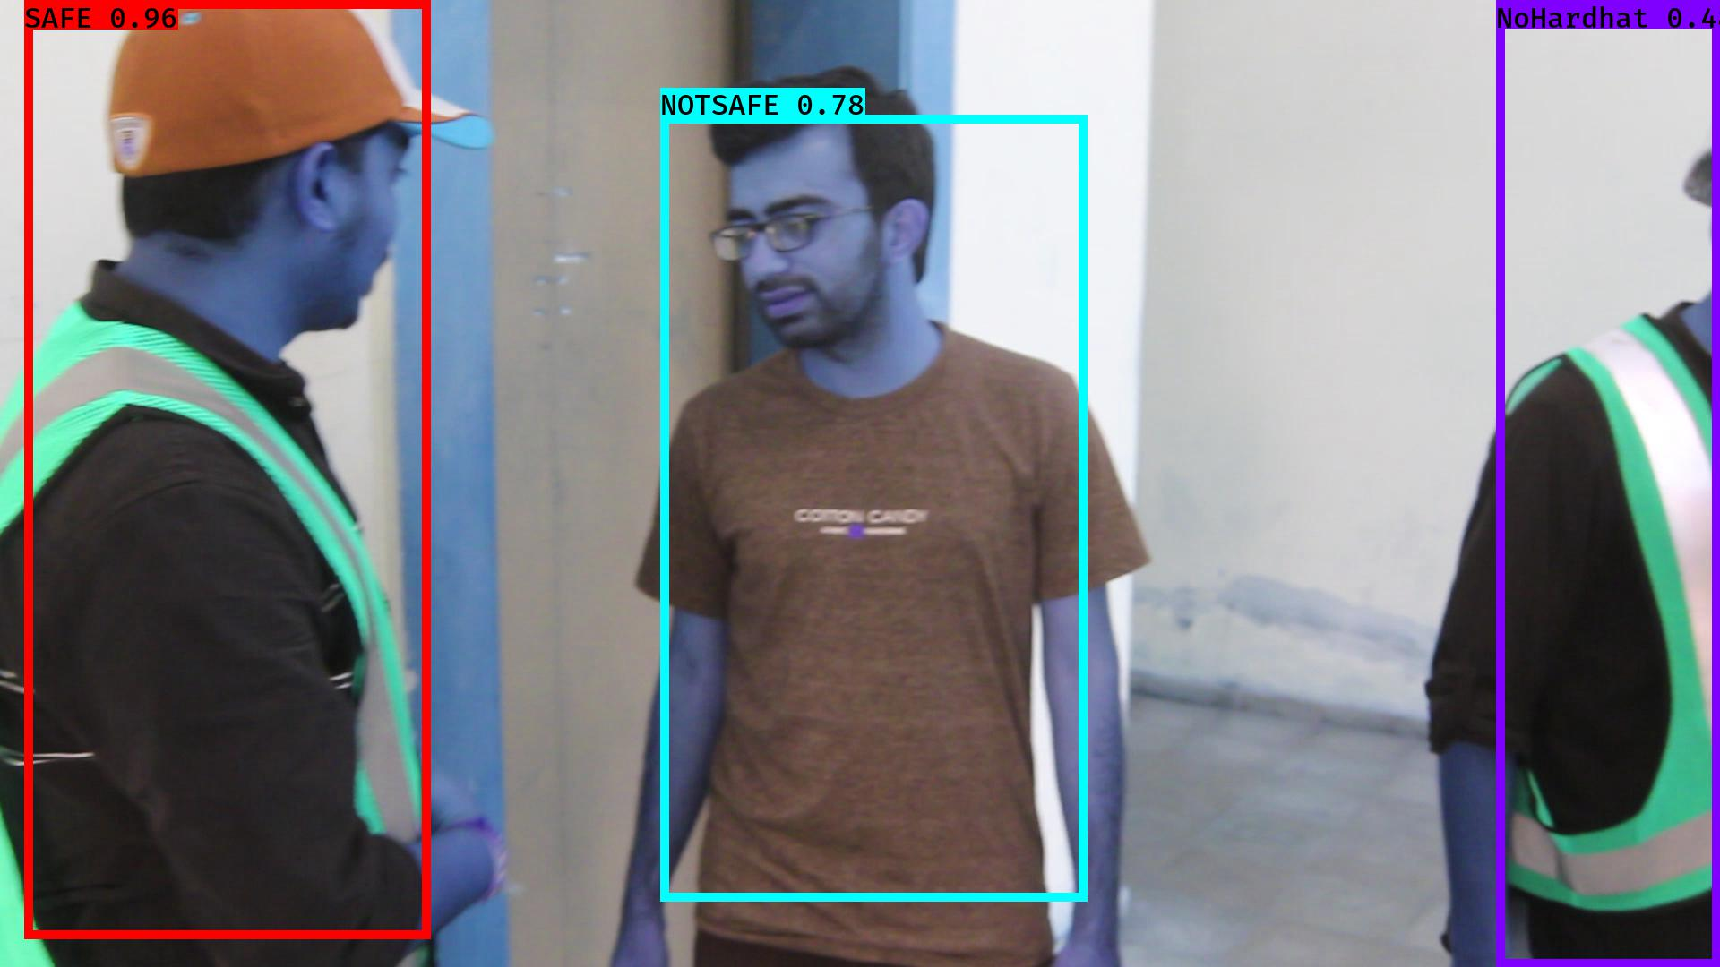

# NOTSAFE2019-06-05 20:16:22.026352.jpg

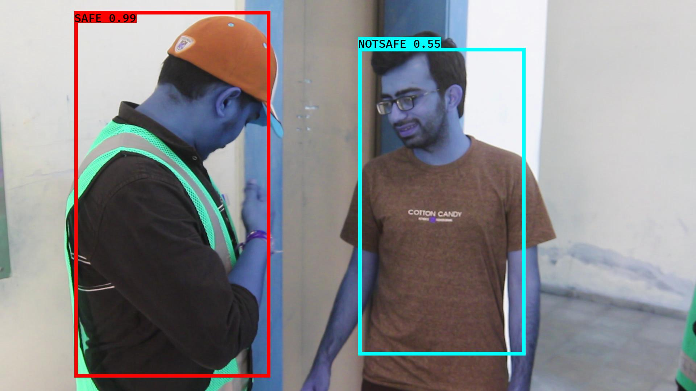

# NOTSAFE2019-06-05 20:16:04.656240.jpg

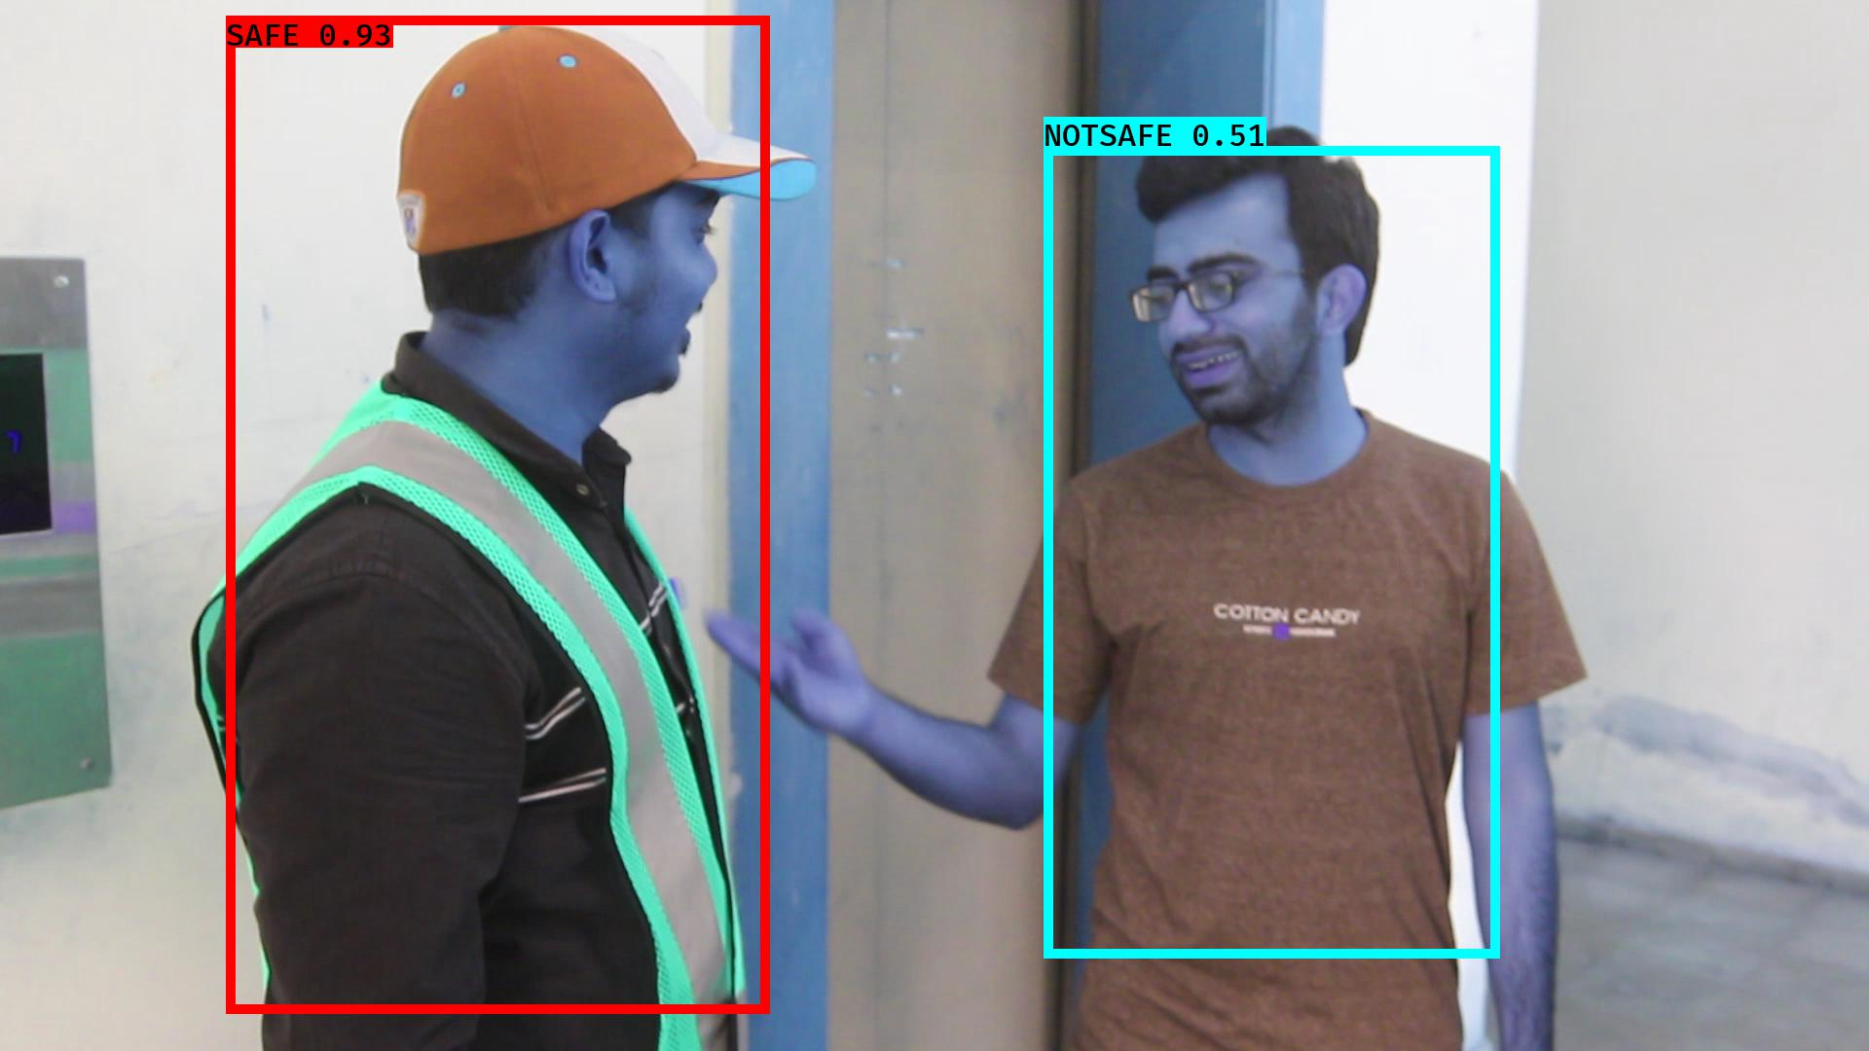

# NOTSAFE2019-06-05 20:16:06.279180.jpg

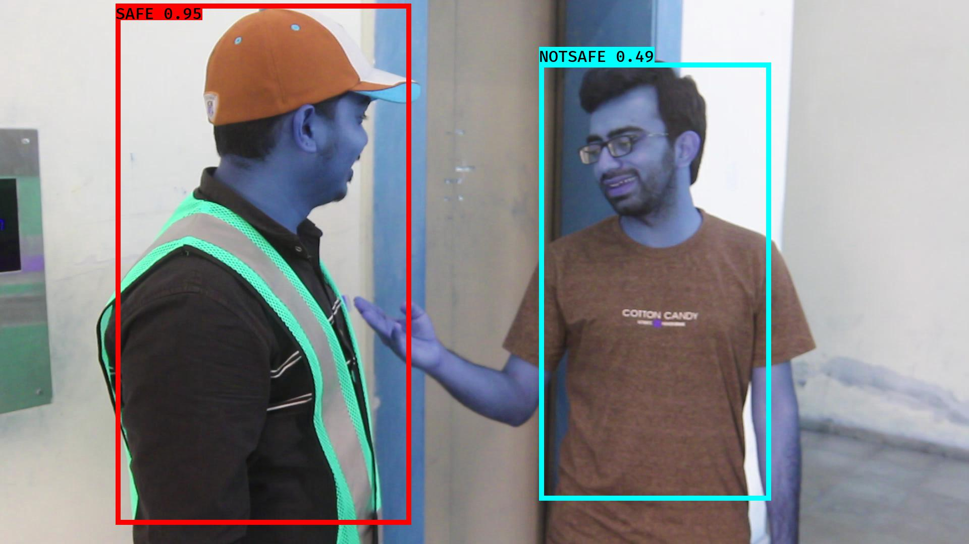

# NOTSAFE2019-06-05 20:16:13.072046.jpg

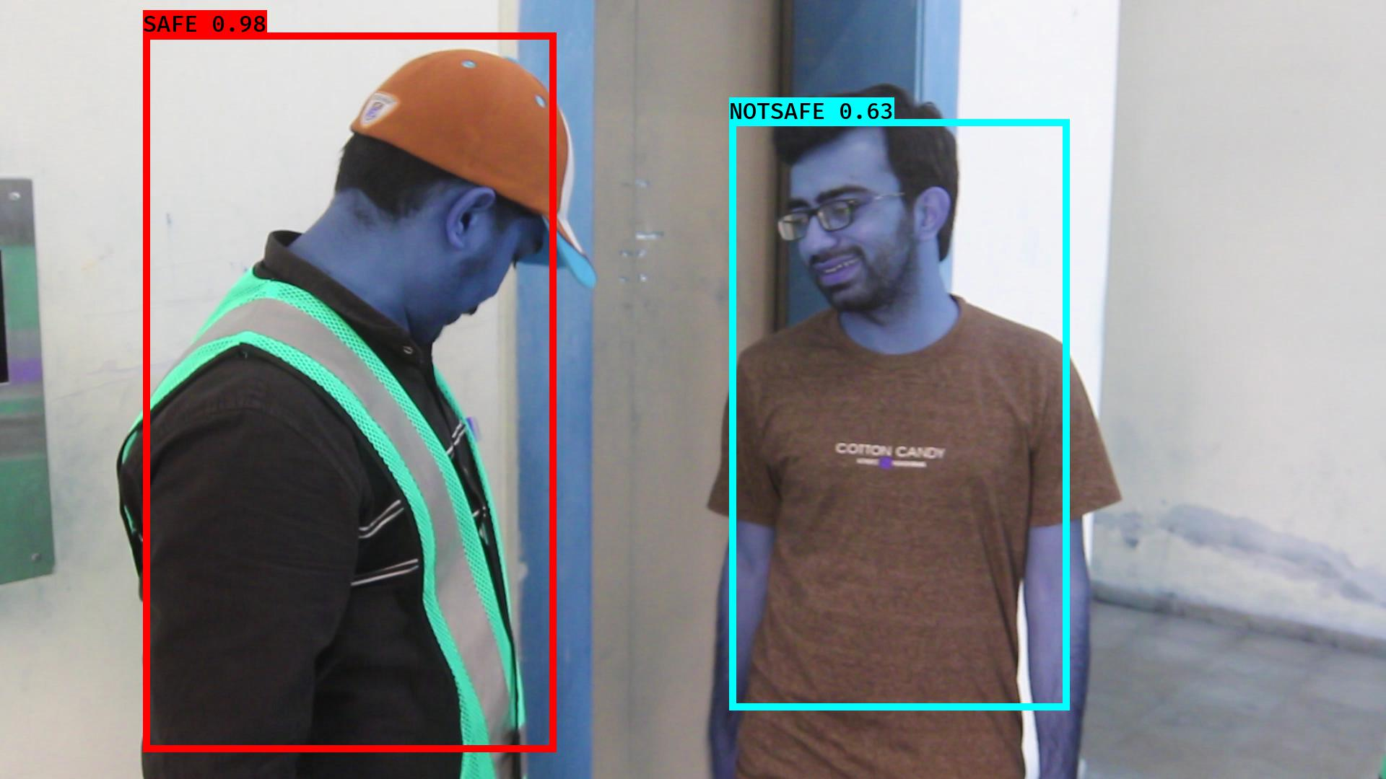

# NOTSAFE2019-06-05 20:16:55.781491.jpg

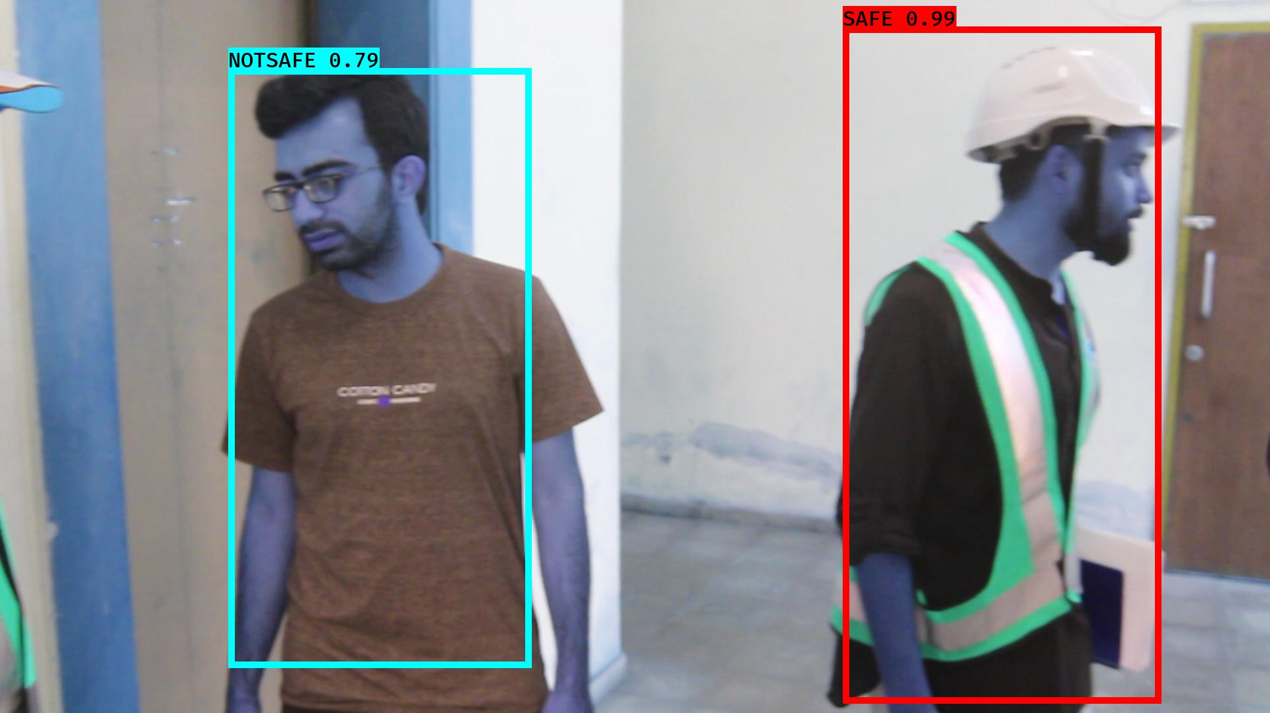

# NOTSAFE2019-06-05 20:16:29.086545.jpg

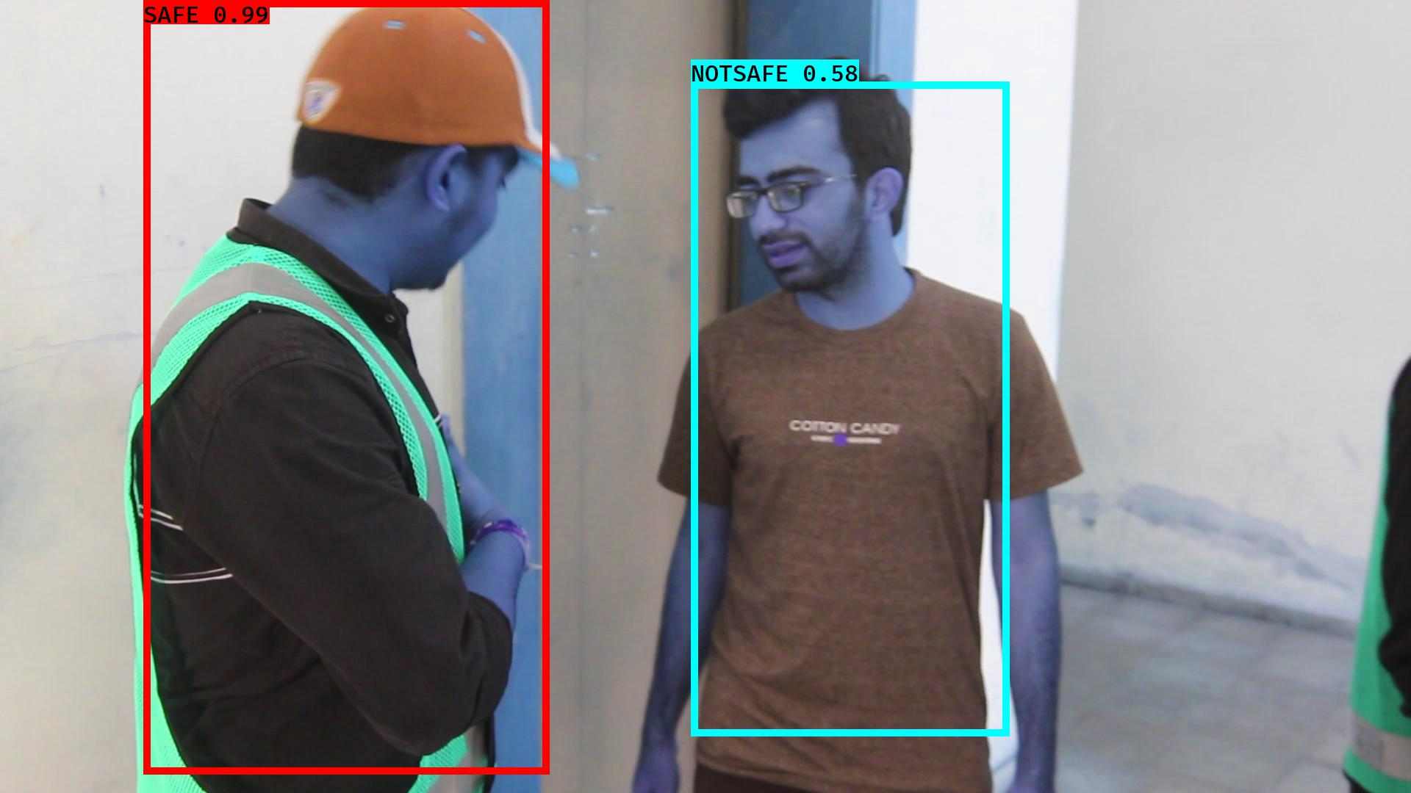

# NOTSAFE2019-06-05 20:16:46.268925.jpg

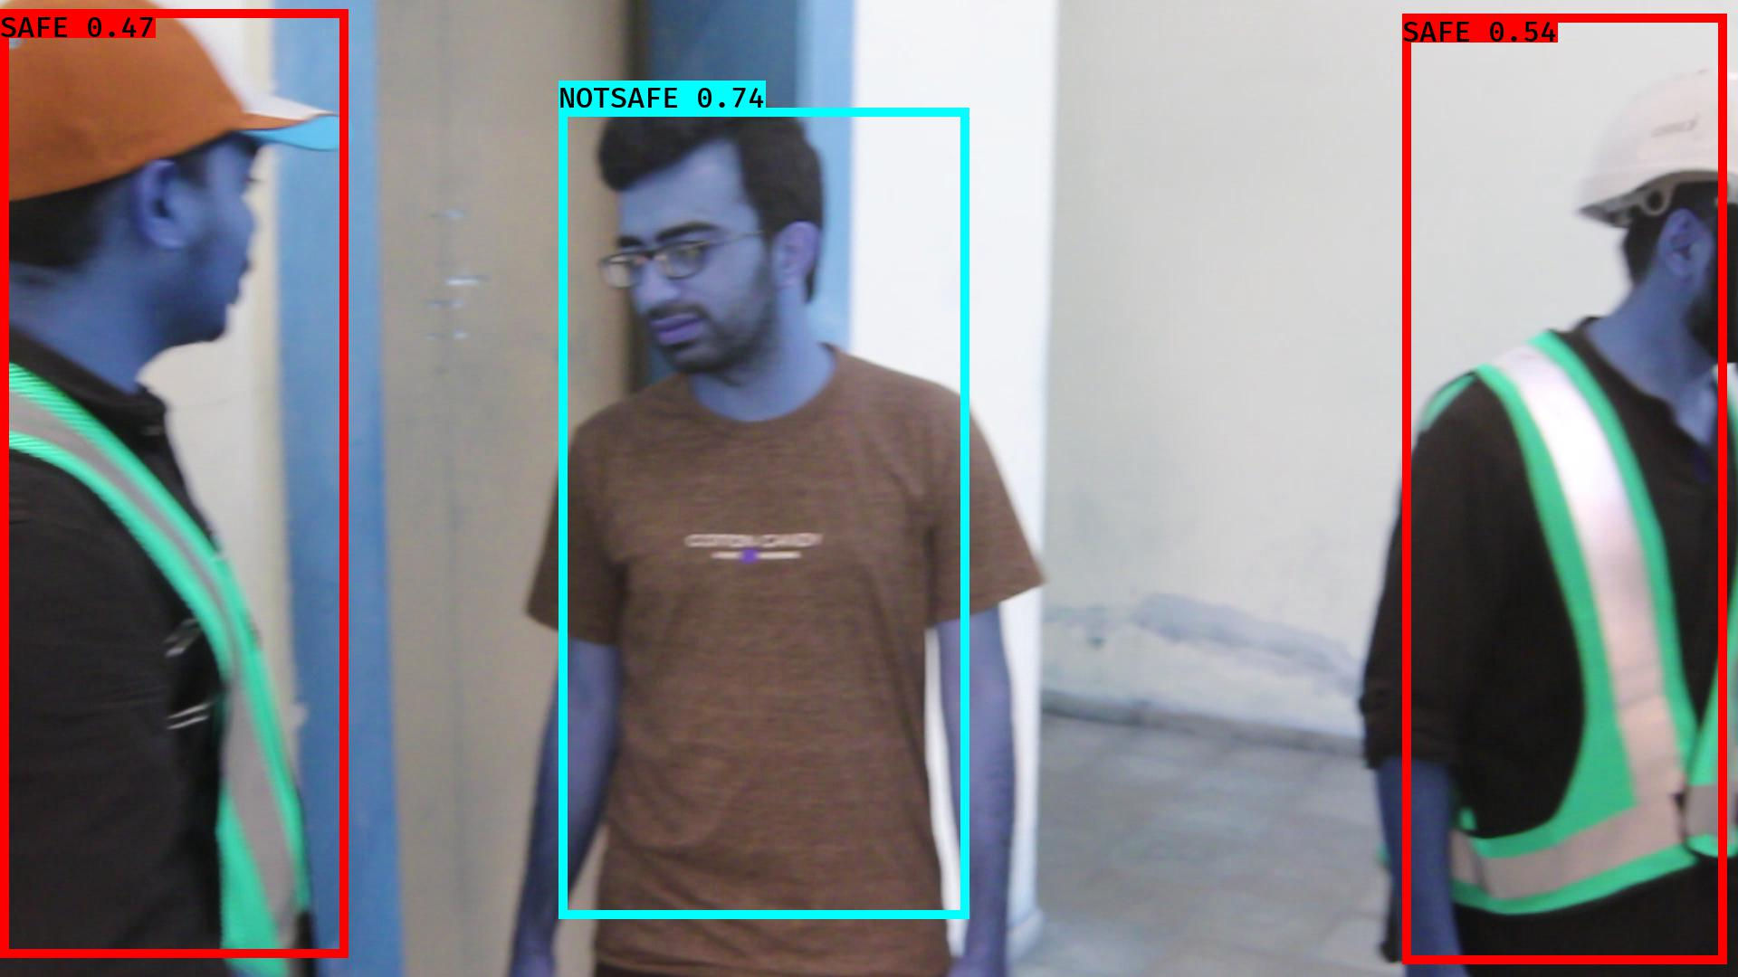

# NOTSAFE2019-06-05 20:16:25.551845.jpg

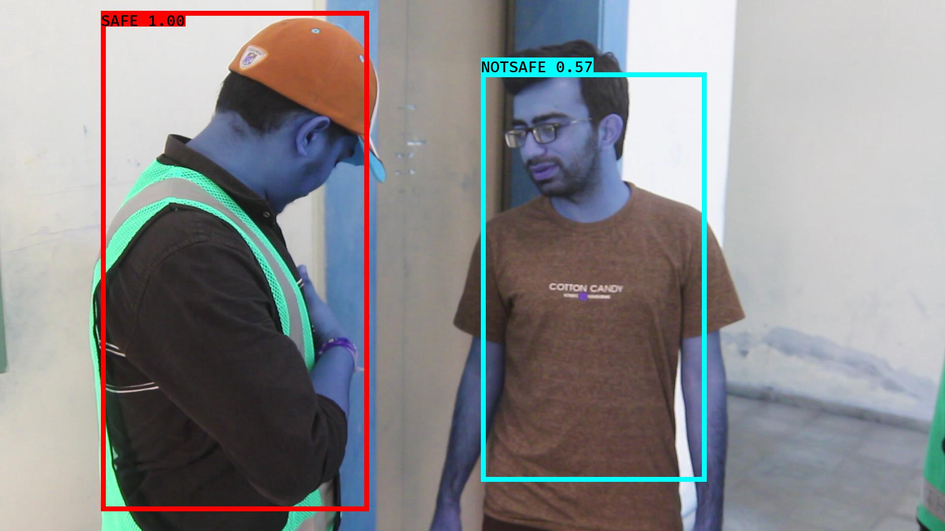

# NOTSAFE2019-06-05 20:16:08.000256.jpg

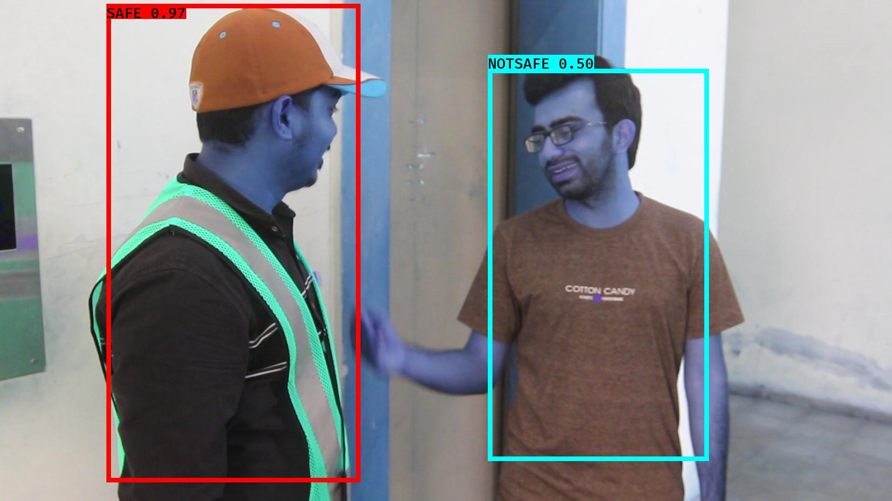

# NOTSAFE2019-06-05 20:16:24.395418.jpg

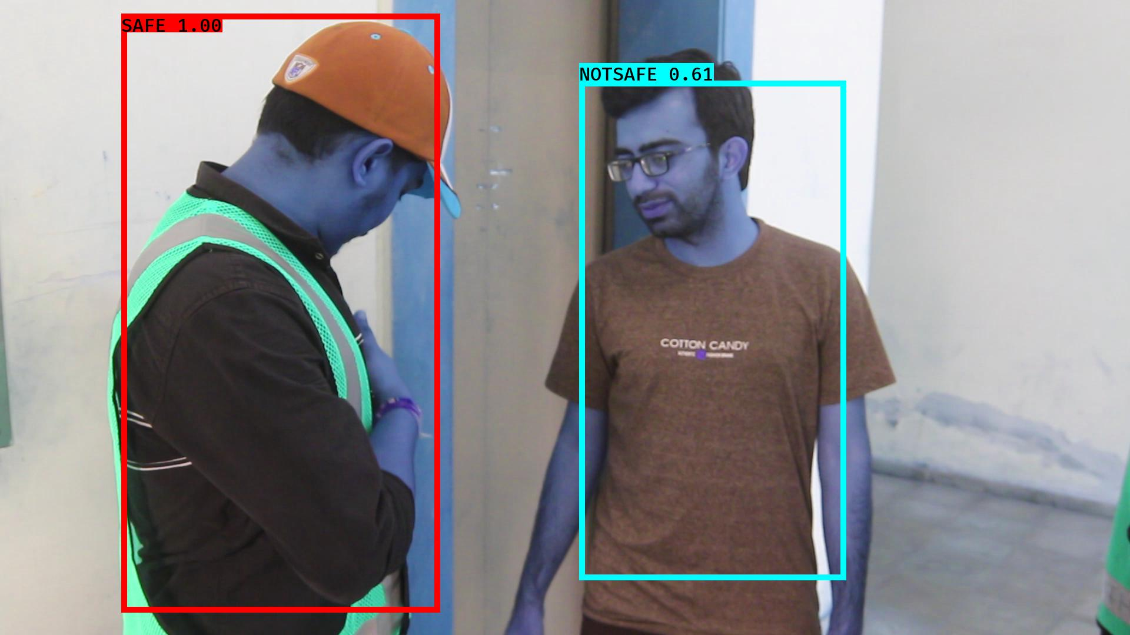

# NOTSAFE2019-06-05 20:16:13.643700.jpg

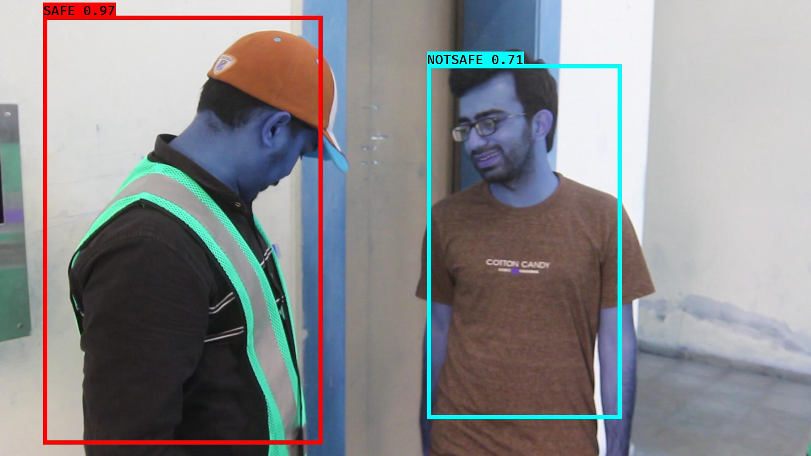

# NOTSAFE2019-06-05 20:16:15.925954.jpg

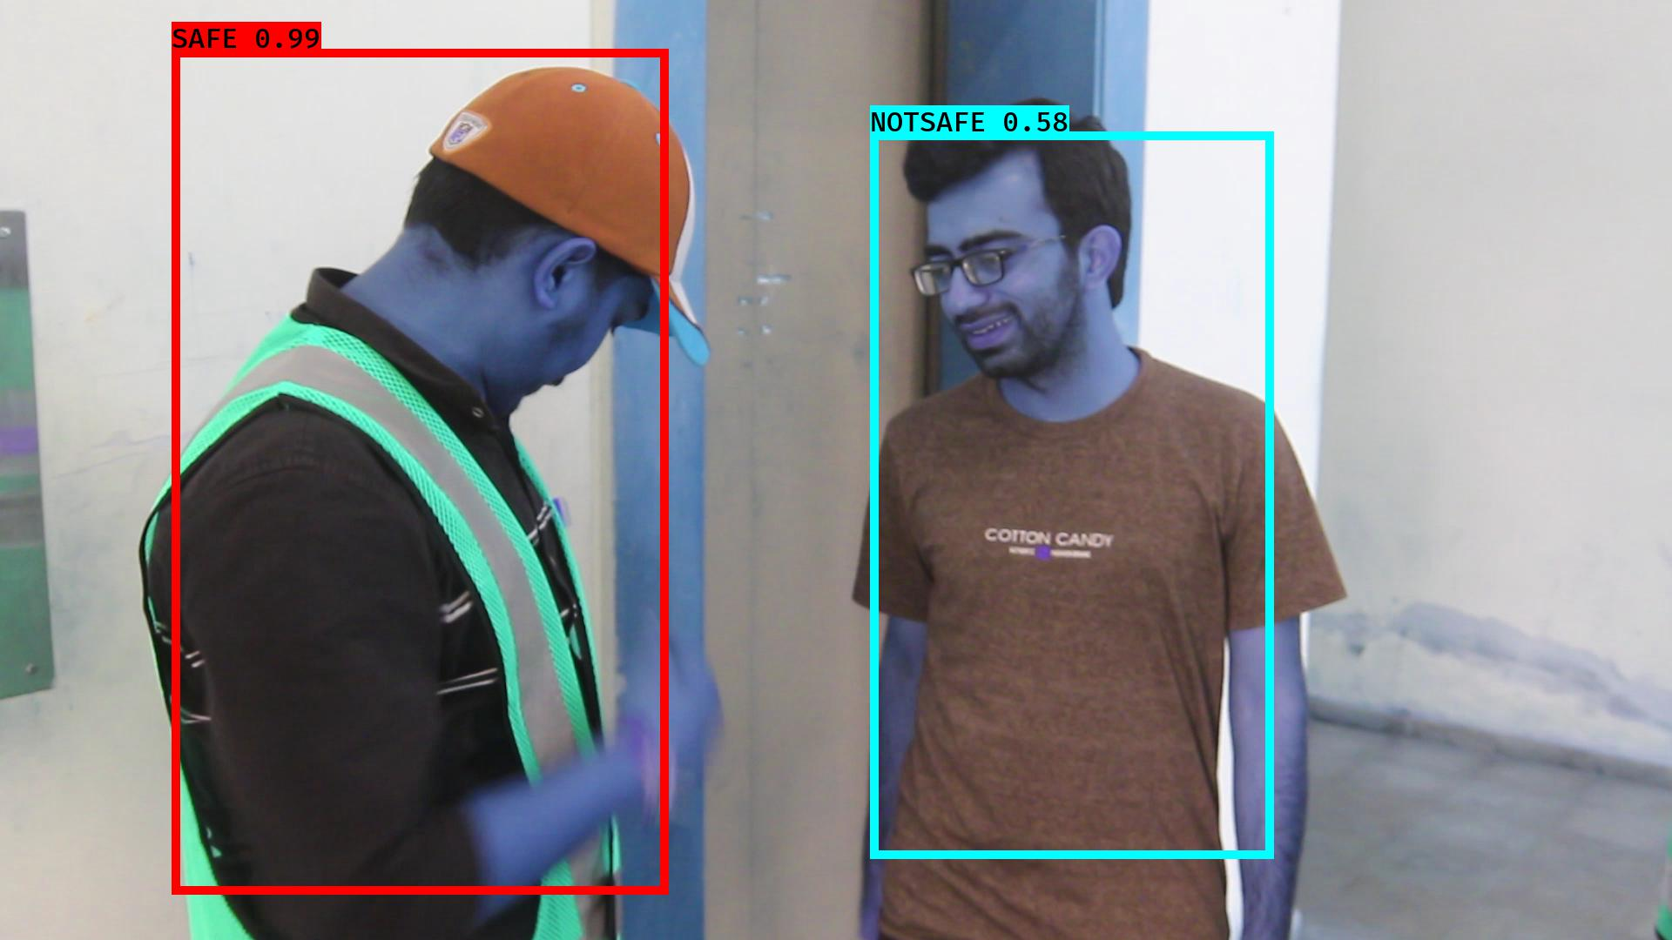

# NOTSAFE2019-06-05 20:16:11.933809.jpg

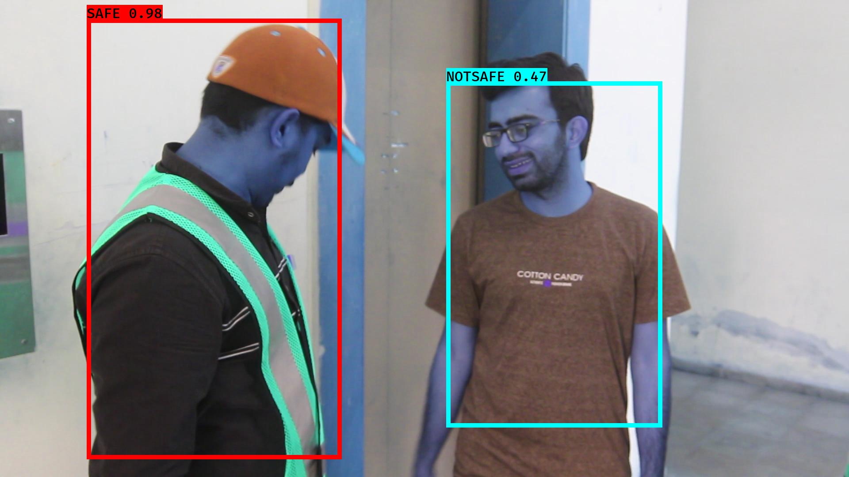

# NOTSAFE2019-06-05 20:16:42.124586.jpg

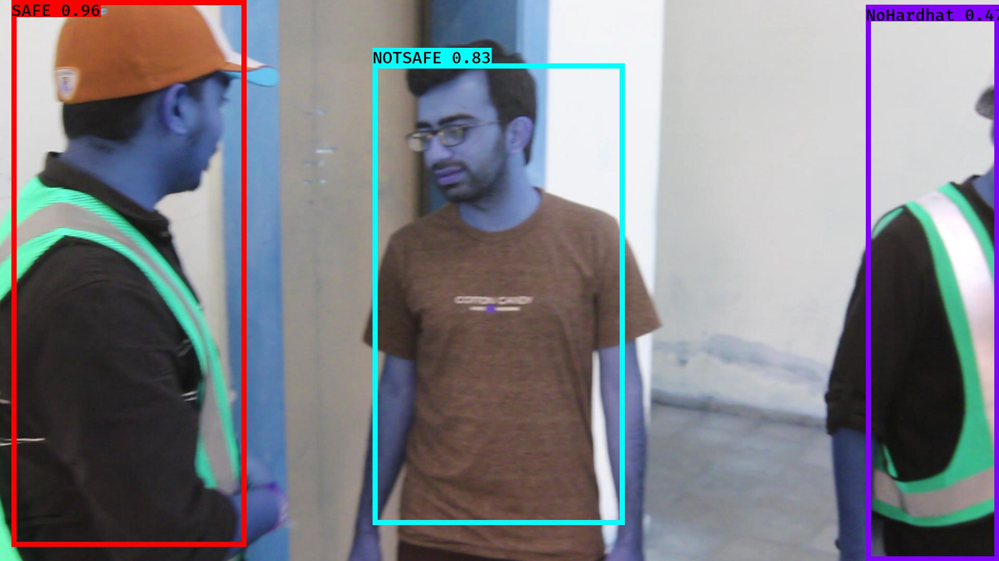

# NOTSAFE2019-06-05 20:16:30.867559.jpg

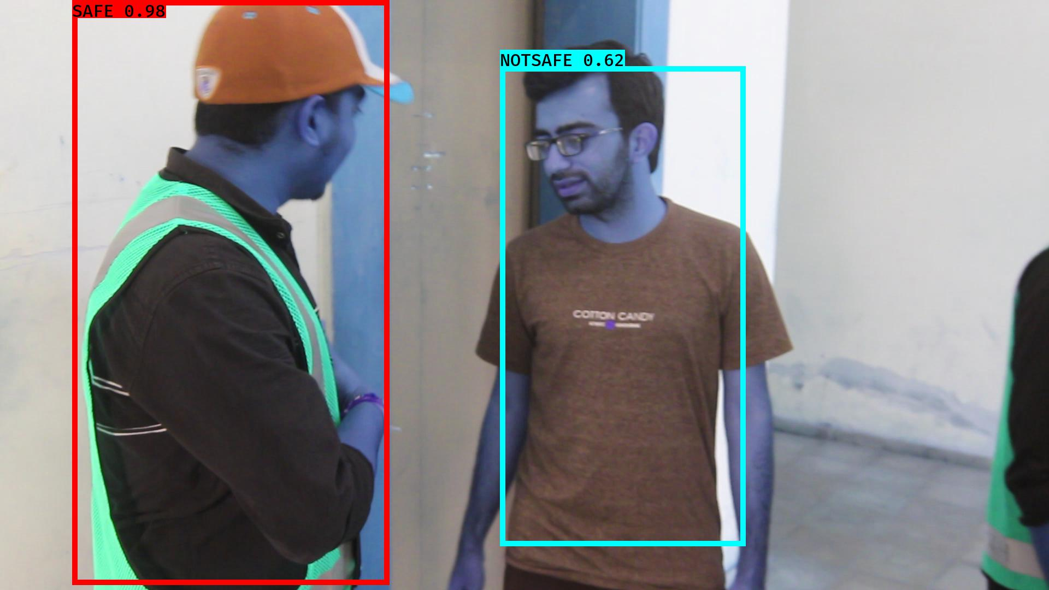

# NOTSAFE2019-06-05 20:16:53.957479.jpg

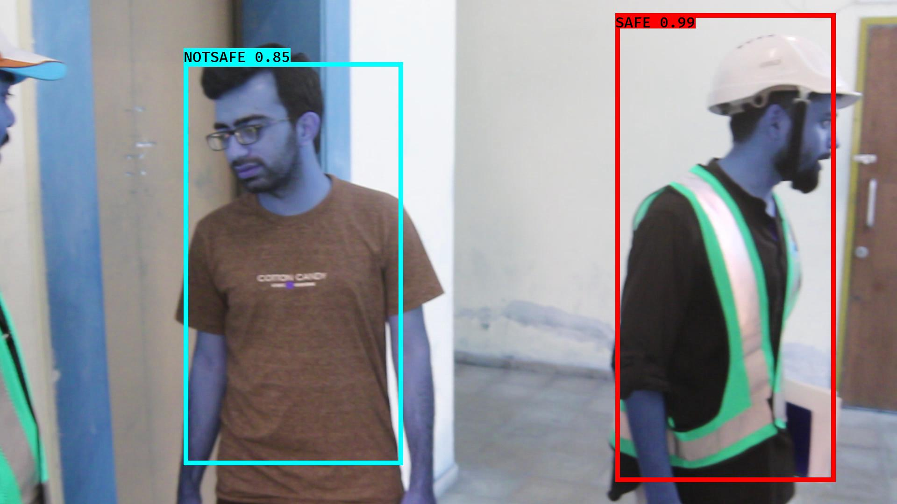

# NOTSAFE2019-06-05 20:16:47.444758.jpg

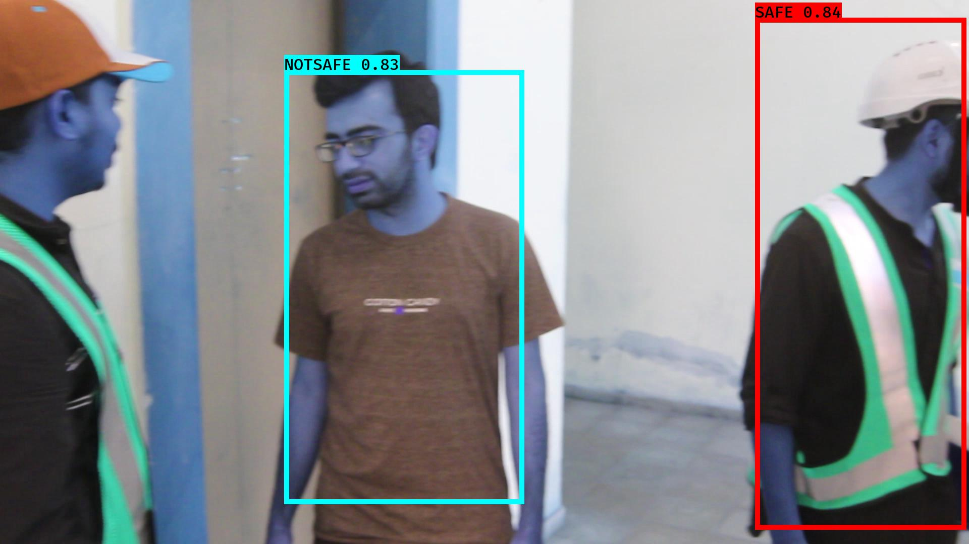

# NOTSAFE2019-06-05 20:16:20.881482.jpg

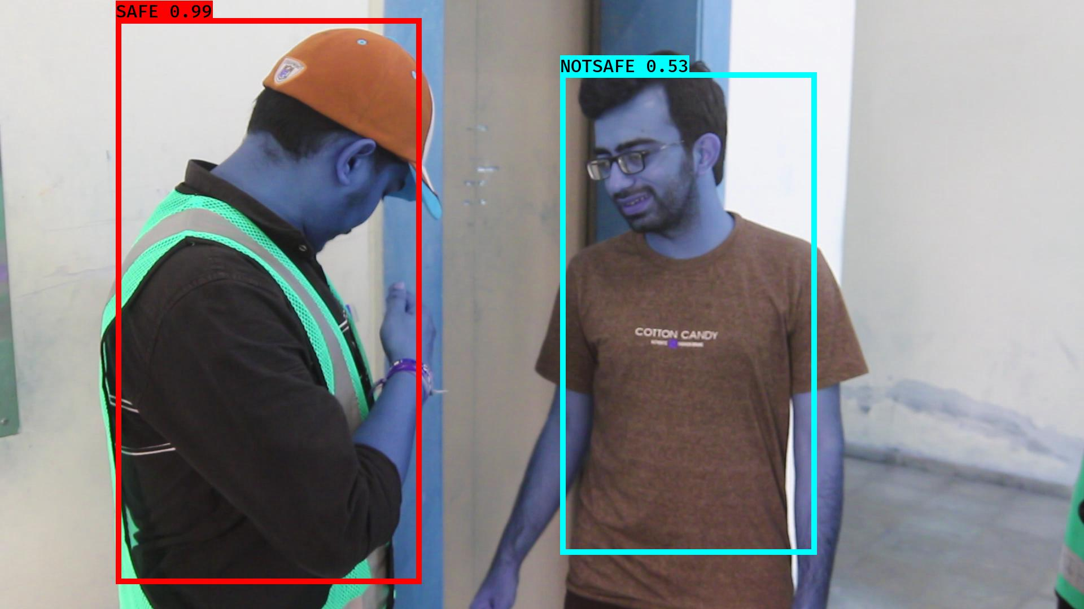

# NOTSAFE2019-06-05 20:16:04.066792.jpg

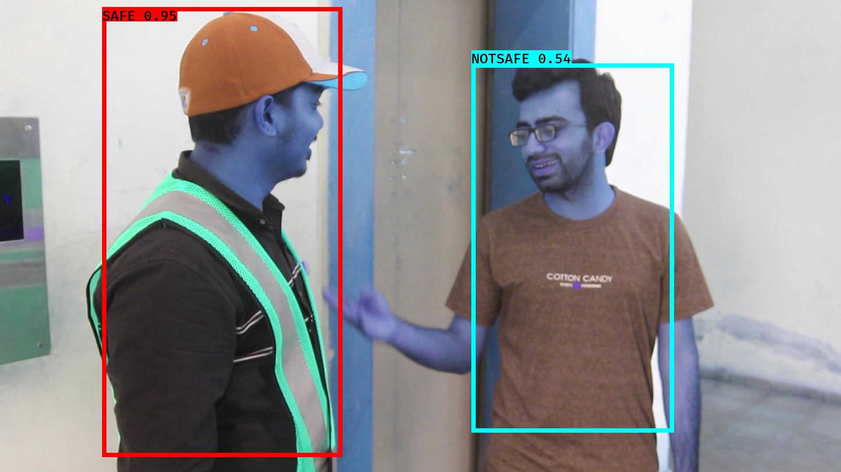

# NOTSAFE2019-06-05 20:16:38.581202.jpg

